List of documents in this case study about Holocaust resistance
- Photograph: Boat used to transport Danish refugees (USHHM)
- A Forgotten Suitcase: The Mantello Mission (USHHM)
- White Rose
- Irena Sendler (Jewish Virtual Library)
- Nicholas Winton, Rescuer of 669 Children From Holocaust, Dies at 106 (New York Times)

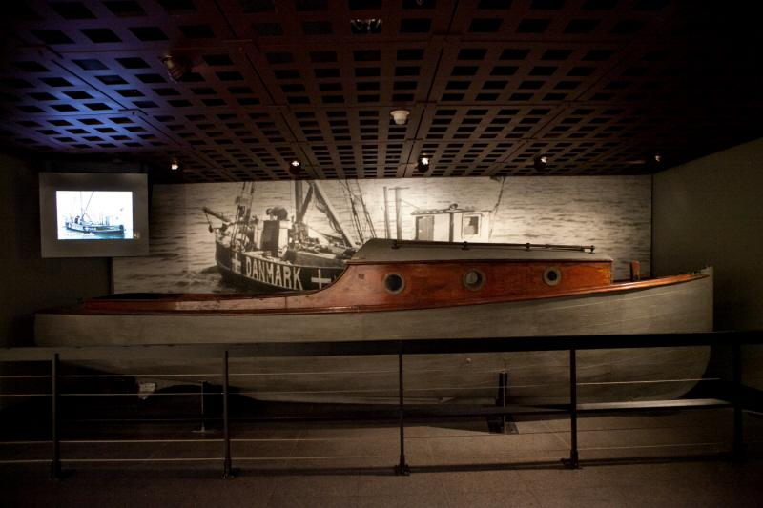
This boat and others like it were used in a rescue operation, organized by a group of Danes code-named the “Helsingør Sewing Club,” to transport Danish refugees from German-occupied Denmark to neutral Sweden in October 1943. The group’s founder was arrested by German authorities in 1944 and imprisoned in the Neuengamme concentration camp. US Holocaust Memorial Museum, gift of Preben Munch-Nielsen
https://www.ushmm.org/information/exhibitions/permanent/resistance/explore-the-objects

A Forgotten Suitcase: The Mantello Rescue Mission
https://www.ushmm.org/information/exhibitions/online-features/collections-highlights/mantello-rescue-mission
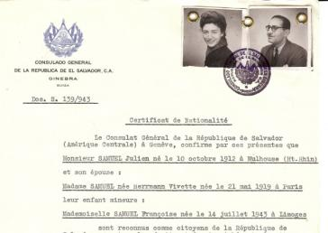
Many certificates were sent to Jews who themselves took active roles in rescue and resistance operations in occupied Europe. This certificate was sent to Julien and Vivette Samuel, leaders of the Children’s Aid Society (Oeuvre de Secours aux Enfants; OSE) in France. —US Holocaust Memorial Museum, courtesy of Enrico Mandel-Mantello
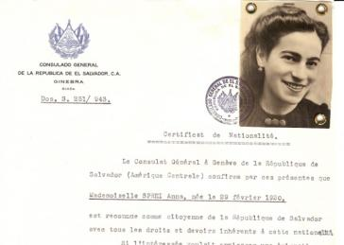
Many certificates were sent to Jews already interned in concentration camps. This certificate was sent to Anna Sprei in Birkenau in December 1943. Almost exactly six months later, Mandel-Mantello launched a press campaign which leaked the Auschwitz Protocol, a clandestine report written by two escapees that testified that over 1,700,000 Jews had been killed in Auschwitz-Birkenau. —US Holocaust Memorial Museum, courtesy of Enrico Mandel-Mantello
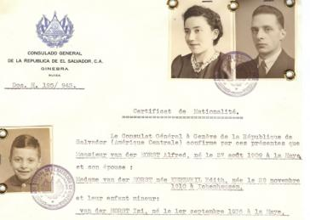
Most Dutch Jews were sent to either the Auschwitz or Sobibor death camps. However, many with Salvadoran certificates, such as Alfred, Edith, and Isi Van der Horst, were instead sent to a special camp for foreign nationals in Bergen-Belsen. Alfred Van der Horst died of disease in Bergen-Belsen, Edith died in April shortly before liberation. Their eight-year-old son Isi (Isaac) survived the Holocaust. —US Holocaust Memorial Museum, courtesy of Enrico Mandel-Mantello
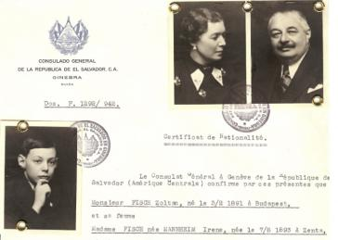
Paul Fisch, a college student in Zurich, arranged for a certificate to be sent to his parents and brother in Hungary. The certificate arrived too late to help his brother Robert who was already in a forced labor brigade, but his parents received it. One day, his father left their apartment without the paper and was arrested. His mother however survived in hiding with the certificate. —US Holocaust Memorial Museum, courtesy of Enrico Mandel-Mantello
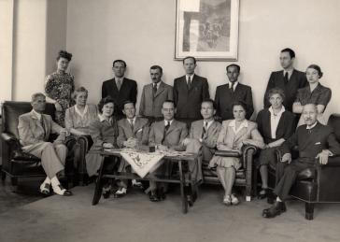
Staff of the Swiss embassy in Budapest. Carl Lutz, the Swiss vice-consul in Budapest, Hungary, sheltered Mantello’s wife Iren, helped Mandel-Mantello distribute certificates in Hungary, and represented Salvadoran interests in Hungary. —US Holocaust Memorial Museum
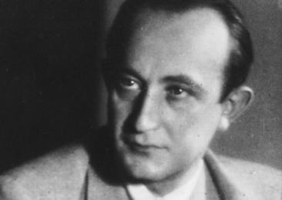
Portrait of George Mandel-Mantello. —US Holocaust Memorial Museum, courtesy of Eric Saul
Around 2005, a woman found a mysterious suitcase in her basement in Geneva, Switzerland. Inside the suitcase were more than one thousand World War II-era certificates bearing the official seal of the Consulate of El Salvador. The certificates also featured the photographs of men, women, and children. What were these documents? Why were the decades-old official papers of a Central American nation lying forgotten in a Swiss basement? How many of these documents reached their intended recipients? Their history reveals one of the largest scale, yet least known, rescue attempts of the Holocaust.
George Mandel was a Hungarian Jewish businessman who befriended a Salvadoran diplomat, Colonel José Arturo Castellanos, in the years leading up to World War II. After Castellanos was named El Salvador’s Consul General in Geneva, he appointed Mandel, who had assumed a Spanish-sounding version of his last name, “Mantello,” to serve as the Consulate’s first secretary. Even in Nazi-occupied Europe, Jews who were citizens of or held official documents from other countries were often able to escape deportation. With the consent of Castellanos, George Mandel-Mantello used his diplomatic position to issue documents identifying thousands of European Jews as citizens of El Salvador. He sent notarized copies of these certificates into occupied Europe, in the hope of saving the holders from the Nazis.
Enrico Mandel-Mantello, the son of George Mandel-Mantello, donated the original certificates to the United States Holocaust Memorial Museum after they were found.
Each certificate tells the unique history of one survivor or victim of the Holocaust. We want to learn as much as possible about the thousands of recipients of Salvadoran certificates. If you or someone you know received a Salvadoran citizenship certificate, please contact Judith Cohen, Director of Photographic Reference Collection, at jcohen@ushmm.org.
WHEN DID GEORGE MANDEL-MANTELLO BEGIN DISTRIBUTING THE CERTIFICATES?
In 1942, Jewish friends in Switzerland began to ask Mandel-Mantello if he could produce a Salvadoran citizenship paper for their relatives. Word then spread among representatives of various Jewish organizations, who also approached Mandel-Mantello, each providing data and photographs of the people they wanted to try to save.
WHERE WERE THE CERTIFICATES SENT?
Copies of the certificates were sent by diplomatic courier throughout wartime Europe. They were sent to almost every country in occupied Europe, some even to French internment camps, Theresienstadt in Czechoslovakia, and Auschwitz in Poland. After the German invasion of Hungary in March 1944, the production of certificates accelerated. In total, Mandel-Mantello may have issued as many as five thousand certificates, many with the names and photographs of several family members. Enrico Mandel-Mantello has donated more than one thousand originals to the Museum. He also donated to the Museum a copy of the Auschwitz Protocol.
DID EVERYONE WHO RECEIVED A CERTIFICATE SURVIVE?
Many people who received certificates survived. Some went to Switzerland; others were sent to a special camp in Bergen-Belsen for foreign nationals. Some certificates spared the holders from deportation. However, certificates frequently arrived too late, including those sent to Mandel-Mantello’s own parents. In other cases the Germans did not accept them. The Museum hopes through continued research to learn exactly how many people were saved through these certificates.
HOW DID THE CERTIFICATES SURVIVE?
After printing each “official” certificate of citizenship, Mandel-Mantello made a notarized copy (Photostat) that he sent into occupied Europe by diplomatic pouch or the underground Jewish courier system. The originals remained with him in Switzerland, accounting for their near pristine condition.
WHAT IS THE CONNECTION BETWEEN MANDEL-MANTELLO AND THE AUSCHWITZ PROTOCOL?
In April 1944, two Slovakian Jews, Rudolf Vrba and Alfred Wetzler, escaped from Auschwitz and wrote a report providing some of the first reliable eyewitness accounts of the camp. Romanian diplomat Florian Manoliu, who was assisting Mandel-Mantello in his rescue efforts, received a copy of the Protocol and immediately gave it to Mandel-Mantello in June. Recognizing the Protocol’s importance, Mandel-Mantello recopied it, translated it, distributed it to Swiss Protestant clergy, and launched a worldwide press campaign condemning Nazi atrocities.

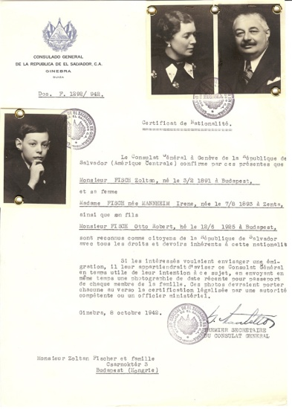
As the first secretary of El Salvador’s consulate in Geneva, Switzerland, Hungarian Jewish businessman George Mandel-Mantello saved thousands of Jews in Hungary by issuing them Salvadoran citizenship papers, like this one for the Fisch family. US Holocaust Memorial Museum Collection, gift of Enrico Mandel-Mantello
https://www.ushmm.org/information/exhibitions/permanent/resistance/explore-the-objects

The White Rose
The White Rose (weisserose), named after a Spanish novel (Rosa Blanco). The Group coordinated efforts on Campus for Civil Rights and Opposition to Nazi policies. Among their efforts on campus were weekly discussion groups, painting 'freedom' on brick walls at the entrance into campus, and distributing leaflets opposing the Reich on moral and political grounds, encouraging students to think for themselves.

The White Rose

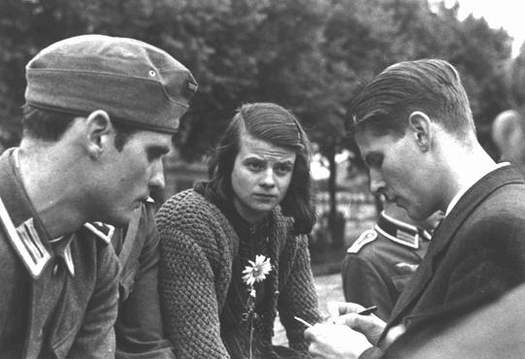
Sophie & Hans Scholl with Christoph Probst summer of 1942

In the early summer of 1942, a group of young men — including Willi Graf, Christoph Probst and Hans Schol formed a a non-violent resistance group in Nazi Germany, consisting of a number of students from the University of Munich and their philosophy professor. The group became known for an anonymous leaflet campaign, lasting from June 1942 until February 1943, that called for active opposition to the Nazis regime.

The group co-authored six anti-Nazi Third Reich political resistance leaflets. Calling themselves the White Rose, they instructed Germans to passively resist the Nazis. They had been horrified by the behavior of the Germans on the Eastern Front where they had witnessed a group of naked Jews being shot in a pit.
The core of the White Rose consisted of five students — Sophie Scholl, her brother Hans Scholl, Alex Schmorell, Willi Graf, and Christoph Probst, all in their early twenties — also members were Hans and Sophie's sister Inge Scholl, and a professor of philosophy, Kurt Huber.
Between June 1942 and February 1943, they prepared and distributed six different leaflets, in which they called for the active opposition of the German people to Nazi oppression and tyranny. Huber drafted the final two leaflets. A draft of a seventh leaflet, written by Christoph Probst, was found in the possession of Hans Scholl at the time of his arrest by the Gestapo, who destroyed it.
The White Rose was influenced by the German Youth Movement, of which Christoph Probst was a member. Hans Scholl was a member of the Hitler Youth until 1936 and Sophie was a member of the Bund Deutscher Mädel. The ideas of d.j.1.11 had strong influence on Hans Scholl and his brothers and sisters. d.j.1.11 was a youth group of the German Youth Movement, founded by Eberhard Koebel in 1929.

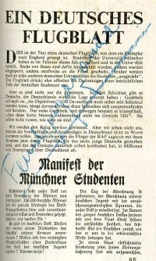
The sixth leaflet (flyer)

Willi Graf was a member of Neudeutschland and the Grauer Orden. Neudeutschland is a catholic youth association. The group's members were motivated by their Christian beliefs. They had witnessed the atrocities of the war, both on the battlefield and against the civilian population in the East, and sensed that the reversal of fortune that the Wehrmacht suffered at Stalingrad would eventually lead to Germany's defeat. They rejected fascism and militarism and believed in a federated Europe that adhered to principles of tolerance and justice.

The Leaflets

During early summer of 1942, Alex Schmorell and Hans Scholl wrote four leaflets, copied them on a typewriter with as many copies as could be made, probably not exceeding 100, and distributed them throughout Germany. These leaflets were left in telephone books in public phone booths, mailed to professors and students, and taken by courier to other universities for distribution. All four were written in a relatively brief period, between June 27 and July 12. As far as is known today, Hans Scholl wrote the first and fourth leaflets, Alex Schmorell participated with the second and third.

.

All leaflets were also sent to the members of the White Rose, in order that we could check whether they were intercepted. Significantly, of the first 100 leaflets, 35 were turned over to the Gestapo.

By turning the leaflets over to the secret police one hoped to be beyond suspicion. It might even have entered one's mind - and it certainly would not have been unthinkable - that such leaflets could have actually been produced and mailed by the Gestapo in order to test one's loyalty to the party and state.
Producing and distributing such leaflets sounds simple from today's perspective, but, in reality, it was not only very difficult but even dangerous. Paper was scarce, as were envelopes. And if one bought them in large quantities, or for that matter, more than just a few postage stamps (in any larger numbers), one would (have) become instantly suspect.

The White Rose

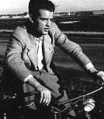  Hans Scholl | 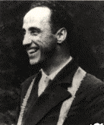  Kurt Huber | 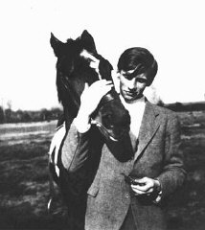  Alexander Schmorell | 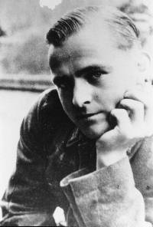  Willi Graf

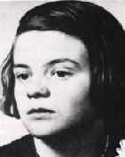  Sophie scholl | 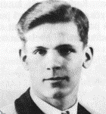  Christoph Probst

Taking leaflets to other cities carried great risk, because trains were constantly patrolled by military police, who demanded identification papers of any male of military service age. Anyone traveling without official marching papers was AWOL - and the consequences predictable.

"Some of us traveled in civilian clothing, hoping for the best, some with forged travel orders, I myself used false identification papers (my cousin's with whom I shared a certain resemblance). We left the briefcases which contained the leaflets in a different compartment, for luggage was routinely searched. Mostly, however, leaflets were taken by female students who were not subject to such scrutiny."
The members of The White Rose worked day and night, cranking a hand-operated duplicating machine thousands of times to create the leaflets which were each stuffed into envelopes, stamped and mailed from various major cities in Southern Germany. Recipients were chosen from telephone directories and were generally scholars, medics and pub-owners in order to confuse the Gestapo investigators.

While Hans and Alex alone drafted the first four leaflets, they counted on Christoph Probst to comment and criticize. Jürgen edited the third and fourth leaflets and traveled to Berlin with the dangerous documents. Willi contributed to the fifth leaflet and did a generous amount of leg-work, getting supplies and trying to recruit support outside of Munich.

Sophie worked at getting stamps and paper (one couldn't buy too many stamps at one place without arousing suspicion) and also managed the group's funds. Kurt Huber contributed to the fifth leaflet and solely drafted the sixth (and final) leaflet, while Hans was apprehended with a rough-draft of a seventh leaflet written by Christoph Probst.

All members traveled throughout Southern Germany (and beyond) to mail stacks of leaflets from undetectable locations. Hundreds of leaflets were also left at the University of Munich, carefully hand-delivered in the middle of the night.
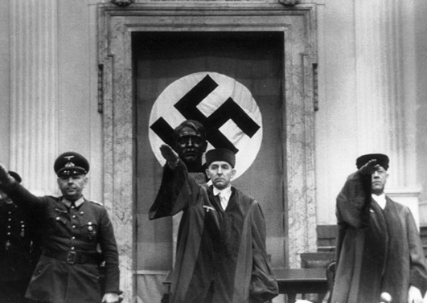
People's Court in Berlin (Roland Freisler center)

Arrest of the White Rose

On three nights in February 1943 -- the 3rd, 8th and 15th -- Hans, Alex and Willi conducted the most dangerous of all the White Rose activities. The three men used tar and paint to write slogans on the sides of houses on Ludwigstrasse, a main thoroughfare in Munich near the University. They wrote "Down With Hitler", "Hitler Mass Murderer", "freedom", and drew crossed-out swastikas... this while policemen and other officials patroled the streets of Munich. It was, by far, the most public, blatant and dangerous of their activities.

On Thursday, February eighteenth, 1943, Sophie and Hans distributed the pamphlets personally at the university. They hurriedly dropped stacks of copies in the empty corridors for students to find when they flooded out of lecture rooms. Leaving before the class break, the Scholls noticed that some copies remained in the suitcase and decided it would be a pity not to distribute them.

They returned to the atrium and climbed the staircase to the top floor, and Sophie flung the last remaining leaflets into the air. This spontaneous action was observed by the custodian Jakob Schmid. The police were called and Hans and Sophie were taken into Gestapo custody. The other active members were soon arrested, and the group and everyone associated with them were brought in for interrogation.

Sophie and Hans were questioned for four days in Munich, and their trial was set for February twenty second. They, along with Christoph, were arrested. Within days, all three were brought before the People's Court in Berlin. On February 22, 1943. The trial was run by Roland Freisler, head judge of the court, and lasted only a few hours, they were convicted of treason and sentenced to death. Only hours later, the court carried out that sentence by guillotine. All three faced their deaths bravely, Hans crying out his last words,

"Long live freedom!"

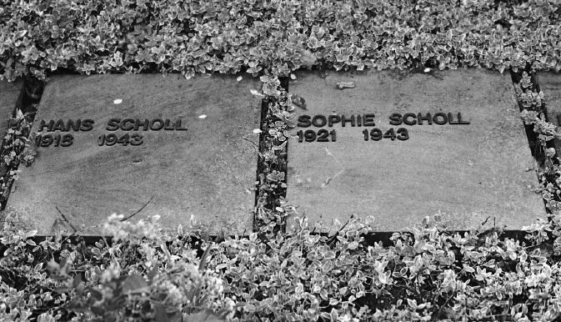
The graves of Hans & Sophie Scholl

Later that same year, other members of the White Rose -- Alexander Schmorell (age 25), Willi Graf (age 25), and Kurt Huber (age 49) -- were tried and executed. Most of the other students convicted for their part in the group's activities received prison sentences.

Prior to their deaths, several members of the White Rose believed that their execution would stir university students and other anti-war citizens into a rallying activism against Hitler and the war. Accounts suggest, however, that university students continued their studies as usual, citizens mentioned nothing, many regarding the movement as anti-national. Their actions were mostly dismissed, until after the war when their efforts were eventually praised by the German consciousness.
Irena Sendler
(1910 - 2008)

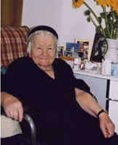

https://www.jewishvirtuallibrary.org/jsource/biography/irenasendler.html

When Hitler and his Nazis built the Warsaw Ghetto and herded 500,000 Polish Jews behind its walls to await liquidation, Irena Sendler defied the Nazis and saved 2,500 Jewish children by smuggling them out of the Warsaw Ghetto. As a health worker, she sneaked the children out between 1942 and 1943 to safe hiding places and found non-Jewish families to adopt them.

Her achievement went largely unnoticed for many years. Then the story was uncovered by four young students at Uniontown High School, in Kansas, who were the winners of the 2000 Kansas state National History Day competition by writing a play Life in a Jar about the heroic actions of Irena Sendler. The girls - Elizabeth Cambers, Megan Stewart, Sabrina Coons and Janice Underwood - have since gained international recognition, along with their teacher, Norman Conard. The presentation, seen in many venues in the United States and popularized by National Public Radio, C-SPAN and CBS, has brought Irena Sendler's story to a wider public.

Sendler was born in 1910 in Otwock, a town some 15 miles southeast of Warsaw. She was greatly influenced by her father who was one of the first Polish Socialists. As a doctor his patients were mostly poor Jews.

In 1939, Germany invaded Poland, and the brutality of the Nazis accelerated with murder, violence and terror.

At the time, Irena was a Senior Administrator in the Warsaw Social Welfare Department, which operated the canteens in every district of the city. Previously, the canteens provided meals, financial aid, and other services for orphans, the elderly, the poor and the destitute. Now, through Irena, the canteens also provided clothing, medicine and money for the Jews. They were registered under fictitious Christian names, and to prevent inspections, the Jewish families were reported as being afflicted with such highly infectious diseases as typhus and tuberculosis.

But in 1942, the Nazis herded hundreds of thousands of Jews into a 16-block area that came to be known as the Warsaw Ghetto. The Ghetto was sealed and the Jewish families ended up behind its walls, only to await certain death.

Sendler was so appalled by the conditions that she joined Zegota, the Council for Aid to Jews, organized by the Polish underground resistance movement, as one of its first recruits and directed the efforts to rescue Jewish children.

To be able to enter the Ghetto legally, Irena managed to be issued a pass from Warsaws Epidemic Control Department and she visited the Ghetto daily, reestablished contacts and brought food, medicines and clothing. But 5,000 people were dying a month from starvation and disease in the Ghetto, and she decided to help the Jewish children to get out.

For Sendler, a young mother herself, persuading parents to part with their children was in itself a horrendous task. Finding families willing to shelter the children, and thereby willing to risk their life if the Nazis ever found out, was also not easy.

Sendler, who wore a star armband as a sign of her solidarity to Jews, began smuggling children out in an ambulance. She recruited at least one person from each of the ten centers of the Social Welfare Department. With their help, she issued hundreds of false documents with forged signatures and successfully smuggled almost 2,500 Jewish children to safety and gave them temporary new identities.

Some children were taken out in gunnysacks or body bags. Some were buried inside loads of goods. A mechanic took a baby out in his toolbox. Some kids were carried out in potato sacks, others were placed in coffins, some entered a church in the Ghetto which had two entrances. One entrance opened into the Ghetto, the other opened into the Aryan side of Warsaw. They entered the church as Jews and exited as Christians. "Can you guarantee they will live?" Irena later recalled the distraught parents asking. But she could only guarantee they would die if they stayed. "In my dreams," she said, "I still hear the cries when they left their parents."

Irena Sendler accomplished her incredible deeds with the active assistance of the church. "I sent most of the children to religious establishments," she recalled. "I knew I could count on the Sisters." Irena also had a remarkable record of cooperation when placing the youngsters: "No one ever refused to take a child from me," she said.

The children were given false identities and placed in homes, orphanages and convents. Sendler carefully noted, in coded form, the children's original names and their new identities. She kept the only record of their true identities in jars buried beneath an apple tree in a neighbor's back yard, across the street from German barracks, hoping she could someday dig up the jars, locate the children and inform them of their past. In all, the jars contained the names of 2,500 children.

But the Nazis became aware of Irena's activities, and on October 20, 1943 she was arrested, imprisoned and tortured by the Gestapo, who broke her feet and legs. She ended up in the Pawiak Prison, but no one could break her spirit. Though she was the only one who knew the names and addresses of the families sheltering the Jewish children, she withstood the torture, refusing to betray either her associates or any of the Jewish children in hiding.

Sentenced to death, Irena was saved at the last minute when Zegota members bribed one of the Germans to halt the execution. She escaped from prison but for the rest of the war she was pursued by the Gestapo.

After the war she dug up the jars and used the notes to track down the 2,500 children she placed with adoptive families and to reunite them with relatives scattered across Europe. But most lost their families during the Holocaust in Nazi death camps.

The children had known her only by her code name Jolanta. But years later, after she was honored for her wartime work, her picture appeared in a newspaper. "A man, a painter, telephoned me," said Sendler, "`I remember your face,' he said. `It was you who took me out of the ghetto.' I had many calls like that!"

Irena Sendler did not think of herself as a hero. She claimed no credit for her actions. "I could have done more," she said. "This regret will follow me to my death."

She has been honored by international Jewish organizations - in 1965 she accorded the title of Righteous Among the Nations by the Yad Vashem organization in Jerusalem and in 1991 she was made an honorary citizen of Israel.

Irena Sendler was awarded Poland's highest distinction, the Order of White Eagle in Warsaw Monday Nov. 10, 2003.

This lovely, courageous woman was one of the most dedicated and active workers in aiding Jews during the Nazi occupation of Poland. Her courage enabled not only the survival of 2,500 Jewish children but also of the generations of their descendants.

She passed away on May 12, 2008, at the age of 98.

Nicholas Winton, Rescuer of 669 Children From Holocaust, Dies at 106
By ROBERT D. McFADDEN
JULY 1, 2015

http://www.nytimes.com/2015/07/02/world/europe/nicholas-winton-is-dead-at-106-saved-children-from-the-holocaust.html?_r=0

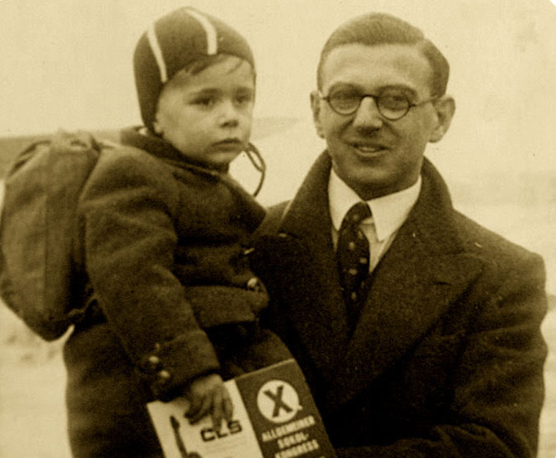

A family picture of Nicholas Winton with one of the hundreds of Jewish children whose lives he saved during World War II. CreditPress Association, via Associated Press
Nicholas Winton, a Briton who said nothing for a half-century about his role in organizing the escape of 669 mostly Jewish children from Czechoslovakia on the eve of World War II, a righteous deed like those of Oskar Schindler and Raoul Wallenberg, died on Wednesday in Maidenhead, England. He was 106.
The Rotary Club of Maidenhead, of which Mr. Winton was a former president, announced his death on its website. He lived in Maidenhead, west of London.

It was only after Mr. Winton’s wife found a scrapbook in the attic of their home in 1988 — a dusty record of names, pictures and documents detailing a story of redemption from the Holocaust — that he spoke of his all-but-forgotten work in the deliverance of children who, like the parents who gave them up to save their lives, were destined for Nazi concentration camps and extermination.
For all his ensuing honors and accolades in books and films, Mr. Winton was a reluctant hero, often compared to Schindler, the ethnic German who saved 1,200 Jews by employing them in his enamelware and munitions factories in Poland and Czechoslovakia, and to Wallenberg, the Swedish businessman and diplomat who used illegal passports and legation hideaways to save tens of thousands of Jews in Nazi-occupied Hungary.

Mr. Winton — Sir Nicholas in England since 2003, when he was knighted by Queen Elizabeth II — was a London stockbroker in December 1938 when, on an impulse, he canceled a Swiss skiing vacation and flew to Prague at the behest of a friend who was aiding refugees in the Sudetenland, the western region of Czechoslovakia that had just been annexed by Germany.
“Don’t bother to bring your skis,” the friend, Martin Blake, advised in a phone call.
Mr. Winton found vast camps of refugees living in appalling conditions. The pogroms of Kristallnacht, the “Night of Broken Glass,” had recently struck Jewish shops, homes and synagogues in Germany and Austria. War looked inevitable, and escape, especially for children, seemed hopeless, given the restrictions against Jewish immigration in the West.

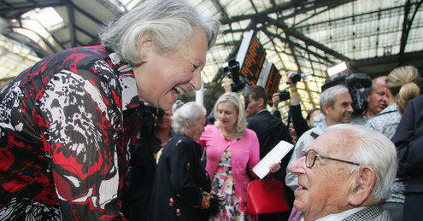

Britain, however, was an exception. In late 1938, it began a program, called Kindertransport, to admit unaccompanied Jewish children up to age 17 if they had a host family, with the offer of a 50-pound warranty for an eventual return ticket. The Refugee Children’s Movement in Britain sent representatives to Germany and Austria, and 10,000 Jewish children were saved before the war began.
But there was no comparable mass-rescue effort in Czechoslovakia. Mr. Winton created one. It involved dangers, bribes, forgery, secret contacts with the Gestapo, nine railroad trains, an avalanche of paperwork and a lot of money. Nazi agents started following him. In his Prague hotel room, he met terrified parents desperate to get their children to safety, although it meant surrendering them to strangers in a foreign land.
As their numbers grew, a storefront office was opened. Long lines attracted Gestapo attention. Perilous confrontations were resolved with bribes. Eventually he registered more than 900 children, although he had names and details on 5,000. In early 1939, he left two friends, Trevor Chadwick and Bill Barazetti, in charge in Prague and returned to London to find foster homes, raise money and arrange transportation.
He and a few volunteers, including his mother, calling themselves the British Committee for Refugees from Czechoslovakia, Children’s Section, enlisted aid from the Refugee Children’s Movement, had photos of the children printed and appealed for funds and foster homes in newspaper ads and church and synagogue bulletins.
Hundreds of families volunteered to take children, and money trickled in from donors — not enough to cover all the costs, but Mr. Winton made up the difference himself. He also appealed to the Home Office for entry visas, but the response was slow and time was short. “This was a few months before the war broke out,” he recalled. “So we forged the Home Office entry permits.”
In Prague, Mr. Chadwick quietly cultivated the chief of the Gestapo, Karl Bömelburg — they called him “the criminal rat” after his inspector’s rank of kriminalrat — and arranged for forged transit papers and bribes to be passed to key Nazis and Czech railway officials, who threatened to halt trains or seize the children unless they were paid off. The Gestapo chief proved instrumental, clearing the trains and transit papers, Mr. Chadwick said.
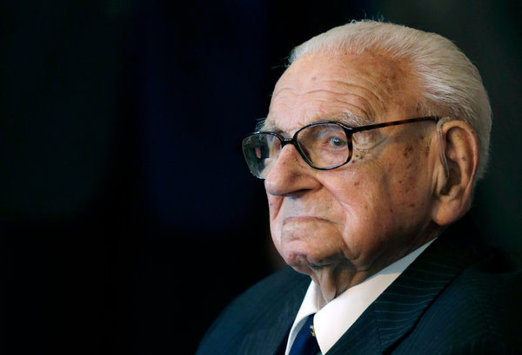
Nicholas Winton in 2014. CreditPetr David Josek/Associated Press

Searing Separations
Mr. Winton sent more money, some for bribes and some to cover expenses for children whose parents had been arrested and shot or had fled into hiding, while many of the Czech families sold possessions to pay for their children’s escape. The red tape and paperwork seemed endless.

But on March 14, 1939, it all came together. Hours before Hitler dismembered the Czech provinces of Bohemia and Moravia as a German “Protectorate,” the first 20 children left Prague on a train. Survivors told of searing scenes on the station platform in the final moments before departure as children sobbed and pleaded not to be sent away and parents faced giving up their children.

Mr. Winton and his colleagues later arranged for eight more trains to get the rest of the children out, crossing the Third Reich through Nuremberg and Cologne to the Hook of Holland, then across the North Sea by boat to Harwich, Essex, and on by British rail to the Liverpool Street Station in London. There, he and the host families met the children. Each refugee had a small bag and wore a name tag.

But only seven of the eight trains made it through, the last in early August, bringing the total rescued to 669. About 250 children, the largest group, were on board the last train out, on Sept. 1, 1939. On that day, however, Hitler invaded Poland, all borders controlled by Germany were closed and Mr. Winton’s rescue efforts came to an end.

“Within hours of the announcement, the train disappeared,” he recalled. “None of the 250 children aboard was ever seen again.” All were believed to have perished in concentration camps.
Nearly all the saved children were orphans by war’s end, their parents killed at Auschwitz, Bergen-Belsen or Theresienstadt. After the war, many remained in Britain, but others returned to Czechoslovakia or emigrated to Israel, Australia or the United States. The survivors, many now in their 70s and 80s, still call themselves “Winton’s Children.”
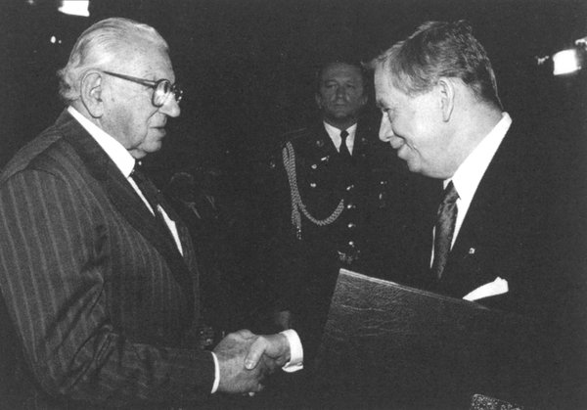
Mr. Winton received the Czech Republic’s highest honor from President Vaclav Havel in 1998.Credit"Nicholas Winton and the Rescued Generation"

A Scrapbook in the Attic
Among them are the film director Karel Reisz, who made “The French Lieutenant’s Woman” (1981), “Isadora” (1968) and “Saturday Night and Sunday Morning” (1960); Alfred, Lord Dubs, who became a member of Parliament; Joe Schlesinger, a Canadian broadcast correspondent; Hugo Marom, a founder of the Israeli Air Force; Vera Gissing, the author of “Pearls of Childhood” (2007) and other books; and Renata Laxová, a geneticist who discovered the Neu-Laxová Syndrome, a congenital abnormality.

Mr. Winton was born Nicholas George Wertheim in London on May 19, 1909, one of three children of Rudolf and Barbara Wertheimer Wertheim. His parents were of German-Jewish origin but converted to Christianity and changed the family name to Winton. His father was a merchant banker, and Nicholas and his siblings, Bobby and Charlotte, grew up in a 20-room mansion in West Hampstead, London. He and Bobby were skilled fencers and late in life established the Winton Cup, a major British competition in the sport.

Nicholas attended Stowe School in Buckingham, was apprenticed in international banking in London and worked at Behrens Bank in Hamburg, Wassermann’s Bank in Berlin and Banque Nationale de Crédit in Paris. He was fluent in German and French when he returned to London in 1931 and became a stockbroker.

He was a Royal Air Force officer in the war and later worked for refugee organizations and the Abbeyfield Society, a charity that assists the elderly. He raised more than £1 million in one fund-raising drive. In 1983, he was made a member of the Order of the British Empire for his charity work.
But for 50 years he said nothing of the children’s rescue, not even to his wife, Grete Gjelstrup, a Dane he married in 1948. They had three children, Nicholas, Barbara and Robin. Robin died at age 7 in 1962. Mr. Winton’s wife died in 1999. The Rotary Club of Maidenhead said his daughter, Barbara, and two grandchildren were at his side at his death, but complete information on his survivors was not immediately available.

After finding his long-hidden scrapbook — crammed with names, pictures, letters from families, travel documents and notes crediting his colleagues — his wife asked for an explanation. He gave her a general idea, but said he thought the papers had no value and suggested discarding them.
Photo
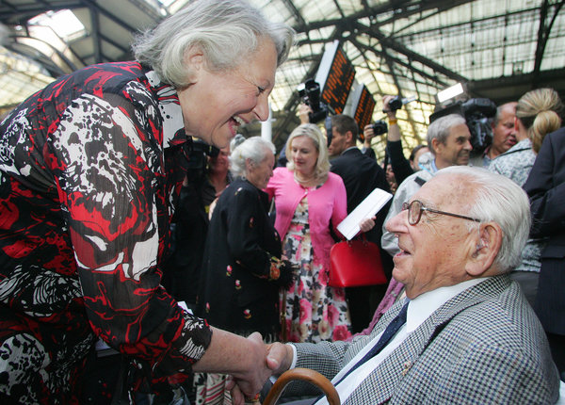
Nicholas Winton is greeted by a woman who was one of the 669 mostly Jewish children that he helped to escape Nazi-occupied Czechoslovakia in 1939. A Briton, he kept silent about his role in organizing the evacuations for 50 years, until his wife found a scrapbook in the attic.CreditGeoff Caddick/Agence France-Presse — Getty Images

“You can’t throw those papers away,” she responded. “They are children’s lives.”

“I did not think for one moment that they would be of interest to anyone so long after it happened,” Mr. Winton recalled later.

But he reluctantly agreed to let her explore the matter. She gave the scrapbook to a Holocaust historian. A newspaper article followed. Then a BBC television program featured the story of his rescues, and the publicity went worldwide.

He was showered with encomiums: the Czech Republic’s highest award, honorary citizenship of Prague, an American congressional resolution, letters of appreciation from President George W. Bush, Prime Minister Tony Blair of Britain, former President Ezer Weizman of Israel and people around the world, and a nomination by the Czech Republic for the Nobel Peace Prize. His scrapbook went to Yad Vashem, the Holocaust memorial in Israel. Streets and schools were named for him. Statues went up in Prague and London.

Incredulous at Fame

Why did he do it?
He never really explained, though he offered a bare rationale in an interview with The New York Times in 2001: “One saw the problem there, that a lot of these children were in danger, and you had to get them to what was called a safe haven, and there was no organization to do that. Why did I do it? Why do people do different things? Some people revel in taking risks, and some go through life taking no risks at all.”

Ms. Gissing, in her book “Nicholas Winton and the Rescued Generation: Save One Life, Save the World” (2001, with Muriel Emanuel), said Mr. Winton was incredulous at his fame. “Winton still shakes his head in bewilderment and disbelief when compared with Oskar Schindler and Raoul Wallenberg,” she wrote. “I try to make him realize that his contribution to the human race is immeasurable.”
The rescues were explored in three films by the Slovak director Matej Minác: the fictionalized “All My Loved Ones” (1999); a documentary, “The Power of Good: Nicholas Winton” (2002); and “Nicky’s Family” (2011), and in Mr. Minác’s book, “Nicholas Winton’s Lottery of Life” (2007).
On Sept. 1, 2009, 70 years after the onset of the war halted the rescue operations, a special train with a locomotive and carriages from the 1930s left Prague to re-create the perilous 1939 journeys. On board were some of the original Winton’s Children and many of their descendants, whose numbers now exceed 6,000.
They were met at Liverpool Street Station by Mr. Winton, who had recently turned 100.
Correction: July 3, 2015
An obituary on Thursday about Nicholas Winton, a Briton who rescued hundreds of children from Nazi-occupied Czechoslovakia, referred incorrectly to the honor bestowed on him in 1983. He was made a member of the Order of the British Empire; he did not “receive” the Order of the British Empire. The error also appeared in an obituary on May 14, 2014, about the British planetary scientist Colin Pillinger and in an article on May 19, 2014, about the death of Louise Wilson, one of the world’s pre-eminent instructors of fashion design.

