List of Documents in this Case Study on Native Americans:
- Introduction about genocide of Native American
- Map of tribes
- Timeline of events
- Cherokee Supreme Court Cases from 1830s
- New York Times Article from 1862
- Indigenous Voices of Resistance
- Mass grave at Wounded Knee photograph
- Alcatraz Proclamation and letter to All Indian Nations
- The Black Hills are not for sale
- Russell Means speech before Congress

Introduction
The issue of genocide and American Indian history has been contentious. Many writers see the massive depopulation of the indigenous population of the Americas after 1492 as a clear-cut case of the genocide. Other writers, however, contend that European and U.S. actions toward Indians were deplorable but were rarely if ever genocidal. To a significant extent, disagreements about the pervasiveness of genocide in the history of the post-Columbian Western Hemisphere, in general, and U.S. history, in particular, pivot on definitions of genocide. Conservative definitions emphasize intentional actions and policies of governments that result in very large population losses, usually from direct killing. More liberal definitions call for less stringent criteria for intent, focusing more on outcomes. They do not necessarily require direct sanction by state authorities; rather, they identify societal forces and actors. They also allow for several intersecting forces of destruction, including dispossession and disease. Because debates about genocide easily devolve into quarrels about definitions, an open-ended approach to the question of genocide that explores several phases and events provides the possibility of moving beyond the present stalemate. However one resolves the question of genocide in American Indian history, it is important to recognize that European and U.S. settler colonial projects unleashed massively destructive forces on Native peoples and communities. These include violence resulting directly from settler expansion, intertribal violence (frequently aggravated by colonial intrusions), enslavement, disease, alcohol, loss of land and resources, forced removals, and assaults on tribal religion, culture, and language. The configuration and impact of these forces varied considerably in different times and places according to the goals of particular colonial projects and the capacities of colonial societies and institutions to pursue them. The capacity of Native people and communities to directly resist, blunt, or evade colonial invasions proved equally important.
http://americanhistory.oxfordre.com/view/10.1093/acrefore/9780199329175.001.0001/acrefore-9780199329175-e-3

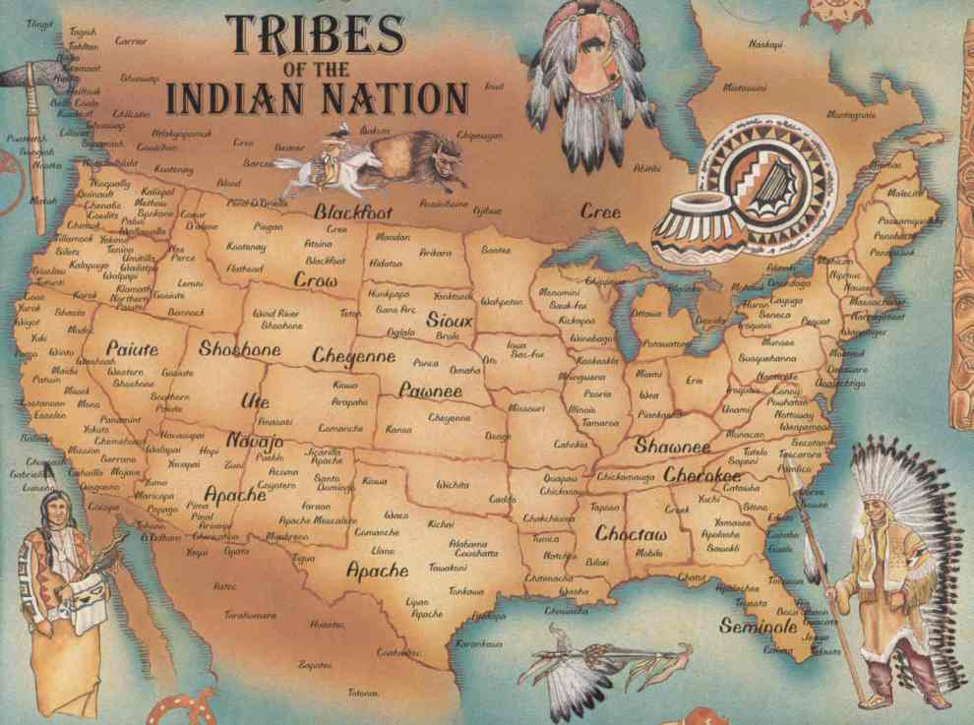

Timeline of events
*Please note that this is not a fully comprehensive timeline of the events surrounding Native Americans. The full version can be found at http://www.legendsofamerica.com/na-timeline.html
1492 | When Christopher Columbus first came in contact with native people, he wrote: "They all go around as naked as their mothers bore them; and also the women." He also noted that "they could easily be commanded and made to work, to sow and to do whatever might be needed, to build towns and be taught to wear clothes and adopt our ways," and, "they are the best people in the world and above all the gentlest."
May, 1513 | Juan Ponce de Leon encountered Calusa Indians while exploring the Gulf Coast of Florida near Charlotte Harbor. In a fight with the Calusa, Juan Ponce de Leon captured four warriors.
1519 | Hernan Cortes invades Mexico, completing his conquest of the Aztec empire in 1521 and establishes the colony of New Spain.
April 16, 1528 | The first significant exploration of Florida occurred when Spanish soldier, explorer, and Indian fighter, Panfilo de Narvaez saw Indian houses near what is now Tampa Bay. Narvaez claimed Spanish royal title to the land.  By fall, the Narvaez Expedition had been reduced to only four survivors, including Alvar Nunez Cabeza de Vaca, who had been shipwrecked on Galveston Island off the Texas coast. The men were enslaved for a few years by various Native American tribes of the upper Gulf Coast.
1539 | Hernando De Soto lands at Tampa Bay, Florida and begins an expedition across the southeast.  After defeating resisting Timucuan warriors, Hernando De Soto executed 100 of them, in the first large-scale massacre by Europeans on what would become American soil. The event is known as the Napituca Massacre.
October 18, 1540 | Hernando De Soto's expedition was ambushed by Choctaw tribe in Alabama who killed their livestock and 200 Spaniards. The remaining Spaniards then burned down the Mabila compound, killing some 2,500 people who were inside.
1546 | The "New Laws" barring Indian enslavement were repealed at the insistence of New World colonists, who developed a society and economy dependent on slave labor.
1600's | Europeans of the time held steadfastly to the belief that their introduced diseases were acts of God being done in their behalf. One settler proclaimed while speaking about the deaths of Native Americans, "Their enterprise failed, for it pleased God to effect these Indians with such a deadly sickness, that out of every 1000, over 950 of them had died, and many of them lay rotting above the ground for lack of burial."
May 14, 1607 | Jamestown is founded in Virginia by the colonists of the London Company. By the end of the year, starvation and disease reduce the original 105 settlers to just 32 survivors. Captain John Smith is captured by Native American Chief Powhatan and saved from death by the chief's daughter, Pocahontas.
1616 | A smallpox epidemic decimates the Native American population in New England.
1622-44 | Powhatan Wars - Following an initial period of peaceful relations in Virginia, a twelve year conflict left many natives and colonists dead.
1636-37 | Pequot War - Taking place in Connecticut and Rhode Island, the death of a colonist eventually led to the destruction of 600-700 natives. The remainder were sold into slavery in Bermuda.
1689-1763 | The French and Indian War, a conflict between France and Britain for possession of North America, rages for decades. For various motivations, most Algonquian tribes allied with the French; the Iroquois with the British.
April 8, 1756 | Governor Robert Morris declared war on the Delaware and Shawnee Indians. Included in his war declaration was "The Scalp Act,” which put a bounty on the scalps of Indian men, women and boys.
August 1, 1758 | The first Indian reservation in North America was established by the New Jersey Colonial Assembly.
May 25, 1776 | The Continental Congress resolved that it was "highly expedient to engage Indians in service of the United Colonies," and authorized recruiting 2,000 paid auxiliaries. The program was a dismal failure, as virtually every tribe refused to fight for the colonists.
1772-74 | Eighty percent of the Arikara died of smallpox, measles, etc.
1781 | Smallpox wiped out more than half the Piegan Blackfoot.
1804-1806 | Lewis and Clark expedition with Sacagawea. Under direction of President Jefferson, Lewis and Clark charted the western territory with the help of Sacagawea, a Shoshone Indian.
1804 | The Sioux meet the Lewis and Clark Expedition  Trading posts begin to be established in the west.  Fur trading becomes an important part of Oglala life.  Oglala and other Lakota tribes expand their region of influence and control to cover most of the current regions known as North and South Dakota, westward to the Big Horn Mountains in Wyoming and south to the Platte River in Nebraska.  On March 26, the U.S. government gave first official notice to Indians to move west of the Mississippi River.
1813-14 | The Creek War was instigated by General Andrew Jackson who sought to end Creek resistance to ceding their land to the US government. The Creek Nation was defeated and at the Treaty of Fort Jackson, the Creek lost 14 million acres, or two-thirds of their tribal lands. To count the Creek dead, whites cut off their noses, piling 557 of them. They also skinned their bodies to tan as souvenirs. This was the single largest cession of territory ever made in the southeast.
1829 | Creek Indians receive orders to relocate across the Mississippi River.
1830 | On April 7, President Andrew Jackson submitted a bill to Congress calling for the removal of tribes in the east to lands west of the Mississippi. On May 28th, the Indian Removal Act was passed, and from 1830 to 1840 thousands of Native Americans were forcibly removed.  On September 15, the Choctaw sign a treaty exchanging 8 million acres of land east of the Mississippi for land in Oklahoma.  On December 22, the State of Georgia made it unlawful for Cherokee to meet in council, unless it is for the purpose of giving land to whites.
1835-42 | Seminole War - The second and most terrible of three wars between the US government and the Seminole people was also one of the longest and most expensive wars in which the US army was ever engaged. Thousands of troops were sent, 1,500 men died, and between 40-60 million dollars were spent to force most of the Seminole to move to Indian Territory - more than the entire US government's budget for Indian Removal.
1836 | In five groups, over 14,000 Creek Indians were forcibly removed by the US Army from Alabama to Oklahoma.
1838 | Trail of Tears - Despite the Supreme Court's rulings in 1831 and 1832 that the Cherokee had a right to stay on their lands, President Jackson sent federal troops to forcibly remove almost 16,000 Cherokee who had refused to move westward under the unrecognized Treaty of New Echota (1835) and had remained in Georgia. In May, American soldiers herded most into camps where they remained imprisoned throughout the summer and where at least 1,500 perished. The remainder began an 800-mile forced march to Oklahoma that fall. In all some, 4,000 Cherokee died during the removal process.  On January 30, Seminole leader Osceola died from complications of malaria at Fort Moultrie, South Carolina. He led a valiant fight against removal of his people to Indian Territory, but eventually the Seminole were forcibly relocated.
1850-75 | Extermination of buffalo herds by sports and hide hunters severely limits Plains Indians food supply and ability to survive.
1862 | Congress passes the Homestead Act making western lands belonging to many Indian Nations available to non-Indian American settlers. This marked the beginning of mass migrations to Indian lands for non-Indian settlement.
August 18, 1862 | Beginning of the Sioux Uprising (or Santee War) in Minnesota. The Sioux declared war on the white settlers, killing more than 1,000. They were eventually defeated by the US army, which marched 1,700 survivors to Fort Snelling. Others escaped to the safety of their western relatives. Over 400 Indians were tried for murder, 38 of whom were publicly executed. By 1864 90% of the Santee, and many of the Teton who sheltered them were dead or in prison.
July 1865 | General Patrick Conner organizes 3 columns of soldiers to begin an invasion of the Powder River Basin, from the Black Hills, Paha Sapa, to the Big Horn Mountains. They had one order: "Attack and kill every male Indian over twelve years of age." Conner builds a fort on the Powder River. Wagon trains begin to cross the Powder River Basin on their way to the Montana gold fields.
March 3, 1871 | Indian Appropriation Act - This Congressional Act specified that no tribe thereafter would be recognized as an independent nation with which the federal government could make a treaty. (From 1607 to 1776, at least 175 treaties had been signed with the British and colonial governments, and from 1778 to 1868, 371 treaties were ratified the US government.) All future Indian policies would not negotiated with Indian tribes through treaties, but rather would be determined by passing Congressional statutes or executive orders. Marking a significant step backwards, the act made tribal members wards of the state rather than preserving their rights as members of sovereign nations.
1874 | George Armstrong Custer announced the discovery of gold in the Black Hills of Dakota, setting off a stampede of fortune-hunters into this most sacred part of Lakota territory. Although the 1868 Fort Laramie Treaty required the government to protect Lakota lands from white intruders, federal authorities worked instead to protect the miners already crowding along the path Custer blazed for them, which they called "Freedom's Trail" and the Lakota called "Thieves’ Road."
Spring 1876 | George Armstrong Custer and the Seventh Cavalry begin to forcibly place the Lakota Sioux onto reservations.  Sitting Bull organizes the greatest gathering of Indians on the northern plains.
June 25, 1876 | The Battle of the Little Bighorn - Ignoring warnings of a massed Sioux army of 2,000-4,000 men, Custer and 250 soldiers attack the forces of Sitting Bull and Crazy Horse at the Little Bighorn. George Armstrong Custer and 210 men under his command are killed. The news reaches the east for the Independence Day Centennial celebrations. In response, the federal government spent the next two years tracking down the Lakota, killing some and forcing most onto the reservation. On July 6, The New York Times referred to those American people as "red devils.”
November 25, 1876 | The U.S. took retaliatory action for the Battle of the Little Bighorn against the Cheyenne. U.S. troops under General Ronald Mackenzie burned Chief Dull Knife's village, even though Dull Knife himself didn’t fight at the Little Bighorn.
1879 | Chief JosephThe first students, a group of 84 Lakota children, arrived at the newly established United States Indian Training and Industrial School at Carlisle, Pennsylvania, a boarding school founded by former Indian-fighter Captain Richard Henry Pratt to remove young Indians from their native culture and refashion them as members of mainstream American society. Over the next two decades, twenty-four more schools on the Carlisle model will be established outside the reservations, along with 81 boarding schools and nearly 150 day schools on the Indians’ own land.
1880 | Civilization Regulations - Congress set up a series of offenses that only Indians could commit. These regulations outlawed Indian religions, the practices of "so-called" medicine men, ceremonies like the Sun Dance, and leaving the reservation without permission. These regulations were in place until 1936.
1887 | The Dawes Severalty Act, otherwise known as the General Allotment Act, gives the President power to reduce the landholdings of the Indian nations across the country by allotting 160 acres to the heads of Indian families and 80 acres to individuals. The "surplus lands" on the reservations were opened up to settlement.  On July 16, J. D. C. Atkins, the Commissioner of Indian Affairs, wrote in his annual report that English would be the exclusive language used at all Indian schools. He argued that native languages were not only of no use, but were detrimental to the education and civilization of Indians.
December 15, 1890 | When Federal troops tried to arrest Sioux Indians in Little Eagle, South Dakota on December 15, Chief Sitting Bull ordered his warriors to resist and he was shot in the back of the head and killed. The aftermath of his death led to the massacre of the Sioux at Wounded Knee.
1911 | Society of American Indians - The Society was the first step in the direction of pan-Indian unity - was established and managed exclusively by American Indians, most of whom were well-known in non-Indian society and well-educated. Although members favored assimilation, they also lobbied for many reform issues, especially improved health care on reservations, citizenship, and a special court of claims for Indians.
1928 | The Meriam Report "The Problem of Indian Administration." - The report, commissioned by the Department of Interior in 1926, focused on the poverty, ill health, and despair that characterized many Indian communities. It recommended reforms that would increase the BIA's efficiency, and promote the social and economic advancement of Indians: the termination of allotment and the phasing out of Indian boarding schools.
1934 | The Indian New Deal - The brainchild of BIA director John Collier, the New Deal was an attempt to promote the revitalization of Indian cultural, lingual, governmental, and spiritual traditions. This blueprint for reform was written by non-Indians who felt they knew how to champion Indian rights.  Indian Reorganization Act (IRA) - The IRA was the centerpiece of the Indian New Deal. It encouraged Indians to "recover" their cultural heritage, prohibited new allotments and extended the trust period for existing allotments, and sought to promote tribal self-government by encouraging tribes to adopt constitutions and form federally-chartered corporations. In order to take advantage of IRA funding, tribes were required to adopt a U.S. style constitution. Tribes were given two years to accept or reject the IRA. Tribes who accepted it could then elect a tribal council. 174 tribes accepted it, 135 which drafted tribal constitutions. However, 78 tribes rejected the IRA, most fearing the consequences of even further federal direction.
1969 | "Indians of All Tribes" occupation of Alcatraz - A group of young Indians seized the abandoned Alcatraz Island in the San Francisco harbor. They issued a "Proclamation to the Great White Father" in which they stated their claim that Alcatraz was suitable as an Indian Reservation and thus, should be converted into an Indian educational and cultural center. The Indians of All Tribes continued to occupy Alcatraz until June, 1971.
1972 | Trail of Broken Treaties - Over 500 Indian activists traveled across the United States to Washington, DC where they planned to meet with BIA officials and to deliver a 20-point proposal for revamping the BIA and establishing a government commission to review treaty violations. When guards at the BIA informed the tribal members that Bureau officials would not meet with them and threatened forcible removal from the premises, the activists began a week-long siege of the BIA building. The BIA finally agreed to review the 20 demands and to provide funds to transport the activists back to their home. Shortly thereafter, the FBI classified AIM as "an extremist organization" and added the names of its leaders to the list of "key extremists" in the US.
1973 | Wounded Knee Occupation - At the Pine Ridge Reservation of the Oglala Sioux in South Dakota, trouble had been brewing between the Indian activists that supported AIM, and tribal leaders who had the support of the BIA. After a violent confrontation in 1972, tribal chair Richard Wilson condemned AIM and banned it from the reservation. In February 1973, AIM leaders led by Russell Means and about 200 activists who were supported by some Oglala traditional leaders took over the village of Wounded Knee, announced the creation of the Oglala Sioux Nation, declared themselves independent from the United States, and defined their national boundaries as those determined by the 1868 Treaty of Fort Laramie. The siege lasted 71 days, during which time federal marshals, FBI agents, and armored vehicles surrounded the village. AIM members finally agreed to end their occupation under one condition - that the government convene a full investigation into their demands and grievances.
1980 | United States v. Sioux Nation of Indians - U.S. Supreme Court ruled that the Sioux Indians were entitled to an award of $17.5 million, plus 5% interest per year since 1877, totaling about $106 million in compensation for the unjust taking of the Black Hills and in direct contravention of the Treaty of Fort Laramie. The Sioux have refused to take the money and sits in a trust fund in Washington, collecting interest.

Cherokee Indian Supreme Court Cases of 1830s
In the cases Cherokee Nation v. Georgia (1831) and Worcester v. Georgia (1832), the U.S. Supreme Court considered its powers to enforce the rights of Native American "nations" against the states. In Cherokee Nation, the Court ruled that it lacked jurisdiction (the power to hear a case) to review claims of an Indian nation within the United States. In Worcester, the Court ruled that only the United States, and not the individual states, had power to regulate or deal with the Indian nations.

In 1828, the state of Georgia passed a series of laws stripping local Cherokee Indians of their rights. The laws also authorized Cherokee removal from lands sought after by the state. In defense, the Cherokee cited treaties that they had negotiated, as an independent "nation," with the United States, guaranteeing the Cherokee nation both the land and independence. After failed negotiations with President Andrew Jackson and Congress, the Cherokee, under the leadership of John Ross, sought an injunction ("order to stop") at the Supreme Court against Georgia to prevent its carrying out these laws.

The Court, in Cherokee Nation v. Georgia, ruled that it lacked jurisdiction to hear the case and could not resolve it. The Court began by sympathizing with the Cherokees' plight, acknowledging that they had been persecuted and marginalized by America's European settlers, then asserted that Indian nations were both "foreign nations" and people within U.S. boundaries. In other words, the Cherokee, though sometimes viewed as an independent nation, were also dependent people on the nation that envelopes them. Thus, the Court asserted that "foreign nations," as used in the Constitution, could not include "Indian nations." Because the Constitution only authorizes the Supreme Court to hear cases brought by "foreign nations," not "Indian nations," the Court was not authorized to entertain this case and dismissed it. Meanwhile, in 1830, Georgia passed another law requiring its citizens to obtain a state license before dwelling inside the Cherokee Nation. A group of missionaries residing there, including Samuel Austin Worcester, refused to obtain such a license. The missionaries were known supporters of Cherokee resistance to Georgia's removal efforts. Worcester and a fellow missionary were indicted by a Georgia court, brought to trial, and convicted. Worcester appealed to the U.S. Supreme Court, claiming that the Georgia court lacked authority to convict them.

On review of the case, the Supreme Court in Worcester v. Georgia ruled that because the Cherokee Nation was a separate political entity that could not be regulated by the state, Georgia's license law was unconstitutional and Worcester's conviction should be overturned. The Court first pointed to evidence proving that the Native American communities were conceived of as "separate nations" dating back to the time of early colonial America. The Court then argued that today's "treaties and laws of the United States [also] contemplate the Indian territory as completely separated from that of the states; and provide that all intercourse with them shall be carried on exclusively by the government of the union." Therefore, only the United States can negotiate the terms of Indian lands and the use thereof. States lack constitutional power to deal with such "nations" at all. Thus, Georgia could not pass the license law and convict Worcester for violation of that law.

The Supreme Court's ruling, however, was neither followed by Georgia nor enforced by the U.S. government. President Andrew Jackson, sensitive to Georgia's claims of independence at a time when the states wielded considerable power, had no interest in enforcing the Court's decree. The missionaries remained imprisoned until 1833, when a new Georgia governor negotiated for their release. The Georgia Cherokees themselves were forcibly relocated in 1838, pursuant to a U.S. treaty, to present-day Oklahoma ("the Trail of Tears"). Today, the substantive ruling in Worcester is no longer binding: the Supreme Court holds that, to a certain extent, a state may regulate the Indian territories within its boundaries.

AUTHOR'S BIO

Alex McBride is a third year law student at Tulane Law School in New Orleans. He is articles editor on the TULANE LAW REVIEW and the 2005 recipient of the Ray Forrester Award in Constitutional Law. In 2007, Alex will be clerking with Judge Susan Braden on the United States Court of Federal Claims in Washington.

http://www.pbs.org/wnet/supremecourt/antebellum/landmark_cherokee.html
THE INDIAN MASSACRES.; Terrible Scenes of Death and Misery in Minnesota. Five Hundred Whites Supposed to be Murdered. The Sioux Bands United Against the Whites. FORT RIDGELEY IN DANGER.
Published: August 24, 1862
HTTP://WWW.NYTIMES.COM/1862/08/24/NEWS/INDIAN-MASSACRES-TERRIBLE-SCENES-DEATH-MISERY-MINNESOTA-FIVE-HUNDRED-WHITES.HTML
Parties from the Minnesota River reached here last sight. They state that scouts estimate the number of whites already killed by the Sioux at 500.
This opinion is based on the number of bodies discovered strewn along the road and by trails of blood.
It is believed that all the missionaries have been killed.
The civilized Indians exceeded their savage brethren in atrocities.
Mr. FRENIER, an interpreter who has spent most of his life among the Indians, volunteered to go alone among them, trusting to his knowledge of them and his disguise, to escape detection. He dressed himself to Indian costume and started on his journey. He arrived at the Upper Agency at night.
The place was literally the habitation of death.
He visited all the houses, and found their former occupants all lying dead, some on the door-steps and some inside their habitations. Others were scattered in the yards and in the roads.
He went to the house of Hon. J.R. BROWN, and recognized every member of the family. They numbered eighteen in all, and every one of them had been brutally murdered.
At Beaver Creek he found that fifty families had been killed outright. At every house he went into he recognized the dead bodies of nearly all the former inhabitants of the place.
Among the dead bodies he recognized at the Agency were the following:
N. GOVERUS and family.
Dr. WAKEFIELD and family.
JOHN TODDENS and family.
JOHN MOYNER.
EDWARD MOYNER.
Rev. Dr. WILLIAMS.
Rev. Mr. BRIGGS, and two missionaries.
Ex-Gov. SIBLEY is now marching to the relief of Fort Ridgley.
He reports that the Sioux bands are united together to carry out a concentrated and desperate scheme, and says that he will be only too happy to find that the powerful upper bands of Yanktons and other tribes have not united with them.
Mr. FRENIER writes to Gov. RAMSEY, on the 21st inst., saying that he left Fort Ridgley at 2 o'clock on that morning. There were then over two thousand Indians at the fort, and all the wooden buildings there had been set on fire, and were burning.
Mr. FRENIER thinks that other tribes are joining the Sloux, and that they will present a very formidable array.
A reliable letter, dated Glencoe, 21st inst., says that the injury done by the stampede of the settlers is immense, and that such another scene of woe can hardly be found in the South as in McLeod, Meaker, and the northern part of Sibley and other counties to Minnesota.
In St. Paul and the adjoining country all the available horses are being gathered together, and all sorts of weapons will be used by willing hands for immediate and summary vengeance upon these blood-thirsty Indians.
CHICAGO, Saturday, Aug. 23.
The St. Paul (Minn.) Pioneer, of the 20th inst., says, it is thought that the Indians have been induced to commit these outrages by Indians from Missouri and secession traitors of that State, and that when Maj. GALBRAITH left the agency on Friday everything was quiet. The Indians had received their goods and had all disappeared apparently satisfied with the Major's promise to send for them as soon as the money arrived to pay them their annuities.
The first attack of the Indians was made on the house of Mr. BAKER, on Sunday last, near the town of Acton, and 30 miles from Forest City, in which three white men and one woman were killed.
On Monday morning an attack was made on Redwood, and at the time the messenger left there, a number of persons had been killed.
After the messenger had crossed the river, he saw the Indians firing into traders' stores and other buildings. He estimated the number of Indians engaged in this firing at 150. He also stated that messengers had arrived at Fort Ridgley with money to pay off the Indians the sums due them.
The St. Paul Press, of the 21st instant, says that several loads of panic-stricken people, from Currer and Sibley Counties, arrived in town last night, principally women and children. They were greatly excited, and give exaggerated accounts of the Indians, who were marching on Shasta County. They also say that the towns of St. Peter, Henderson and Glencoe have been burned.
A private letter received in this city, to-day, from St. Paul, dated the 20th instant, says, that it seems to be the general opinion among the best informed of our citizens that these Indian troubles originated with the cursed Secessionists of Missouri.
Major GALBRAITH was told by one of the Indians that there are now in arms ten thousand of the Sioux tribe, besides other tribes from Northern Missouri.
ST. PAUL, Minn., Saturday, Aug. 23 -- 9 P.M.
ANTOINE FRENIER, the disguised Indian scout, got through the Indian lines into Fort Ridgeley and brought back the following to Gov. RAMSEY:
FORT RIDGELEY, Thursday, Aug. 21 -- 2 P.M.
We can hold this position but little longer unless we are reinforced. We are being attacked almost every hour, and unless assistance is rendered us we cannot hold out much longer. Our little band is becoming exhausted and decimated. We had hoped to be reinforced to-day, but as yet can hear of no one coming.
T.G. SHEHAN, of Company C, Fifth Minnesota Volunteers, commands the post.
Gov. SIBLEY cannot reach here with his twelve hundred troops until to-morrow, when a day of reckoning for the Indians will be at hand.

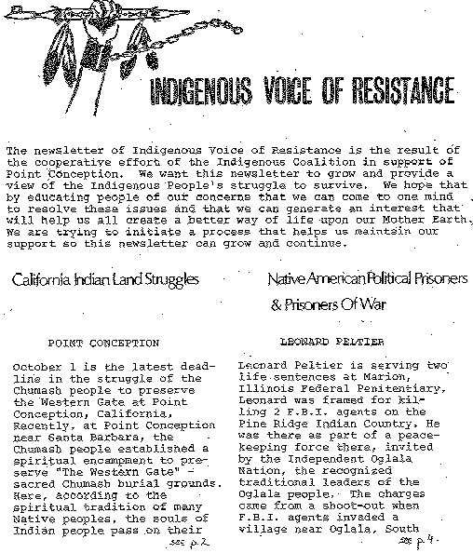
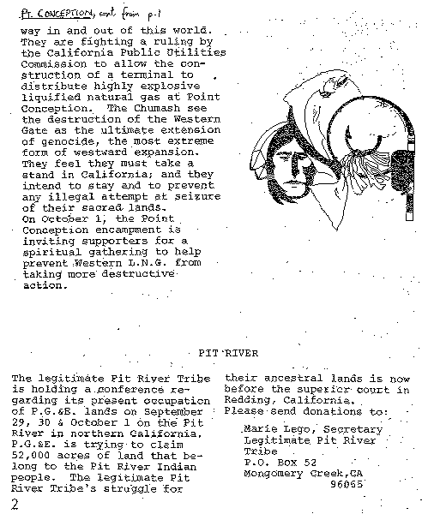

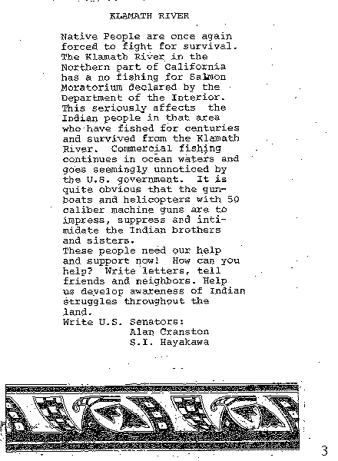
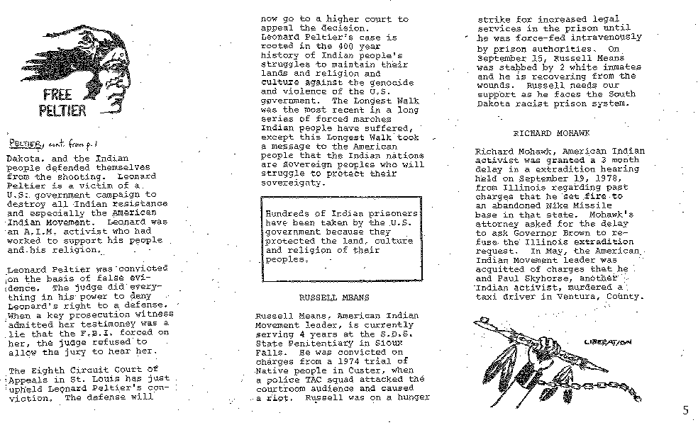
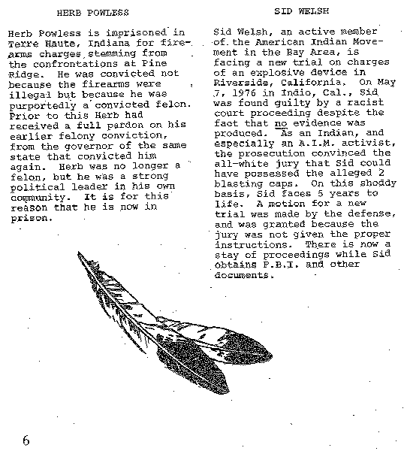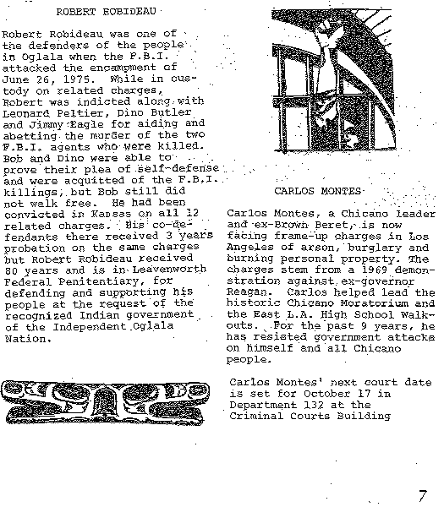

Mass grave at Wounded Knee
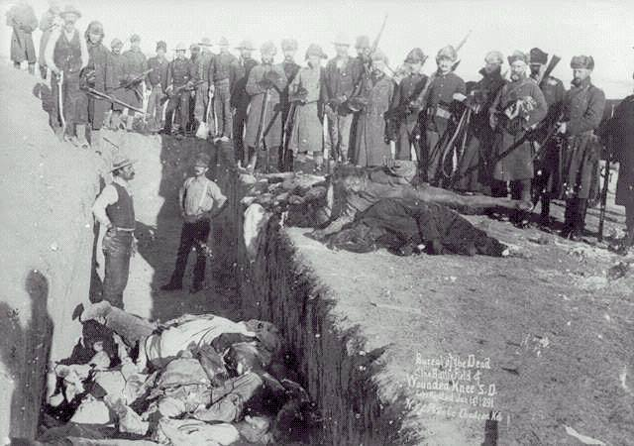

Alcatraz Proclamation
Proclamation to the Great White Father and All His People
We, the native Americans, re-claim the land known as Alcatraz Island in the name of all American Indians by right of discovery.
We wish to be fair and honorable in our dealings with the Caucasian inhabitants of this land, and hereby offer the following treaty:
We will purchase said Alcatraz Island for twenty-four dollars ($24) in glass beads and red cloth, a precedent set by the white man's purchase of a similar island about 300 years ago. We know that $24 in trade goods for these 16 acres is more than was paid when Manhattan Island was sold, but we know that land values have risen over the years. Our offer of $1.24 per acre is greater than the 47¢ per acre that the white men are now paying the California Indians for their land. We will give to the inhabitants of this island a portion of that land for their own, to be held in trust by the American Indian Affairs [sic] and by the bureau of Caucasian Affairs to hold in perpetuity—for as long as the sun shall rise and the rivers go down to the sea. We will further guide the inhabitants in the proper way of living. We will offer them our religion, our education, our life-ways, in order to help them achieve our level of civilization and thus raise them and all their white brothers up from their savage and unhappy state. We offer this treaty in good faith and wish to be fair and honorable in our dealings with all white men.
We feel that this so-called Alcatraz Island is more than suitable for an Indian Reservation, as determined by the white man's own standards. By this we mean that this place resembles most Indian reservations in that:
1. It is isolated from modern facilities, and without adequate means of transportation.
2. It has no fresh running water.
3. It has inadequate sanitation facilities.
4. There are no oil or mineral rights.
5. There is no industry and so unemployment is very great.
6. There are no health care facilities.
7. The soil is rocky and non-productive; and the land does not support game.
8. There are no educational facilities.
9. The population has always exceeded the land base.
10. The population has always been held as prisoners and kept dependent upon others.
Further, it would be fitting and symbolic that ships from all over the world, entering the Golden Gate, would first see Indian land, and thus be reminded of the true history of this nation. This tiny island would be a symbol of the great lands once ruled by free and noble Indians.

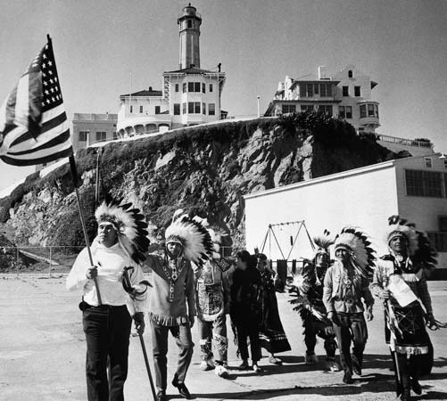

Alcatraz Letter
December 16, 1969
Dear Brothers and Sisters:
This is a call for a delegation from each Indian nation, tribe or band from throughout the United States, Canada, and Mexico to meet together on Alcatraz Island in San Francisco Bay, on December 23, 1969, for a meeting to be tentatively called the Confederation of American Indian Nations (CAIN).
On November 20, 1969, 78 Indian people, under the name "Indians of all Tribes," moved on to Alcatraz Island, a former Federal Prison. We began cleaning up the Island and are still in the process of organizing, setting up classes and trying to instill the old Indian ways into our young.
We moved onto Alcatraz Island because we feel that Indian people need a Cultural Center of their own. For several decades, Indian people have not had enough control of training their young people. And without a cultural center of their own, we are afraid that the old Indian ways may be lost. We believe that the only way to keep them alive is for Indian people to do it themselves.
While it was a small group which moved onto the island, we want all Indian people to join with us. More Indian people from throughout the country are coming to the island every day. We are issuing this call in an attempt to unify all our Indian Brothers behind a common cause.
We realize that there are more problems in Indian communities besides having our culture taken away. We have water problems, land problems, "social" problems, job opportunity problems, and many others.
And as Vice President Agnew said at the annual convention of the National Congress of American Indians in October of this year, now is the time for Indian leadership.
We realize too that we are not getting anywhere fast by working alone as individual tribes. If we can gather together as brothers and come to a common agreement, we feel that we can be much more effective, doing things for ourselves, instead of having someone else doing it, telling us what is good for us.
So we must start somewhere. We feel that if we are going to succeed, we must hold on to the old ways.This is the first and most important reason we went to Alcatraz Island.
We feel that the only reason Indian people have been able to hold on and survive through decades of persecution and cultural deprivation is that the Indian way of life is and has been strong enough to hold the people together.
We hope to reinforce the traditional Indian way of life by building a Cultural Center on Alcatraz Island. We hope to build a college, a religious and spiritual center, a museum, a center of ecology, and a training school.
We hope to have the Cultural Center controlled by Indians, with the delegates from each Indian nation and urban center present for the first meeting on December 23, and at future meetings of the governing body.
We are inviting all our brothers to join with us on December 23, if not in person, then in spirit.
We are still raising funds for Alcatraz. The "Alcatraz Relief Fund" is established with the Bank of California, Mission Branch, 3060 16th Street, San Francisco, California 94103, and we are asking that donations of money go to the bank directly.
Many Indian Centers and tribal groups from throughout the country have supported the people on Alcatraz by conducting benefits, funded [sic] drives, and so forth. We are deeply appreciative of all the help we have received, and hope that all Indian people and people of good will, will join us in this effort.
We are also asking for formal resolutions of support from each organized Indian tribe and urban center. We can have great power at the bargaining table if we can get the support and help of all Indian people.
We have made no attempts at starting a hard and fast formal organization. We have elected spokesmen because someone has had to be a spokesman. We feel that all Indian people should be present or represented at the outset of a formal national Indian organization.
We have also elected a Central Council to help organize the day-to-day operation of the Island. This organization is not a governing body, but an operational one.
We hope to see you on December 23rd.
Indians of All Tribes
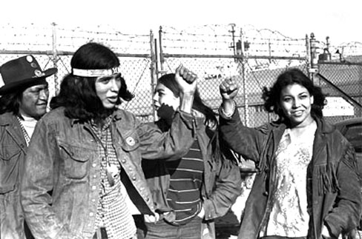
The Black Hills are not for sale
Clifford White Eyes, Garvar Good Plume, Charlie Waters & Janice Bad Horse Larson
12/13/12

The Black Hills Teton (Tituwan) Sioux Nation Treaty Council for the Teton Sioux Nation and The Great Sioux Nation has experienced a traumatic tragic history of relentless oppression since 1851. Our people live in abject horror, realizing that this continued oppression can only lead to the total depopulation and eradication of the Great Sioux Nation. The conditions still exist today, which perpetuate the injustices being heaped upon our people.
We want to express our concerns in the laws, treaties, amendments, settlements made by the United States concerning the Sioux Nations such as; United States vs. Sioux Nation (Supreme Court), 448.U.S. 371 (1980), 1851 & the 1868 Treaties with the Great Sioux Nation. Based on these treaties and laws already historically made with the Sioux Nations and the United States, we object accordingly with the current legislation of the United States in regards to the case involving 101 million trust law suit in involving Sioux nation tribes which is a separate case from the Cobell 3.4 billion class action settlement involving individual trust funds. We have as a responsibility as a Lakota Nation and people to protect our way of life which includes our language, lands, culture and spirituality, which denotes a tribe as specified by the United States and as natural law of the Oceti Sakowin Oyate.
The four tribes (Standing Rock Sioux tribe, Rosebud Sioux Tribe, Lower Brule Sioux Tribe, and Crow Creek Sioux Tribe) are part of the settlement from the total 101.4 million payout. This money goes to the tribes and not to individual members and information specifically about this case from individual tribal members , are requested to ask their tribal officials.
According to the 1868 treaty that was abrogated in 1877, 1851 treaty and case law to present, it behooves tribes to go against their forefathers' wishes in rejecting any settlement, altering of any treaties, making or approving any trust claims in regard to lands and minerals that belong collectively to the Oceti Sakowin as the Great Sioux Nation. In addition, the lands originally known today as Pe’sla in the Black Hills, should be returned to the Great Sioux Nation, according to Lakota natural law and the Treaties already made with the United States.
We as The Black Hills Teton (Tituwan) Sioux Nation Treaty Council for the Teton Sioux Nation and The Great Sioux Nation request recognition of the rights of the original treaty descendants who are now alive and the protection of all the rights under these treaties. We request that the wrongs committed by the United States government, its representatives, and the citizens of the United States against the full-blooded treaty participants and their descendants be corrected, including all lands wrongfully taken and should be returned. We request that all of our rights under various treaties should be fully honored. In particular, we request that all of our rights be fully protected pertaining to the Treaty territories which exists from the Canadian border to the Mexican border and from the west bank of the Missouri river to the line of the Rocky Mountains in Wyoming and Montana.
According to historical oral tradition by our forefathers, and as specified in prior Treaties with our forefathers (the bands of the Great Sioux Nation), no settlement monies should be accepted for land claims. We still honor our Great chiefs and warriors who set the path before us, so that the future generations will be protected. We still firmly hold our ground in stating “The Black Hills and all our Treaty lands are not for sale!”
We respectfully ask that you respond to our letter and the requests we are making.
http://indiancountrytodaymedianetwork.com/2012/12/13/black-hills-are-not-sale
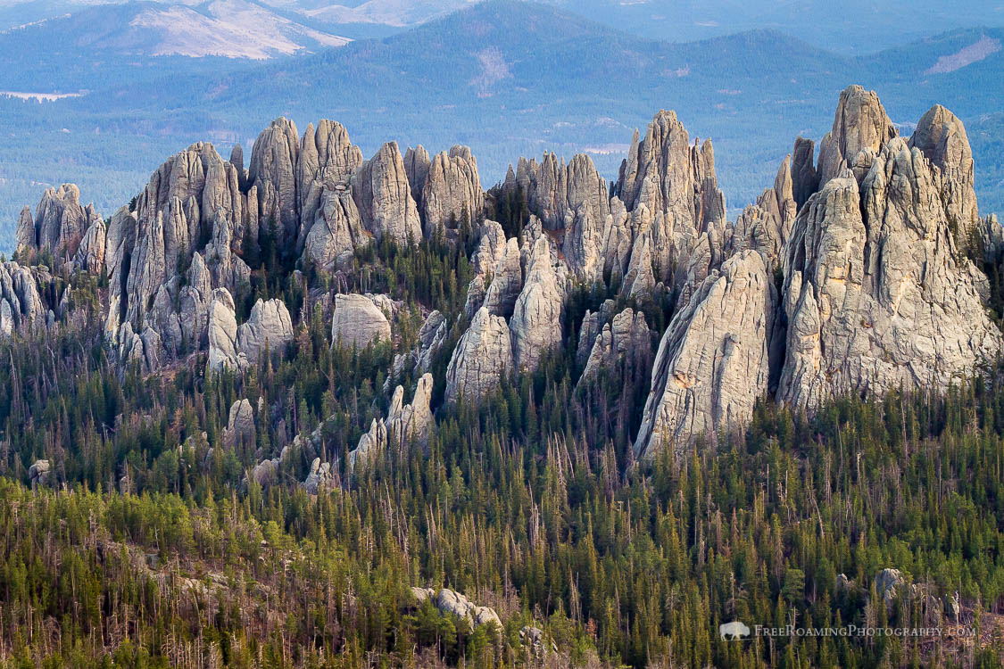

Russel Means speech to Congress, delivered 30 January 1989
Hau mitakuyepi, miye malakota. Maje tahan ki ne zi tiyospaye ki le hesa woke lila wakan. Mitakuye ate tasunka witko tiyospaye. Mitakuye ina wanbli zuya tiyospaye.
This is the traditional greeting of my people that I am bound to give; albeit, it's a short version. What I said in my own language translated into English thusly:
Hello my relatives, I am an Oglala Lakota and I come from a very sacred holy land, the Black Hills where Yellow Thunder Village is. My mother is from the War Eagle clan and my father’s family is from the Crazy Horse clan.
This greeting is, to this day, the way all Indians throughout the nation still greet one another, those that still know their culture. This is the only way we present ourselves to one another that is acceptable. We tell you who we are, where we are from, who we are from, our clans, and we do this without ever saying our name. Anything less would be an insult to you and to my people.
Senators, my morning prayers to the great mystery always include you and your colleagues in Congress, as well as leaders in all governments. It is an honor to come before you as a spokesman for my people, the American Indians of the United States of America. In these United States of America, this great country of ours, we American Indians, we can be anything we want to be except American Indians; and that is created by the laws of this nation and condoned by its subsidiaries, the so-called Tribal Government, and designed for the Indian to fail, to be expendable, to be eliminated.
I take you back in your history. After the American Indian hostiles have been subdued and forcibly confined to Indian reservations, it took approximately 30 years, one generation, for us to adjust and become economically viable, contrary to what the anthropologists say and we even ourselves are taught as Indian people. However, allotments were made smaller. Our remaining lands were opened to homesteading, and we were forced into reducing our livestock.
Nevertheless, we made the adjustment again, in less than half the aforementioned time, 15 years; we have become economically self-sufficient again. But once again, the American Indian was forced into reducing our livestock. The "boss-farmer" concept was instituted. We were told what, when, where, how much and how little we could grow the supply to agriculture and our livestock. Again, we recovered in a time span of approximately 15 years.
We were so successful in our third recovery that the American Indians enjoyed the finest of economic times while the rest of the industrialized world was wallowing in the Great Depression. It was then that President Roosevelt introduced the Howard-Wheeler Act, better known as the Indian Reorganization Act, the IRA, which institutionalized the so-called Tribal Governments, which are not one of our institutions, and it is still foreign to us this very day. We have yet to recover.
Forty-five years later, the IRA -- Indian Tribal Governments on their own initiative, began renewed efforts at reestablishing their sovereignty, focused on the oldest profession of American Indians -- that is gambling. Bingo and other gaming operations have been, without exception, a proven initial success. Failure through mismanagement, politics, or litigation has been less than 15%. Showing a better than 85% success rate, the new Indian-sponsored gaming industry on reservations dwarfed success ratios of any and all other non-Indian industries in America. Gaming operations have proven to benefit the revenue gathering of all governments, be they county, state, or Indian reservation. With regulation of bingo and gaming by the congress, we are experiencing repetition of history. One shouldn't remedy success. The results: the United States government, through Congress, once again intervenes to regulate a proven success in violation of all basic and fundamental rules of economics and totally contrary to all laws of capitalism.
American Indians are human beings. We are supposed to be citizens of the United States of America. We fought in your wars in other countries. Our Navajo Nation code talkers served and saved this nation in World War II. We have the inalienable right to joint venture with whom we choose as long as we do not harm nor commit fraud upon anyone. There is no piece of evidence anywhere that proves Indians ever conspired with criminal elements to establish bingo. The Bureau of Indian Affairs, the infamous colonial office of the Department of Interior and the initiator of sleaze in government, has been regulating contracting on Indian reservations since 19 -- since 1824. This fact alone should convince and teach every student of government that regulation of commerce and enterprise does not work. In fact, it only produces the opposite result. Graft and corruption is rampant to the contracting officers of the BIA and its surrogate Tribal Government.
Indian front contractors bid for and receive government contracts only to proceed to build shoddy dangerous bridges, buildings, schools, roads, and dams. The Indian is the scapegoat when there is a failure and is always the one indicted. Contracting on reservations has proven historically to breed and feed corruption within the BIA and now, the tribal governments.
Within the past two years, I personally have attempted to assist seven Indian reservations located in the southwest, the northwest, and the northern plains, to no avail. The investors I represented were from various groups interested in establishing banks, resorts, Indian-owned public relation firms, factories, fishing ports, and international trade. I now know that tribal governments do not want economic development unless graft is a major ingredient.
The BIA is a major player in land leases being sold by petty bureaucrats for as meager in amount as 40 dollars. There is a scandal of monstrous proportions occurring in at least two Indian agencies, the BIA’s branch of land operations and the branch of realty. I challenge this Investigations committee1 to intricately go into the branches of realty and land operations. The BIA does not enforce its trust -- trust responsibility. Quite to the contrary.2
In September of -- of 1987, I moved from the poorest county in America, the Pine Ridge Indian Reservation, to the richest area in the country, the Navajo Indian reservation. There is no difference. I have paraphrased the former Secretary of the Department of the Interior, James Watt: If you want to see an example of failed socialism, go to an Indian reservation.3

The poorest and richest reservations in our nation suffer from identical problems: mismanagement, a bloated patronage system, no checks and balances, and tribal governments' waiver of sovereignty in order to initiate debt. This is not anything new. This is an everyday occurrence in all tribal governments. [The] problem is leadership. In this case, it is the lack of leadership. Ironically, everyone, including you senators, referred to the allegedly elected tribal officials as leaders.
Leaders are supposed to work for a better quality of life for their constituents. It is an insult to my heritage, my ancestors, and my dignity as an Oglala Lakota to have the term used loosely. Many of the tribal officials are honest and sincere men and women who have good hearts. Nevertheless, a vast majority of the tribal officials parasite on the incestuous world of tribal politics, not as our forefathers who were the best providers, protectors, defenders, advocators, and friends. The game of "who is the most important" rules. It's embarrassing.
At the turn of the century, American Indians numbered about 230,000, all traditional. With each succeeding generation, we lose a population base and our spirit as once proud peoples. The American Indians statistics of deprivation have remained constant since the end of World War II. All other groups of citizens -- rortunes rise and fall with the gross national product, the -- the GMP. The American Indian statistical lines of deprivation remains constant, a straight line. With the blatant genocide of our traditional people, we have less than 50 thousand in America today. We are averaging a loss of 1000 a year since 1900. We are losing a value system as distinct people that sets us apart from the industrialized world. These facts surface in our tribal statistics and no one attempts to do anything about it except for a few social workers and reservation police.
This new statistical horror is women and child abuse. Child’s sexual abuse is epidemic on Indian reservations and all you hear are whispers. This abuse can be directly attributable to the schools on the reservations. Education, BIA, public, the contract and missionary schools do not teach positive values from non-Indian culture and in collusion with the BIA certainly do not allow Indian culture and values to be taught. The fact is, educators continually denigrate American Indian traditional lifestyle as primitive, dirty, and without any redeemable virtues. And the tribal councils condone it. Needless to say, every time the U.S. Government has interfered with American Indian lifestyles, it has been proven to be disastrous.
In the 1960s, legal services were implemented on Indian reservations. It was a boon for the people. Tribal officials all of a sudden were held accountable. Legal services stepped in and lo and behold, tribal courts had power to the power of attorney for the people. The result, an edict from Washington D.C. is handed down and legal services can no longer represent people against the Tribal Government and they can no longer represent class action lawsuits against any government.
Presently, legal services are not much more than a meal for divorce lawyer trainees. Congress passed the American Indian Religious Freedom Act in 1978. To date, six cases concerning our freedom of religion has reached the Supreme Court. We lost every one of them. We do not win lawsuits. State governments lose. The only time we allegedly win a lawsuit, it is in reality the federal government winning out over the sovereign rights of a state. Once again, the American Indians are the pawn.

The major factors presenting American Indian people were the existing rights to self-determination. American Indians suffer under a system of dual citizenship, that is U.S. citizenship and Tribal citizenship, maintained by the BIA. Only Hitler did that. The dual citizenship is a major obstacle in the free exercise of individual and tribal sovereignty. The continuing loss and attrition of existing lands to various federal, state, and local laws and/or regulations is a hindrance, the abridgment of sovereign rights to remaining lands and the arbitrary monetary policies of settlement of these rights whenever they are recognized.
Another major factor preventing Indian people from self-determination, subjugation of the American Indian individual to the laws of government sponsored tribal governments and the continuing arbitration of the BIA rules and regulations, which have the force of law yet are not repealable solutions.
The American Indian people’s right to self-determination is recognized and will be implemented through the following policies:
The American Indian individual shall have the right to choose his or her citizenship and the American Indian nations have the right to choose their level of citizenship and autonomy up to absolute independence;
The American Indian will have their just property rights restored which include rights of easement, access, hunting, fishing, prayer, and water;
The BIA will be abolished with the American Indian tribal members deciding the extent and nature of their governments, if any;
Negotiations will be undertaken to exchange otherwise unclaimed and un-owned federal property for any and all government obligations to the American Indian nations, and to fully -- and to hold fully liable those responsible for any and all damages which have resulted from the resource development on or near our reservation lands including the -- including damages done by careless and inexcusable disposal of uranium mill tailings and other mineral and toxic wastes.
I want to thank you, gentlemen, for inviting me here. It's been a high honor, especially since I'm the only one invited here today to testify that doesn't receive money from the federal government. Also, I want to make -- I was introduced as a former founder and leader of American Indian movement to the tribal chairwoman that you have here, a former associates for the American Indian Movement back in the days when we were gross militants and so I just wanted to let you in on that, that the American Indian Movement is a very proud continuing part of American Indian Society.
I thank you.

