List of documents in this case study about the Zoot Suit Riots
- Introduction to the Zoot Suit riots
- The Sleepy Lagoon Murder Trial of 1942
- Map of the progress of the riots
- Letter from Manuel Reyes to Alice McGrath
- Letter from Youth Committee for the Defense of Mexican American Youth to Vice President Henry A. Wallace
- Excerpts from the Los Angeles Examiner- June 8, 1943
- “Nazis Spur Zoot Riots” from Los Angeles Daily News- June 9, 1943
- Photograph of men being arrested
- Photograph of men in jail
- Photograph of man being looted
- Photograph of women being arrested
- Photograph of sailors with bats

Introduction to the Zoot Suit Riots

In August 1942 the murder of a young Mexican-American man ignited a firestorm in the City of the Angels. In no time at all, ethnic and racial tensions that had been building up over the years boiled over. Police fanned out across the city in a dragnet that netted 600 Mexican Americans. Among those accused of murder was a young "zoot-suiter" named Hank Leyvas -- the poster boy for an entire generation of rebellious Mexican kids who refused to play by the old rules. As he and sixteen other boys headed to trial, the mood of the city turned violent. The deck was stacked against the defendants, and a verdict of guilty would spark a series of brutal riots. The convictions were ultimately overturned, but the city and its inhabitants would be forever changed.

The Zoot Suit Riots were influenced by the 1942 Sleepy Lagoon Trial that fostered an atmosphere of hate and prejudice towards the Mexican American community. In 1943, conflict broke out on the streets of Los Angeles between servicemen and young Pachucos and Pachucas. During the riots which broke out on May 31, 1943 in Los Angeles, servicemen targeted Pachuco youth wearing zoot suits, who were all underage youth too young to be drafted by the service. Servicemen physically beat zoot-suiters, stripped them of their zoot suits, cut their duck tails and destroyed their clothing as the Los Angeles Police Department stood by and watched. The Zoot Suit Riots have been interpreted as a clash between uniformed gangs: the U.S. military issued uniformed servicemen, law enforcement and Mexican American youth donning a creative uniform of their own making. Several elements fed the flame that incited these riots:
- Newspapers were eager to distract attention from the war and single out what they falsely determined were internal enemies and thus, negatively publicized Pachuco gangs as scapegoats.
- Servicemen, who came from all corners of the United States, naively formed racist attitudes about zoot suiters based on stories published by the press.
- Growing public sentiment viewed Pachuco zoot suiters as “foreign,” un-American and a threat to war time patriotism.
- Law enforcement held very prejudiced views of Mexican Americans, Pachuco youth and Native Americans, as stated in the following quote:
…“they [Mexican authorities] have stated that which we are now learning the
hard way. The Mexican Indian is mostly Indian — and that is the element which
migrated to the United States in such large numbers and looks upon leniency by
authorities as an evidence of weakness or fear, or else he considers that he was able
to outsmart the authorities.” —Los Angeles Lieutenant Sheriff Edward D. Ayres

Riots of 1943: Sequence of Events
- May 31: Twelve sailors and servicemen clashed violently with Pachuco youth near downtown Los Angeles.
- June 3: Fifty sailors leave the Naval Reserve Armory in Chávez Ravine, near Chinatown, attacking anyone wearing zoot suits.
- June 4-5: Rioting servicemen conduct search-and-destroy raids on Mexican Americans in the downtown area.
- June 6: The rioting escalates and spreads into East Los Angeles.
- June 7: The worst of the rioting occurs.
- June 8: Major rioting ends in Los Angeles but spreads into other ports and urban centers such as Detroit, Chicago, Philadelphia and Harlem where African Americans dressed in zoot suits become targets.

Power of the Press
The press played a large role in shaping public opinion concerning the Sleepy Lagoon Murder Trial, the Zoot Suit Riots and subsequently of Mexican and Mexican Americans in the United States. This sensationalist misrepresentation of Pachuco youth and gangs was a form of yellow journalism.
Yellow journalism emerged in the early 1900s. It was sparked by the style of newspaper magnet Joseph Pulitzer and furthered by journalists working under
William Randolph Hearst, who transformed publications into sensationalist propaganda sheets in order to increase sales. With incrementing sales, newspapers became so powerful that they began to greatly impact public opinion.
Newspaper articles written during the 1940s on Pachuco and Pachuca youth highlighted delinquency and non-conformity in behavior and language. One article in the Los Angeles Times in July 16, 1944 titled, “Youthful Gang Secrets Exposed,” sought to uncover the foreign underworld of Pachuco language. The article reported: “Gang members speak a strange argot unintelligible to the uninitiated.” Press reports like this fueled mass paranoia concerning the
American allegiance of Mexican youth in the United States during war time efforts.

Declaring an End to the Zoot Suit Riots
Realizing the disastrous international effects of the riots several measures were finally taken to end the Zoot Suit Riots. Federal Government officials in Washington, D.C. placed pressure on various government officials to stop the conflict. Among actions taken, the:
- Navy canceled all shore leaves and declared downtown Los Angeles out of bounds to all service men.
- Mexican Ambassador in Washington, D.C. requested Secretary of State Edward Stettinius to conduct a formal inquiry into the matter.
- Press was pressured to cease printing negative reports misrepresenting Mexican American zoot suit-wearing youth.

The Sleepy Lagoon Murder Trial of 1942
Murder at the Sleepy Lagoon
The 38th Street Gang was located in what is now part of South Los Angeles near Vernon and Long Beach Boulevards. The gang, along with other community members, frequented a water reservoir in a gravel pit located on the Williams Ranch in East Los Angeles. This reservoir, known to the community as Sleepy Lagoon, was used as a swimming pool by Mexican youth who were not allowed to use segregated public pools.
On the evening of August 1, 1942 Henry and Dora had a violent confrontation at Sleepy Lagoon with a neighboring gang from Downey. Henry and Dora left but returned later to the location with his gang in search of the attackers who had already fled the scene.
Futile in their search for the rival gang, the members of the 38th Street Gang decided to head for a party at the home of the Delgadillo family. When a fight broke out at the Delgadillo home Henry and the gang fled the scene. The following morning the dead body of José Díaz was found on a dirt road near the Delgadillo home. The Sleepy Lagoon Murder Trial began when Henry Leyvas and the 38th Street Gang were identified as being at the scene of the murder.
The Trial
Six hundred Mexican American youth were rounded up by a citywide dragnet led by the Los Angeles Police Department (LAPD). Eventually twenty-two alleged members of the 38th Street Gang were accused of the murder of José Díaz. Young women of the 38th Street Gang were also detained and placed in jail on suspicion of wrongdoing.
On October 13, 1942 People v. Zamora went to trial as the largest mass trial in California history. The trial took place in an atmosphere of intense prejudice fed and sustained by the press in Los Angeles. Throughout the trial the prosecutor pointed to the clothing and hairstyle of Pachucos as evidence of their guilt. This only added fuel to the fire of prejudice held by the non-Latino community. The prejudice and discrimination encountered by Leyvas and the 38th Street Gang was an example of racial profiling.
In failing to provide an unbiased trial, the United States Justice System failed to protect its citizens. Today, the trial is still considered by many as one of the most egregious miscarriages of justice in the United States.
The Conviction
On January 12, 1943 in the case of People v. Zamora, presided by Judge Charles Fricke, the court found five of the seventeen defendants in the case guilty of assault and sentenced to six months to one year in jail. Nine were found guilty of second degree murder and sentenced to five years to life. Henry Leyvas, Jose Ruiz and Robert Telles were found guilty of first degree murder and sentenced to life imprisonment. The twelve found guilty of murder were sent to San Quentin State Prison to serve their sentences.
The young women of the 38th Street Gang refused to testify against the gang during the trial. Due to their refusal to cooperate they were sent to the Ventura School for Girls, a women’s reformatory, without benefit of trial or jury. Dora Baca, Henry’s girlfriend, was among the five young women sent to this reformatory.
Sleepy Lagoon Defense Committee
Following the trial, the Sleepy Lagoon Defense Committee (SLDC) was organized by the community. Attorney and author Carey McWilliams served as chair to the committee. The goals of the SLDC were to raise community awareness and to fund a legal appeal for the young men of the 38th Street Gang who were serving sentences.
The committee quickly drew people from the community, film industry, education, political arena and labor unions. Alice McGrath joined the SLDC after the members of the 38th Street Gang were imprisoned. She became the executive secretary of the organization. Every six weeks she paid visits to the sentenced members, reviewed the progress of the committee, distributed SLDC news bulletins and raised morale. By 1944 the SLDC had raised enough money and the
case was moved to the Second District Court of Appeals. In October of the same year Judge Clement Nye overturned the verdicts of the case citing insufficient evidence, the denial of the defendants’ right to counsel and the overt bias of Judge Fricke in the courtroom. Henry Leyvas and the 38th Street Gang were released and their sentences overturned.
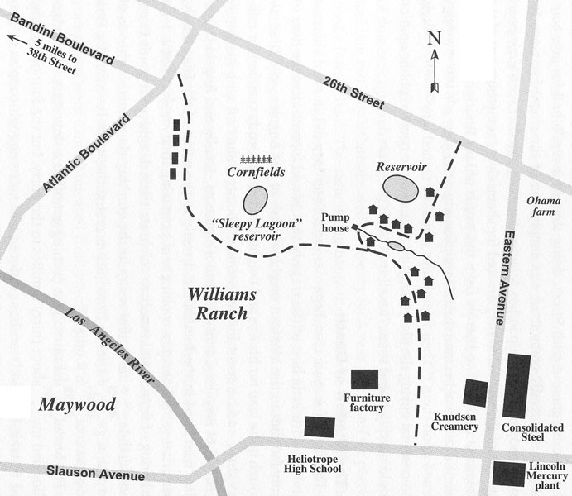

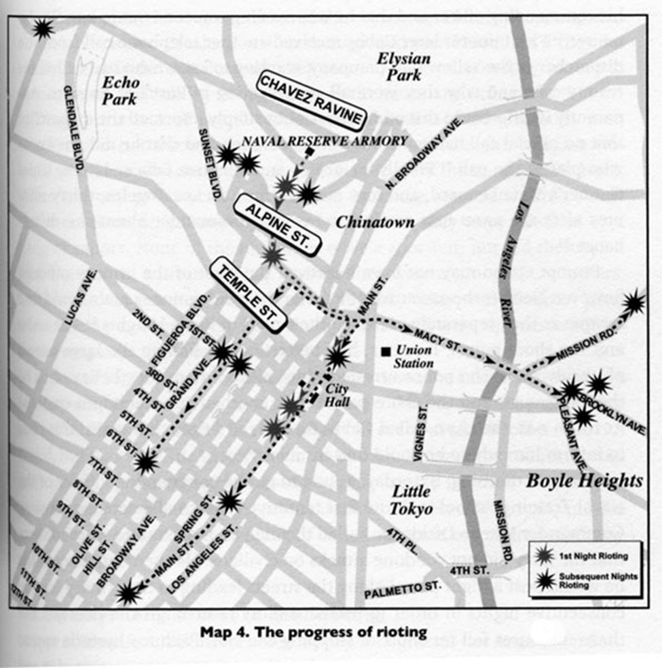
Letter from Manuel Reyes to Alice McGrath
Manuel Reyes
Box 69597
San Quentin, Calif
April 28, 1943
Dear Alice,
Received your letter, and was glad to receive the appeall news, and to hear from you. I also received the book, from New York, and was glad to know that there is prejudices against the Mexicans, and how the police treated us, when we were arrested just because we are Mexican's, but being born a Mexican is something we had no control over, but we are proud no matter what people think, we are proud to be Mexican-American boys. I joing the Navy, in July of last year, they didn't turn me down because I was a Mexican, because we are needed to fight this war. I was told to return back to the Navy Station, to take my pleage, but unfairly I was arrested for this crime, with I didn't have anything to do with or know of. When we were arrested we were treated like if we were German spies, or Japs, they didn't figure we are American, just like everybody else that is born in this country. Well, anyway, if I didn't get to joing the Navy to do my part in this war, I am still doing my part for my country, behind these walls. I am buying Defense stamps, and going to volunteer, to do some war work. Well I also receive the " People's World." It's a good idea you have. Well I am getting along straight, and volunteer to work in the jute mill, for three week's, the warden asked for 400 men to work in the mill for three weeks and volunteer, they are going to move the jute mill to Folsom, and want us to finish making the jute we have on hands. Then we are going to do some war work. Well how is every little thing out there? Did you have a good Easter Sunday? Well as for me, I did, I went to Church, and received Holy Communion. (...) Saturday we went to see a show, "The Navy Comes Through," and the New's, it was alright. I am listening to my earphones, I am listening to Tommy Dorsey. Well, I am running out of words so I'll close. One question, before I do so! Are we going to get the "People's World" and the "Fraternal Outlook," when they come out again? We would appreciated it if we would. Give my regards to the Committee.
I remain yours truly
Manuel Reyes

Letter from Youth Committee for the Defense of Mexican American Youth to Vice President Henry A. Wallace
YOUTH COMMITTEE
for the
DEFENSE OF MEXICAN AMERICAN YOUTH
1700 East 22nd Street, Los Angeles (in care of Mrs. Telles)
Reginald Garcia, Chairman
Dora Baca, Vice Chairman
Frank Hermosillo, Secretary
Roger Cordona, Treasurer
Hon. Henry A. Wallace,
Vice President of the United States,
Washington, D.C.
Dear Mr. Wallace:
We are writing you this letter because we heard you speak on the 16th of September here in Los Angeles, and we feel you should know about the bad situation facing us Mexican boys and girls and our whole Spanish-speaking community.
What you said on that day was the truth, and you made us all think and wonder why everything around us was different than it should be.
On the very day you spoke there were 24 Mexican American boys accused of first degree murder. These 24 boys come from our neighborhood. In our neighborhood there are no recreation centers and the nearest movie is about a mile away, We have no place to play so the Police are always arresting us. That's why most of the boys on trial now have a record with the Police, from suspicion even up to robbery. A lot of the boys worked in Defense plants and have brothers in Australia fighting under Gen. MacArthur. Our folks work in some defense plants if they are citizens, but if they are not citizens they don't get jobs even though Mexico is in the war too. Our mothers and fathers would like to help in the Red Cross and Civilian Defense but they cannot because it's all in English. There is still a lot of discrimination in theaters and swimming pools and the Police are always arresting us and searching us by the hundreds when all we want to do is go into a dance or go swimming or just stand around and not bother anybody. They treat us like we are criminals just by being Mexicans or of Mexican descent. The newspapers have made us look like criminals too. They make fun of zoot suits and use the word "Mexicans" like it was a dirty word.
We have talked about all this in our club and we think it is very bad for the war because it is against unity and divides us from the rest of the people. Also some Mexican Nazi papers are saying that we are not satisfied and that we are sabotaging the war. Also there are some people around here that use these things to say that Uncle Sam is no good.
We know that is not true and we also know that us Mexican-American boys and girls can do a lot of things to win the war if someone will give us a chance. We have got a Defense Club to help the 24 boys on trial and the way we are raising money for that is to collect scrap iron. That way we help the boys and also help the war and also prove that we are not any help to the Fifth Column.
Mr. Wallace, we know that you can help us. Please go and see Mr. Rockefeller and ask him to help us too. He can tell them to give us radio programs in Spanish to tell us how we can help. Also if the Government would print up the speeches of you and President Roosevelt and President Avila Camacho we would distribute them, if they are in Spanish so our folks could read them. There are a lot of things we could do and we will talk about them in our meetings.
Discrimination is what hurts the most, so help us with that particularly because discrimination is the thing that makes the other Americans divide from us. Maybe also you can ask the city to give us places to play. The other thing is to ask the Police to stop arresting us all the time and treat us like criminals because we are Mexican or of Mexican descent.
Mr. Wallace, you helped us very much with your speech on the 16th of September and we need your help more so we can grow up to be good American citizens and win the war.
We don't like Hitler or the Japanese either.
We thank you very much.
Respectfully
(signed)

Latin America Group Probes Street Fights
Fact-Finding Committee to Delve Into Causes of Brawls Between Servicemen, Gangs
Los Angeles Examiner
June 8, 1943
Alarmed at the recent outbreak of street fights between so-called zoot suit gangs and men of the armed forces, the Citizens' Committee for Latin American Youth yesterday launched an extensive investigation of the situation and will report its findings to the press and public.
...The committee appointed several months ago by the supervisors to investigate relations among Latin Americans in Los Angeles County was told by various spokesmen for the Mexican community that only a small percentage of zoot suiters are trouble makers and that it is regrettable they should bring the entire Mexican population into ill repute...

Crowds Downtown on Hunt for Zoot Suiters
Los Angeles Examiner
June 8, 1943
...As riot call after riot call was reported at police headquarters, the auxiliary police and motorcycle reserves were called out to help maintain order. Sirens sounded for hours as radio cars and patrol wagons raced to the scenes of reported riots.
...As the main element of the revenge-bent service men converged on downtown streets for the fourth night, they were joined -- for the first time in large numbers -- by civilians. From Main street they fanned out to comb through all possible haunts of pachucos....
Law enforcement officers did not attempt to stem the surging throngs. Occasionally, however, they stepped in to disarm anyone with a club or a weapon. ...
At Twelfth and Central police were summoned after a melee developed between servicemen and pachucos. Five of the latter were arrested...
At 10th and Los Angeles streets 20-year-old Edward Massey was taken in hand by 150 sailors and soldiers after he assertedly pilled a knife on a sailor. He was stripped of all clothing but his long coat...
The United States Attorney's office in Los Angeles announced it was checking Federal laws to see whether action can be taken against anyone assaulting men in uniform.

Nazis Spur Zoot Riots
Los Angeles Daily News
June 9, 1943
...Sailors state that in fighting zoot suiters and other gangsters in Los Angeles they have only been avenging injuries inflicted on themselves and their wives in this area. A number of servicemen have been badly beaten by zoot suiters, and cases of attacks on wives of navy men have been reported.
...[A] telegram from the sailors said:
"We make this plea in hopes that all fighting Americans are not in service, that there are some left to protect the families of ours. Our intent in taking justice in our own hands was not an attempt to instill mob rule but the only desire to insure our wives and families safe passage in the streets.
"As none of the creators of the outrages on your wives and ours have been brought to justice or the streets made clean we felt that something had to be done.
"Our past activities, we realize, were not within the law, but we are sure they met the honest approval of the people.
"The so-called zoot suiters may now have free reign throughout our city of Los Angeles to do what they may with the wives of servicemen and civilians as they make their way home from swing and graveyard shifts in war plants.
"The Los Angeles city limits are out of bounds to we servicemen. We are not permitted to enter the city.
"Has Los Angeles fallen to the zoot suiters?
"We are anxious to know. How about telling the folks at home for us?"

