List of Documents in the Case Study on Darfur
- Genocide in Darfur (United Human Rights Council)
- Victims of Darfur atrocities find a voice (The Guardian)
- The Forgotten Genocidal War in Darfur Revealed in New Satellite Photos (Enough Project)
- Response (USHHM)
- Aftermath (USHHM)
- Map of Sudan by Province
- Map of conflict in Sudan
- Interview with Mukesh Kapila (PBS-Frontline)
- Photograph: The Village of Tama burning (PROOF: Media for Social Justice)

Genocide in Darfur (United Human Rights Council)

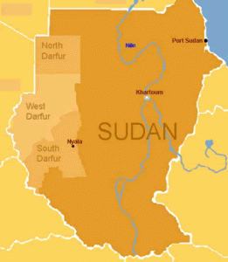
Darfur is in the western part of Sudan, bordering on Libya, Chad, and the Central African Republic.
Darfur is a region in Sudan the size of France. It is home to about 6 million people from nearly 100 tribes. Some nomads. Some farmers. All Muslims. In 1989, General Omar Bashir took control of Sudan by military coup, which then allowed The National Islamic Front government to inflame regional tensions. In a struggle for political control of the area, weapons poured into Darfur. Conflicts increased between African farmers and many nomadic Arab tribes.

In 2003, two Darfuri rebel movements- the Sudan Liberation Army (SLA) and the Justice and Equality Movement (JEM)- took up arms against the Sudanese government, complaining about the marginalization of the area and the failure to protect sedentary people from attacks by nomads. The government of Sudan responded by unleashing Arab militias known as Janjaweed, or “devils on horseback”. Sudanese forces and Janjaweed militia attacked hundreds of villages throughout Darfur. Over 400 villages were completely destroyed and millions of civilians were forced to flee their homes.
In the ongoing genocide, African farmers and others in Darfur are being systematically displaced and murdered at the hands of the Janjaweed. The genocide in Darfur has claimed 400,000 lives and displaced over 2,500,000 people. More than one hundred people continue to die each day; five thousand die every month. The Sudanese government disputes these estimates and denies any connection with the Janjaweed.

The Sudanese government appears unwilling to address the human rights crisis in the region and has not taken the necessary steps to restrict the activities of the Janjaweed. In June 2005, the International Criminal Court (ICC) took the first step in ending impunity in Darfur by launching investigations into human rights violations in Darfur. However, the government of Sudan refused to cooperate with the investigations.

On March 4, 2009 Sudanese President Omar al Bashir, became the first sitting president to be indicted by ICC for directing a campaign of mass killing, rape, and pillage against civilians in Darfur. The arrest warrant for Bashir follows arrest warrants issued by the ICC for former Sudanese Minister of State for the Interior Ahmad Harun and Janjaweed militia leader Ali Kushayb. The government of Sudan has not surrendered either suspect to the ICC.
Darfuris today continue to suffer and the innumerable problems facing Sudan cannot be resolved until peace is secured in Darfur. According to UN estimates, 2.7 million Darfuris remain in internally displaced persons camps and over 4.7 million Darfuris rely on humanitarian aid. Resolving the Darfur conflict is critical not just for the people of Darfur, but also for the future of Sudan and the stability of the entire region.

http://www.unitedhumanrights.org/genocide/genocide-in-sudan.htm
Victims of Darfur atrocities find a voice
Halima Bashir, a Sudanese doctor who escaped to London from Darfur, tells of the ongoing tragedy in her country
Mark Tran- @marktran
Tuesday 22 July 2008 03.51 EDT

Halima Bashir, a young Sudanese woman who has been a victim of and witness to numerous barbaric acts in Darfur, has spoken out against the government in Khartoum with a hard-hitting account of the tragedy.

A member of the Zaghawa tribe, Bashir puts a human face on a situation where the number of casualties is so large as to be incomprehensible. The conflict between the Arab-dominated government in Khartoum and black Africans in Darfur, in western Sudan, has left about 300,000 dead and created as many as 2.5 million refugees, according to the UN.

Bashir, 29, said Tears of the Desert, written with the journalist Damien Lewis, who won an award for his reporting from Darfur last year, was her chance to speak out about the atrocities perpetrated by the Sudanese government against black Africans in Darfur.

"My story is not the only one," she said in London, where she lives with her husband and young son after a long battle to win asylum. "There are hundreds of thousands of other stories more painful than mine. With this book it is as if I'm telling this story for Darfuri women. I will keep on talking – it is the only thing I can give my people."

In Bashir, the victims of what the international criminal court has described as a policy of genocide by Sudan's leaders have found a soft-spoken but iron-willed representative.

Bashir arrived for our interview at a hotel in central London with her round, youthful face uncovered. But she was firm about not revealing her face to the world, particularly to the Sudanese authorities. While she remains safe in Britain, she fears for the safety of her mother, sister and two brothers, who joined the rebels in Darfur.

She still does not know what happened to her family after they fled their village when government troops and the notorious Janjaweed militia attacked. The men of the village stood and fought to buy time for the women and children to flee to the forest. Her father died in the attack. Bashir does not want the Khartoum government to use the knowledge of what she looks like to track down her family – if they are still alive.

Because of fears for her family, Bashir talked to us with her face covered by headgear, hastily purchased around the corner from John Lewis. Only her eyes were visible during the interview.

Tears of the Desert is not just an account of the atrocities committed by the government-backed Janjaweed – or devils on horseback – against black Africans. The first half of the book describes a happy childhood in a close-knit Darfur village, although it does not gloss over Bashir's hideous circumcision at the age of eight.

For the most part, however, growing up was a happy time for Bashir. Family scenes that feature her much-loved grandmother and her best friend, Kadiga, are vividly brought to life. Like little girls anywhere, Bashir played with dolls, although these were rag dolls made from old clothes stuffed with straw.

Her father had big plans for Bashir and she was the first girl from her village to go away to school. Eventually she became a doctor, but she ran into trouble with the authorities for telling a reporter that the government should help all Darfuri people regardless of their tribe.

As punishment she was transferred to Mazkhabad, a village in the remote north of Darfur, and put in charge of a clinic. This is where she saw and experienced at first hand the atrocities of the Darfur conflict. Not even in her darkest nightmare had she imagined she would witness such horror, she wrote, as she treated girls as young as eight who had been repeatedly raped.

Bashir had to care for more than 40 girls who were sexually assaulted at their school while government soldiers cordoned off the premises. Parents were kept standing outside the school as their daughters' screaming pierced the air.

A rape victim who was a teacher told Bashir: "They were shouting and screaming at us. You know what they were saying? 'We have come here to kill you! To finish you all! You are black slaves! You are worse than dogs. The worst was that they were laughing and yelping with joy as they did those terrible things."

The Janjaweed eventually came for Bashir herself. Three men in khaki uniforms took her from the clinic to a military camp, where she was beaten and repeatedly raped. The ordeal went on into a second day with Bashir retreating in her head "to a faraway place where my God had taken me, a place where they couldn't reach me".

One of her captors told her: "We're going to let you live because we know you'd prefer to die. Isn't that clever of us? Aren't we clever, doctor? We may not have your education, but we're damn smart, wouldn't you agree?"

Hard as it was for her to go over such painful memories, Bashir said the process of writing her memoir help her come to terms with her terrible ordeal. More importantly, she wanted to tell the whole world about what was going on, especially the atrocities committed against young girls.

"These men were not normal," she said. "No normal people would do such a thing to children. I wanted to tell the whole world what was happening."

She could only explain the actions of the aggressors as an extremely virulent form of racism.

"It is because of the colour of our skin, it is because we are black," she said. "Even at school they give us nicknames and make jokes about us. It is something that has gone on a long time."

Bashir cited her experience at medical school where she had a reputation as a swot. The corpses students worked on were exclusively black. One of her friends said: "Arabs do not give a damn about us when we're alive, and even less when we're dead".

Some foreign policy commentators have criticised the international criminal court's decision to charge Omar al-Bashir, the Sudanese president, with genocide and crimes against humanity. They say it will make a peace deal between the Sudanese government and the rebels harder to achieve and warn it could jeopardise the already troubled deployment of a joint UN-African Union peacekeeping force in Darfur.

Bashir, however, has no reservations about the court's decision. She told an audience at the Royal Festival Hall: "I can't explain how happy I am for the ICC case," she said. "It is now more than five years this has been going on and very little has been done. It's as if we've been talking to deaf people. For me this is a step for justice."

· Tears of the Desert, by Halima Bashir, written with Damien Lewis, is published by Hodder & Stoughton.

The Forgotten Genocidal War in Darfur Revealed in New Satellite Photos
Posted by Akshaya Kumar and Jacinth Planer on Mar 25, 2014

http://enoughproject.org/blogs/forgotten-genocidal-war-darfur-revealed-new-satellite-photos

DigitalGlobe imagery - Saraf Omra, North Darfur, Sudan
This post originally appeared on the Daily Beast.

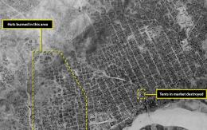
Our generation went to college when green “Save Darfur” rubber bracelets were ubiquitous on campuses across the country. Congress passed a unanimous resolution in 2004 declaring that the situation in Darfur amounted to a state-sponsored genocide by proxy Janjaweed militias. We stood on the National Mall and chanted “never again starts right now.” A decade later … Darfur is up in flames once again.

New images from the Satellite Sentinel Project offer the first independent confirmation of the reprisal of Janjaweed attacks in Darfur this year. Sudanese government restrictions on access to the conflict zone mean that reporters and human rights groups have to rely on second- or third-hand descriptions of this fighting. These accounts, smuggled out through a network of activists and civil society groups, are still our best source of evidence. But, Digital Globe satellite images dated March 17, 2014, corroborate their stories.

In the photographs we can see at least 150 homes reduced to black ash on the western side of the Darfuri town of Saraf Omra, where Janjaweed fighters are once again wreaking havoc. Our expert analysts say confidently that the patterns of destruction in Saraf Omra mean that the damage was intentional—not accidental. The damage leaps across natural firewalls, leaving an indisputable trail of destruction.

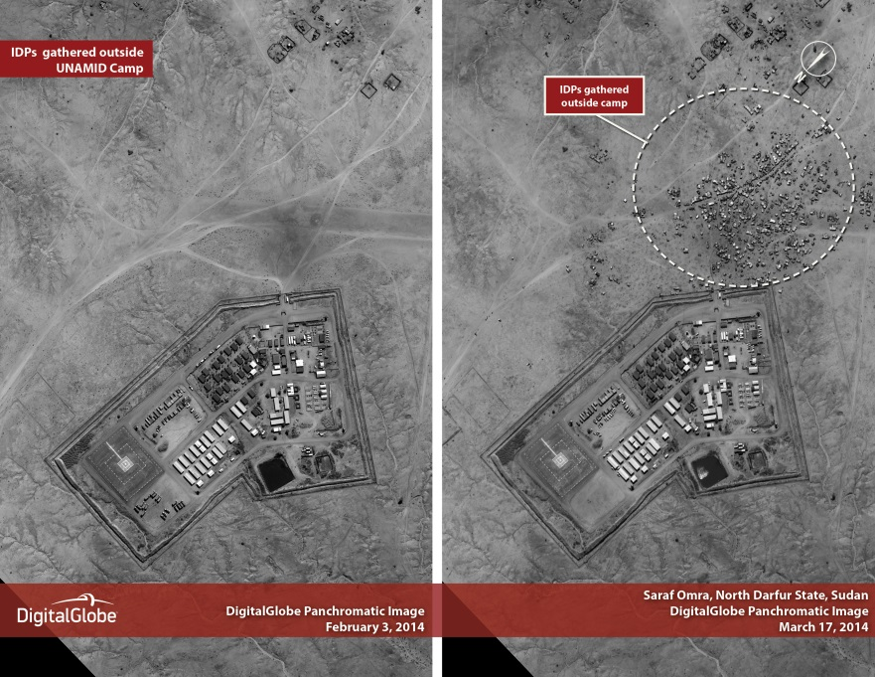
​

When actor and activist George Clooney and John Prendergast first came up with the idea of using a private satellite to monitor Sudan’s conflict zones, they were focused on the Nuba mountains in the eastern side of the country. Since then, the project has expanded its scope to report on violence in South Sudan and also in Darfur. As co-founder Clooney explains, “We’re going to keep watching and reporting to keep the spotlight on as bombs drop from the sky and villages burn once again.” With the publication of each of these images, the Satellite Sentinel Project seeks to bolster local human rights reporting and challenge the government’s denials.

While the conflict in Sudan’s troubled western region never really stopped, 2014 has seen a dramatic escalation in violence. According to the United Nations, 215,000 people were displaced by violence in Darfur in the first 11 weeks of this year. The sheer scale of these numbers is difficult to comprehend, especially in a place that saw half a million people pushed from their homes by violence last year. The UN has quit updating its Darfur death tolls and even experts on the conflict are hard pressed to provide accurate estimates. We just know that the numbers are growing by the day. Darfuris are living through a largely forgotten war. Waves of violence just keep on sweeping over them, but the world’s attention is elsewhere.

Response (United States Holocaust Memorial Museum)

Responses varied to the war between the north and south and to genocide and conflict in Darfur.
https://www.ushmm.org/confront-genocide/cases/sudan/sudan-response

NORTH-SOUTH WAR
The international policy responses to the conflict in Sudan (1985-2005) varied greatly over the twenty years of the conflict, affected by the Cold War, multiple conflicts and regime changes in neighboring countries, and other shifting geopolitical and economic interests. The governments of neighboring Ethiopia, Eritrea, Egypt, Libya, Chad, Uganda, and Kenya all played significant roles. Key players among the broader international community included the US, United Kingdom, and China. Sudan's support for Iraq during the first Gulf War and various radical Islamist movements (including hosting Osama Bin Laden from 1992-1996) resulted in increased isolation from western countries. In 1993, the US placed Sudan on its list of state sponsors of terrorism and imposed sanctions in 1997.

A peace process for southern Sudan, sponsored by the regional Intergovernmental Authority on Development and mediated by Kenyan General Lazaro Sumbeiywo, gained momentum with the signing of a framework for peace in July 2002 by the Government of Sudan and the SPLM. The United States, Italy, Norway, the Netherlands and the United Kingdom increased their engagement in the peace process after 2001.

The Comprehensive Peace Agreement (CPA) was signed by the government and the SPLM on January 9, 2005. It ended the two-decade war and provided the framework within which the South eventually voted for independence, creating the new country of South Sudan on July 9, 2011. Following the signing of the CPA, the UN Security Council authorized the establishment of the United Nations Mission in Sudan (UNMIS) for a period of seven years. Deployed across Sudan, the 10,000-strong peacekeeping force was unable to prevent a recurrence of fighting between the government army and SPLA soldiers in oil-rich Abyei on the north-south border or in Kordofan.

Beginning in April 1989, humanitarian assistance came from Operation Lifeline Sudan, which was set up following a devastating famine in Southern Sudan—the result of drought and the civil war—which killed an estimated 250,000 people. The consortium included three UN agencies, UNICEF, the World Food Programme and 40 non-governmental organizations. Although it saved countless lives, the system was manipulated by both sides in the war, which limited access to suffering displaced populations and siphoned off aid.

DARFUR
With mounting pressure from public advocacy groups a wide array of measures was deployed in response to violence in Darfur, which helped spark the beginning of an anti-genocide movement across the United States. Print journalists, like Nicholas Kristof, played a central role in bringing the story of violence in Darfur to the general public early in 2004. Bolstered by public interest, editors kept reporters on the scene in Darfur and their stories on the pages of major newspapers. Another important early alarm was sounded by Amnesty International, which published one of the first full-length reports on Darfur in February 2004. In the next months attention focused on the growing crisis in the region—on July 22nd, both houses of the US Congress passed resolutions condemning the atrocities in Darfur as genocide; on July 26th the US Holocaust Memorial Museum issued a "genocide emergency" warning; and on September 9th, US Secretary of State Colin Powell voiced the Bush Administration’s opinion that "genocide has been committed in Darfur and that the government of Sudan and the Janjaweed bear responsibility—and genocide may still be occurring." While the UN, the African Union (AU), and the European Union disagreed that genocide had occurred, they all accused the Sudanese government and its allied militias of committing crimes against humanity.

Most of the deaths in Darfur resulted from malnutrition and exposure after civilians were forcibly displaced into the harsh desert environment. A massive aid effort that began in 2003 saved countless lives and stemmed the death toll. As the conflict continued, however, humanitarian aid workers themselves increasingly became targets of violence. On March 5, 2009, the day after the International Criminal Court issued its arrest warrant for President Bashir, the Sudanese government ejected some 13 international humanitarian aid groups from, Darfur and disbanded several national groups, with blatant disregard for the humanitarian needs of the displaced populations.

As part of a 2004 agreement between the Sudanese government and the Darfurian rebels, the AU sent in soldiers mandated to protect unarmed ceasefire monitors. The ceasefire was not honored, and when civilians came under attack the AU soldiers often were not present or provided limited protection. On December 31, 2007, after protracted negotiations with the Sudanese government, the AU and the United Nations formed a joint force with a stronger mandate to protect civilians, but undermanned and ill-equipped, its presence has been inadequate to change the situation on the ground.

Aftermath (United States Holocaust Memorial Museum)
https://www.ushmm.org/confront-genocide/cases/sudan/sudan-aftermath

Civilian populations throughout Sudan and South Sudan continue to be at risk.

The war between the north and south officially ended with the signing of the Comprehensive Peace Agreement (CPA) in 2005. As part of the CPA the south was guaranteed the right to vote to stay as part of a unified Sudan, or become an independent country. This vote was held in January 2011, and the the citizens of South Sudan voted overwhelmingly for independence. On July 9, 2011, the Republic of South Sudan was born.

Despite this momentous change, the fates of Sudan and South Sudan remain inextricably linked. They share not only a history, but also signicant cross-border interests, including trade, migration, and resource development, especially with regard to the oil rich border areas. Because of the long history of violence and fears of ongoing interference, southerners greatly distrust their northern neighbors, and the two countries have yet to find a way to respect each other’s sovereignty and peacefully negotiate their relations. There are tensions over the disputed region of Abyei, which has large oil reserves, and which threaten the economic wellbeing and the security of both countries. In the Nuba mountains of South Kordofan, a humanitarian crisis in the border areas between Sudan and South Sudan in the context of a civil war between the government of Sudan and rebels from the Sudan People's Liberation Movement—North, has impacted large swaths of the population. By mid-2013, hundreds of thousands of civilians had fled the fighting as the Sudanese air force indiscriminately bombed civilian targets, and humanitarian groups reported on the dangers of widespread famine because the government of Sudan had blocked aid from reaching peoples in the mountains.

In South Sudan, inter-communal violence continues to be widespread, due to a range of issues – the availability of weapons, ethnic tensions, among armed groups, corruption and limited economic opportunities. Militias, which many experts presume to be supported by the government of Sudan, are a major source of insecurity, and there is potential for continued instigation of violence, either direct or indirect. Finally, South Sudan faces an ongoing challenge of creating a democratic system of governance in a region with little history and few models for such practices.

DARFUR
Large segments of the Darfurian population are traumatized by the experience of losing family members, homes, communities, and livelihoods. Those who survived attacks, particularly women who were raped, suffer long-term physical and emotional effects of the violence, which continues today. Many of the more than two million displaced now live in massive sprawling camp "cities," where they face harassment and abuse. Inside Darfur, violence continues with a wider array of perpetrators. Since the peak of the violence in 2005 when millions of Fur, Zaghawa, and Masalit civilians were displaced by large-scale government and Janjaweed offensives, new populations have settled in lands cleared of their former inhabitants.

Many of Darfur's Arab tribes tried to remain neutral during the early years of the conflict. They were neither targeted by nor did they join the government and Janjaweed, but as the conflict continued, some became victims of generalized violence and were displaced. The armed rebel movements also splintered several times and committed acts of violence against civilians.

JUSTICE
On March 31, 2005, the UN Security Council referred the case of Darfur, Sudan, to the International Criminal Court (ICC). On March 4, 2009, the ICC announced its historic decision to issue an arrest warrant charging Sudanese President Bashir with five counts of crimes against humanity and two counts of war crimes for his leadership role in orchestrating the conflict in Darfur. The next day, in retaliation, the Sudanese government expelled some 13 international humanitarian aid groups from Darfur and disbanded several national groups, with direct disregard for the needs of the displaced populations they were serving. Despite his indictment, President Bashir remains in office and travels abroad with impunity, as do other Sudanese leaders charged with war crimes and crimes against humanity.

Map of Sudan by Provinces
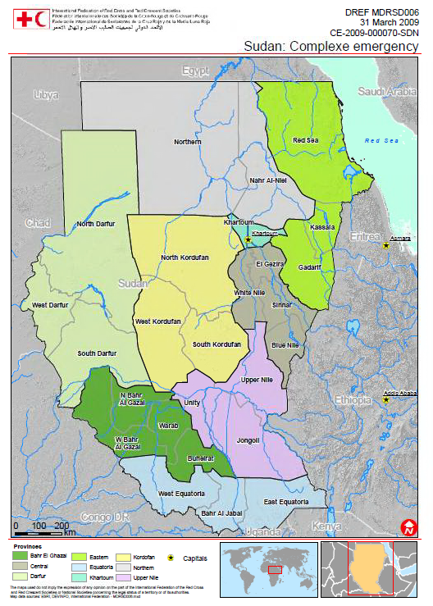

Map of Conflict in Sudan
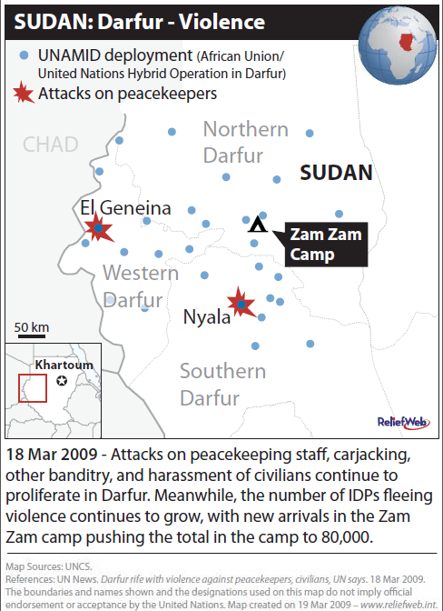

Interview with Mukesh Kapila
http://www.pbs.org/wgbh/pages/frontline/darfur/interviews/kapila.html

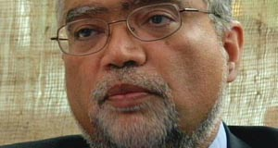
A medical doctor and former British diplomat, Mukesh Kapila was the U.N. resident humanitarian coordinator in Sudan from 2003 until 2004, when he was recalled. He details here the evidence of genocide that he saw early on in Darfur and how he alerted the Sudanese government, U.N. leaders and foreign ministries around the world, to little avail. He finally decided to go public, at the cost, he says, of his career in the mainstream of the United Nations. This is an edited transcript of an interview conducted June 11, 2007.

Tell me how you first learned of these terrible things that were beginning to happen in Sudan.

When I first arrived in Sudan, ... we knew there was insecurity taking place in Darfur. We heard reports, but then the whole vast country was in conflict, particularly in relation to the South. We had no international observers of our own in Darfur, so it took us a little bit of time to understand that what was going on in Darfur was not just yet the latest skirmish of instability in this vast country, but that this was something very special. ...

Stories started trickling out of Darfur from about the middle of 2003. ... We had the first tricklings of displaced people coming to Khartoum, at that time not so much going to Chad but more toward the east. And we had our own local staff giving us reports.

Then one day I was sitting in my office in Khartoum, and a noise outside came, and my assistant said that someone was wanting to see me. So I asked them to come in, and this was a young woman, in her late 20s perhaps, who had trekked all the way from Darfur. And she sat in my office, and she told me her personal story of how not only had she herself been multiply raped but also that her sisters and her family had also been maltreated in that way, and that this had actually been done by soldiers and people dressed in military and paramilitary uniforms.

She went on to then also describe how ... the small village that she was living in, small community, had been completed razed to the ground. So it made me realize not only that there was a campaign going on, but it was actually being orchestrated by the Sudanese authorities -- or at least with their consent at that particular time -- and that the nature of the violence being inflicted on civilian population was often extreme, including vast rape. ...

So this was the first indication that this was something other than just a war going on here?

Yeah. ... Immediately after that, we started getting more stories. Populations were displaced. Then visitors ... gave us repeated stories of flying over Darfur, as I did myself, and seeing villages completely burnt, smoke rising. Not necessarily all villages -- you would have two or three villages that were smoldering, and next there would be a village that was completely normal. So it made one realize that this was a targeted attempt at particular segments of the community. ...

And then as ... we were able to analyze who was being displaced and where the reports were coming out [of], it was quite clear that it was an orchestrated attempt against the people of African origin, and this was being perpetrated by people who were of Arab origin. That's why I was forced to the conclusion that this was ethnic cleansing. ...

Subsequently, [the] genocidal proportions became clear, but that was really toward late 2003 that we began to realize this is more than just ethnic cleansing; it was actually genocide that was being committed.

Give me some sense of what happened personally to you when you began to realize what you're dealing with.

Well, a range of mixed feelings really. Firstly, for me, this was my very first big job in the international community. I was the head of the biggest United Nations country program in the world. ... I wanted to do a job that would bring real results. I was very excited about that job because one of the reasons I had agreed to take it on when the secretary-general [Kofi Annan] had asked me to was because there was this prospect of the peace between the North and South. ...

In parallel to that, ... developing an understanding of what was going on in Darfur, I could not help but remember what I had witnessed in the former Yugoslavia around Srebrenica. ... I had been to Bosnia and had seen some of the aftereffects of Srebrenica but also been in Rwanda within hours of the liberation of Kigali and been in Goma on the day that the actual mass exodus took place. ... I could smell the dead bodies in Rwanda, which was still fresh when I had got to them.

I had also been to Cambodia as part of my work as special adviser to the late Sergio Vieira de Mello, the high commissioner for human rights, and been to other places as well. And I had resolved at those times that if ever I was in a position of responsibility, this would not happen on my patch, and yet it was beginning to happen on my patch. ...

And so what happened?

My first track was to go down the route of systematically making the international community, through the proper channels, aware of what was going on, starting off, of course, by making representations to the Sudan government itself. ... I was listened to very, very politely, but we did not, of course, get anywhere at all.

Then I embarked on track two of my approach, which was to actually speak to the international community, starting with the ambassadors in Khartoum. They, of course, knew more than me because they had access to intelligence and other information that we in the United Nations didn't have. And they confirmed that my fears were not only justified, but things far worse than I'd realized were actually happening that they were aware of. So I realized that the powerful governments of the world were actually quite aware of what was happening in Darfur.

And of course the diplomatic community in Sudan, in Khartoum, were very sympathetic, ... but clearly the situation in Darfur continued to deteriorate. The trickle of displaced became a modest flood, and the flood became a torrent. Then the numbers started going into Chad. So ... we realized that this was no longer just a domestic Sudan matter. ...

So then I embarked on my third stage of attempts, which was to make personal visits to the powerful capitals. I came to my own government in London. I came to Washington, D.C; I had meetings at the National Security Council in the White House and various places. I actually went to Oslo, because Oslo, Norway, along with the U.K. and the U.S., was part of the troika for the North-South peace agreement. I went to Brussels; I went to Rome; I went to many places.

Who personally did you meet with at the State Department?

Senior officials. In some of the countries I visited, I met at the ministerial level ... and other places at the very senior official level. Everywhere I went in Europe and North America, what I was told was that yes, we are aware of what is going on these places. Indeed, in some places I was even shown photographic evidence. ...

But apart from in Washington, D.C., everywhere else I was told that ... now was not the time to make a noise because the North-South peace process was at a very critical stage, and the expectation was that as soon as the North-South peace agreement was signed, we would have a framework for bringing peace to the other part of the country, and then the problem of Darfur would be taken care of.

And I said to everyone, because of course I had met John Garang, the [late Sudan People's Liberation Army] leader, several times, and John Garang had said to me personally that he was delaying signing the North-South peace agreement because he was concerned that the situation in Darfur would then become his responsibility when he became part of the government of unity in Khartoum. ...

When I spoke to my friendly contacts in the Sudan government in Khartoum, they told me that yes, they were also delaying the North-South peace agreement because they wanted to -- and I quote -- "have a lasting solution in Darfur" before they signed the North-South peace agreement and the international community forced them to stop."

And when I heard a phrase like "lasting solution," it of course reminded me of the Holocaust and the "Final Solution" and all those things. And then, allied with the stories that were going on, it was clear that there was genocidal intent being perpetrated by the government in Khartoum. ...

Give me an example of a conversation you might have had at this time.

Well, one conversation in a particular European foreign ministry ran something like this: "Don't be impatient, Mukesh. This is something that will be sorted out in time. We have to look for sustainable solutions, not just knee-jerk reactions. We have to make sure we don't make the situation worse. And we have to ensure that the North-South peace agreement is not imperiled in the process," to which my reaction is: "People are dying in the tens of thousands. People have been murdered and raped. ... And you are not going to have your sustainable long-term solution for the Sudan if what is going on in Darfur is not stopped."

Excuses were ranging from "Why does it have to be us?" through to "It's not as bad as this" through to "We will discuss this matter in this council, that parliament and get back" through to "We have to do much more on providing humanitarian aid"; in other words, turning the whole thing into a humanitarian problem or seeking humanitarian solutions to what were essentially political problems.

In some other cases I think it was simply the fear that if it was escalated into an international, Security Council-driven response, it would impose obligations on countries that they would then have to contribute to that, were they sanctions or troops or whatever.

So virtually everywhere, they were sort of from cynicism to skepticism through to disbelief through to actually the opposite -- "We know exactly what's going on, but actually, what do you expect? This is a country where nasty things happen, and there's wars going on everywhere" -- through to, indeed, even I was accused in one place of attention seeking, that this was actually a publicity stunt.

For you?

Yeah, for me, and I was trying to get money for our aid programs. Or it was trying to whip up emotion. In fact, senior people in the Department of Political Affairs in the United Nations Secretariat accused me of being unstable and hysterical; I was losing my judgment. ...

We're now in 2004, when you first informed your bosses at the U.N. What sort of response are you getting from the U.N.?

Basically the response was, the United Nations has a humanitarian role in Sudan; I was resident humanitarian coordinator; ... I was told to get on with my job. And clearly I wasn't getting enough humanitarian aid to the refugees and displaced; therefore I was actually not being very good at my job, ... conveniently ignoring all the political and other obstructions that the Sudan government was playing.

The second thing in relation to that was that basically the United Nations had contracted out the peace process in the North-South to the troika countries, ... and the Department of Political Affairs in the United Nations Secretariat in New York simply did not want to know and simply did not want to get engaged in this particular process. ...

So ultimately what were you feeling at this point?

At the end of February, beginning of March, I was summoned by the Ministry of Foreign Affairs in Khartoum, and they said that we could resume aid operations in Darfur, because what had happened between December 2003 and around February 2004 was that the international presence had been withdrawn. There had been threats against the security of our staff, and I had been obliged to issue instructions to withdraw our staff, including local staff. ... And of course we had made repeated representations to Sudan government to allow resumption of operations at the beginning of 2004. But they said, "Not yet, not yet, not yet." ...

We went back in again toward the end of February, beginning of March, I believe. And there, of course, we then had a firsthand account of what had happened between December 2003 and February 2004, which [was] basically devastation on a massive scale. By then the number of displaced and refugees had grown into the hundreds of thousands -- in fact, into millions if you take the total displacement into account. ...

So then I felt I had enough smoking-gun evidence to allow me to do the only thing that I could possibly do, having failed miserably in my political and diplomatic efforts against all the powers of the world: ... I spoke to the world media.

And what response did you then get from your bosses at the U.N.?

The reaction from my bosses was silence; no one said anything at all. ... But the reaction was, in terms of the media, electrifying. Within six to 12 hours this was all over the world, and by the time New York woke up -- because this was done from Nairobi -- basically there was no going back, really.

What was gratifying was that within a few weeks, ... we had the first presidential statement from the Security Council. Within three months we had the first Security Council resolution. And this was when I had been told, literally only a month or so before, that there would be no Security Council decision. ...

So actually ... it is the fastest ever compared to Rwanda or Yugoslavia or anywhere else. Ironic. But I consider that a failure because of course the job had been done. ... A mass murder was more or less over, and people who had been displaced were displaced. And it was just too late.

And it's gone on for four years.

Yes. I think the root causes, if you like, have still to be addressed, which is the basic grievances of people. And of course I think also that it cannot be resolved unless there is accountability.

That is why -- and I argued for this very strongly, and people laughed at me at that time in 2004 -- I said, "If we can set up tribunals for Yugoslavia and Sierra Leone, ... and we could do this in Rwanda and all the rest of it, why could not we have some judicial accountability for what was going on in Sudan, in Darfur?" And people laughed at that particular time. ...

Here one should give credit to the United States eternally that they did not obstruct -- despite the U.S. government's position on the International Criminal Court [ICC], because it's been opposed to that -- it did not obstruct the setting up of an International Criminal Court mandate for investigating what was going on in Darfur.

And I don't think we will have resolution of this conflict in Darfur until at least there is some justice done. ...

And I want to come to the justice, but the truth is we haven't even had a reasonable response to it from the U.N. and their powers, who are still arguing about whether a hybrid force can go in, what the numbers would be, what it would do. The very latest is sometime next year.

[The] peace enforcement approach would have been difficult under any circumstances. The lesson from peace operations around the world is that, apart from having the right mandate, you need sufficient resources, and there wasn't a willingness to deploy those sufficient resources. And of course without the consent of the Sudan government, it makes the job even harder.

But then, other measures could have been taken. For example, I think if financial and economic sanctions had been taken against individuals who we know are behind this ... several months or years ago, then I think maybe we might have seen greater pressure being applied. ...

But even that is not the answer. Wars are caused by individuals, and those individuals profit from them. And striking and hurting those individuals who are the cause of perpetrating these things is where pressure and leverage has to be applied.

Now, you argue that had that sort of pressure been applied earlier, it might have stopped this. Explain your argument there for me.

I have absolutely no doubt -- and this is going to be my lasting regret to my dying day -- that if we had intervened in late 2003 and early 2004, ... even though many bad things would have continued to happen, the worst might have been reduced a bit. ... That to me is a failure of the United Nations leadership. It is a failure of the permanent members of the Security Council who must bear prime responsibility, along with the United Nations, for the failure in Sudan. If you have a Security Council and ... if they cannot deal with these particular issues, then we have to ask ourselves, what is the purpose of this Security Council? ...

And who should we hold to account?

Well, let me start with myself. ... I left after a year when I would have been expected to have been there for longer, and I would have liked to have done much more. In not being able to prevent the worst of what happened in Darfur, I consider I failed. ... Then going on from that, I consider that those people who were in the seniormost positions in governments and in the United Nations political secretariat have to take personal accountability for their failure to act. ...

The extraordinary thing about the Darfur crisis is that it is the first genocide in history, I think, ... that not only did we fail miserably, despite all the resources and technologies and policies at our disposal, but that we had the satisfaction of documenting every single step of the way. In other words, not only did we fail, but we beautifully recorded our failure, and we beautifully recorded the act of failing. Extraordinary. Extraordinary failure.

The other extraordinary thing about all this is that not a single person of importance anywhere -- in any foreign ministry of powerful countries or in the echelons of the United Nations system -- lost their jobs as a consequence of this. Where is the personal accountability? ...

So what are we to do then? I mean, what are the citizens of the world to expect? What can be done to stop this?

Two or three things need to happen. Firstly, this doctrine of personal accountability has to be brought forward. ... Unless we can track those people who make decisions and hold them accountable for the personal advice and personal decisions they make, we're not going to have personal accountability, and we will see no particular change.

The second thing that I think needs to happen is that we need some kind of system where there is an automaticity of response. The problem is we have too much discretion given to making judgments: Is this ethnic cleansing? Is this genocide? Is the situation bad enough to intervene? How bad does it have to get before you intervene?

The history of genocide prevention is actually a history of failure, because ... by the time you actually declare something genocide, it has already happened. Therefore, in order to actually have a preventive impact on these things, then one has to have a system of graded responses which is almost automatic in terms of what the international community does. ...

When the U.N. Commission of Inquiry goes to Darfur, it seems to go out of its way to avoid the word "genocide." ... What is your interpretation of why that would be, or why they didn't call it genocide?

From my own conversations, my understanding was that a significant proportion of the members of the inquiry wanted to call it by its proper name; i.e., a genocide. But I think also that there was a lot of political pressure to not make that final resolution. The political pressure came from governments who might possibly then have to act, because a determination of genocide has with it a responsibility to act; that is in the Genocide Convention and all the things that follow. And also it came from within the high levels of the U.N. Secretariat, probably.

So yes, it was very disappointing. But having said that, the determination of genocidal acts being committed has moved us forward, even though it didn't say genocide had been committed. It's a moot point, really.

Because it did at least explain what was going on?

Yeah, yeah. Certainly the inquiry was quite clear that acts of a genocidal nature had been committed. ...

Now, what did happen to you in Sudan? Why did you leave?

A combination of circumstances. I made myself quite unpopular in the United Nations system because what we were trying to do were reforms of the way the different organizations of the U.N. system worked: different programs, departments, funds and so on. This is all part of the global U.N. reform agenda, and Sudan was a bit of a pilot case. ... This was certainly not very popular among many agencies. Ironically, many of those reforms have now been carried through, both in Sudan and elsewhere, but at that time it was maybe a bit premature. ...

I think the second area was that there was a strong dirty-tricks campaign. Certainly my strong pressure on the Sudan government, including some very corrupt parts of the Sudan government, ... certainly didn't win me any friends from my host government. ...

Then I had very strong security threats against me, which was not surprising, I guess, and [the] combination of those factors made my stay in Sudan quite unviable. I was spent.

How do you feel going public and campaigning on Darfur affected your career?

It basically came to an end in terms of the projected rise at that time when I would have gone on to other senior positions in the U.N. or even more senior positions in the U.N. In fact, I was extremely grateful to the World Health Organization, who then took me on as a public health expert and director of one of the units there dealing with emergencies and crises around the world. ... But effectively my international career in the mainstream of the United Nations came to an end.

And how was that made clear to you by the U.N.?

Oh, no, it was never made clear to me. I mean, even to this day it's not made clear to me. I was never sacked, and I was never declared persona non grata by the Sudan government. ... I was withdrawn by the U.N., and I think that was right, considering the circumstances. ...

Privately, I had a lot of positive communications. Senior people in the U.N., colleagues ... sent me warm letters of appreciation. Many of them said, "Thank God, at least someone in the U.N. spoke up." And I have to be grateful, by the way, to Jan Egeland, who was emergency relief coordinator, and his backing all the way through. ... Without him I think I would have been out even earlier.

But I had thousands of e-mails of support. One e-mail -- and this was from a Sudanese who had opened a Hotmail account to send me a quick e-mail and then closed it down, because I could never reply -- and it simply said: "God bless you. We had no voice, and you gave us a voice." And that's all it said. ...

You certainly weren't promoted, Mukesh, for standing up against the first genocide of the 21st century.

No, certainly not. ... I managed to maintain some level of employment and status, and I'm content in that. The most important thing is I sleep well at night, other than my sense of failure.

Having witnessed the last few genocides of the 20th century ... and having presided over the first genocide of the 21st century, it doesn't make you feel good about yourself. So I have to be quite honest about that, and sometimes it's difficult to sleep. But by and large I have no doubt that I did my best, and I would do the same thing again. ...

You said earlier you were less impressed by the "Responsibility to Protect" resolution, which passed in 2005. Why are you so critical of that?

I think the "Responsibility to Protect" is a very good doctrine. I think it is a very convenient and it's a very lucid framework for international action to prevent crimes against humanity and promote peace along the lines that we're talking about.

However, it has no executive element to it. It is still at a level of principles and frameworks. We live in a complex, cruel and nasty world, or at least there are many nasty people that are out there. ... Genocides are not committed by people who manage to just have tipped over from just ordinary murder into mass murder. These are evil deeds perpetrated by evil people. These are very special crimes, and they're not amenable entirely to rational approaches from a Western, liberal point of view.

So my disappointment with the "Responsibility to Protect" so far is, basically, I would like to know how much protection it has brought about. And certainly, even though the "Responsibility to Protect" ideas were prevalent at the time of Darfur, certainly they would not have prevented what went on in Darfur.

It is because we don't have a sharp enough system that has got enough elements built in that allow action to be taking place and sanctions to be put in place. ...

Currently the International Criminal Court is holding two people accountable. ... What's your response to that?

I think that it is good that the International Criminal Court, against all the odds, has managed to get this investigation to a stage where it can launch prosecutions against named individuals, if those individuals can be produced, which of course is a big issue. The International Criminal Court deserves and needs all the support it can get to bring this to a successful conclusion so that justice can be done.

... We seem to be stymied by the idea that sovereignty is a trump card you can play at any time, ... that [President Omar al-]Bashir would have to invite us in to stop the genocide in Darfur. How do you feel about that? How do we get around that?

We get around that by firstly recognizing that these deeds are done by evil people who are not amenable to normal approaches. The only way to deal with evil people is through coercive means, whether it's military or financial or economic to hurt those evil people directly. ... I think the more we simply pursue single tracks of reasonable negotiation and diplomacy, ... the more we give alibis and time for these evil deeds to go to the even greater logical conclusions.

So that's why the determination of genocide or the determination of extreme crimes against humanity are so important at an early enough stage, because it would unleash a whole set of thinking different from the incremental approaches that we normally take when we confront international crises. ...

What is the ultimate lesson you take from your experience?

I have realized, I think, that the issue of personal accountability starts with one's own self. In other words, before one can blame others, try to reform institutions and so on, one has to analyze and understand one's own conduct and learn whatever lessons there are for that.

Allied to that, I've also realized that it is not enough to rely on traditional mechanisms. ... Those of us who come from democratic countries, we have this idea that ultimately the right thing will happen. But I have learned that ultimately the right thing will happen, but only after all the other things have been tried and the cost has been paid in a way.

So I have learned that it is important for citizens, regardless of their official position or whatever, to not be afraid to play their role to create this different world where we are not entirely reliant on cowardly institutions to protect the most important things -- our lives and liberties -- and that countries that have got themselves in that position where they have blind faith in our institutions, they are making a very bad mistake. And some people have paid for that mistake with their lives and liberties.

The village of Tama burning (2005)
By Lynsey Addario
http://proof.org/darfur/

