List of documents in this case study about Attitudes towards Muslim post 9/11
- Introduction to Islam in America post 9/11
- Why the Chapel Hill Shooting Was More Hate Crime Than ‘Parking Dispute’ (Huffington Post)
- “Why we burn Korans, a prophetic warning” (Stand up America now)
- Propaganda about Muslims
- Photograph: Muslim man with labels
- “Trump: 27 percent of Muslims very militant” (The Hill)

Attitudes towards Muslims post 9/11- Introduction

http://www.pluralism.org/religion/islam/issues/post-911

The terrorist attacks of September 11th, 2001 brought Islam into the national and international spotlight with a new intensity. Its impact on the Muslim community cannot be underestimated. When Al Qaeda, an Islamist militant network founded and formerly overseen by Osama bin Laden, claimed responsibility for the attacks, many feared Muslims in America would be targeted for retribution. As people of many faiths and none came together in the wake of the attacks, many sought to stand by the Muslim community, offering protection and support. President George W. Bush visited a mosque in Washington, DC a few days after the attack. There he spoke of Islam as a peaceful religion, noting that “...[t]hese acts of violence against innocents violate the fundamental tenets of the Islamic faith, and it's important for my fellow Americans to understand that.”

Despite efforts by the White House and others to discourage Americans from targeting blame at the Muslim community after 9/11, the number of attacks against those who “looked Muslim” rose exponentially. Just days after September 11th, Balbir Singh Sodhi, a Sikh, was shot outside of his gas station in Mesa, Arizona. The turban he was wearing as a tenet of his faith was mistaken for a “Muslim garment,” and the murderer was seeking revenge for the terrorist attacks. In the weeks and years that followed, many people who “appeared to be” Muslim, particularly South Asians and Arabs of any religion, became the targets of discrimination and hate crimes.

Muslim organizations and individuals suddenly came under scrutiny. Several prominent and trusted American Muslim charities such as the Holy Land Foundation and the Global Relief Foundation were shut down by the American government, charged with having ties to terrorists. Muslim Student Associations on college campuses across the country came under secret surveillance by American police. Muslims continue to be singled out by federal security. The FBI continues to closely monitor Muslim communities at mosques. While the federal agents often work collaboratively with Muslim community members, investigations are not always made transparent. Many Muslims are eager to work with local and federal agents, while others are frustrated by the lack of privacy they are able to maintain.

Politicians have also added fuel to the fire of anti-Islam sentiments in the United States. Former Speaker of the House of Representatives Newt Gingrich identified Shariah as “a moral threat to the survival of freedom in the United States.” U.S. Congressional Representative Joe Walsh from Illinois said that there were “radical” Muslims in American neighborhoods that “try to kill Americans every week.” Within less than two weeks after Walsh made that statement at a town hall meeting in suburban Chicago, eight incidents of hate crime, primarily mosque defacements, were reported within the area. Representative Peter King of New Jersey chaired a series of congressional hearings beginning in 2011 to investigate the radicalization of American Muslims. The tone of the hearings coupled with the scrutiny King received for convening them underscores the tension that still exists in how Americans understand Islam and the Muslim community in the United States.

As public attention focused on Muslims in America after 9/11, many American Muslims asked themselves how their identities as Muslim individuals and communities living and participating in a western democracy, fit into the American religious landscape. Muslim leaders and communities across the nation realized a need to educate their non-Muslim neighbors about Islam. Many Muslim communities opened their doors to the public, inviting non-Muslims to introductory lectures on Islam, and encouraging questions from non-Muslims. Even so, immediately post-9/11 many American Muslim women who had been veiling decided no longer to do so in order to look “less Muslim.” The hijab has seen resurgence in popularity more recently, as these women seek to reassert themselves as American Muslim women. Scholars like Islamic Studies professor Omid Safi are becoming increasingly vocal in expressing the compatibility of Islam with American democracy. The years following 9/11 have also seen Muslim communities become more active in interfaith dialogue, co-hosting events with Christian, Jewish, or Hindu groups, and creating comfortable environments in which to converse and “break bread” together.

Today, many American Muslims continue to be victims of “Islamophobia”, or the “fear of Muslims.” Mosques and Muslim community centers around the country have faced and continue to face vocal and legal opposition. In recent years these have included Park51 in lower Manhattan (dubbed in the media as “the Ground Zero Mosque”) and a planned Muslim community center and mosque complex in Murfreesboro, Tennessee. Nearly a decade after September 11th, a taxi driver in New York was slashed by a passenger when the latter learned that the driver was Muslim. Mosques in places like Joplin, Missouri and Toledo, Ohio were the targets of arson attacks in 2012.

Within this post- 9/11 context many Muslim public interest groups were founded and those already in existence became more vocal. The Islamic Society of North America (ISNA), an umbrella group for many Muslim organizations that seeks to address many of the broader issues facing American Muslims, has maintained a proactive and important voice in shaping the discourse of Islam in America. The Council for American-Islamic Relations (CAIR) is also focused on political activism, specifically countering anti-Islam prejudice through lobbying. For example, CAIR has been involved in trying to stop anti-Shariah legislation from passing in several states. Organizations like ISNA and CAIR, although not necessarily supported by all American Muslims, have been critical in framing the public discourse surrounding Islam in America after September 11th.

Why the Chapel Hill Shooting Was More Hate Crime Than 'Parking Dispute'
02/18/2015 09:06 am ET|UpdatedApr 20, 2015
http://www.huffingtonpost.com/erik-ose/why-the-chapel-hill-shooting-hate-crime_b_6681968.html

- Erik Ose Activist and political blogger at LatestOutrage.org
CHAPEL HILL, N.C. -- When word of the execution-style killings of three Muslim students here leaked onto social media on the evening of Feb. 10, the internet exploded with outrage. Frustration with the lack of any major media coverage gave birth to the hashtag #MuslimLivesMatter, and within hours, #ChapelHillShooting became the top worldwide trending subject on Twitter.

Overnight, the national and international press picked up the story. Pronounced dead at the scene were Deah Shaddy Barakat, 23, his wife Yusor Mohammad Abu-Salha, 21, and her sister, Razan Mohammad Abu-Salha, 19, three talented and promising young community members, killed in their own apartment in a quiet complex near the University of North Carolina's campus, all shot in the head. This grisly crime came at a time of rising anti-Muslim tensions in North Carolina and nationwide, on a day marked by a nonstop media drumbeat about the confirmed death of U.S. hostage Kayla Mueller, who was being held captive by ISIS militants. Many suspected the students' shooting was hate-related.

Yet early the next morning, Chapel Hill Police released a statement that said their "preliminary investigation indicates that the crime was motivated by an ongoing neighbor dispute over parking."
From that point on, corporate media outlets seemed content to follow Fox News' lead in whitewashing any suggestion that the killings were at least partially sparked by hate, trumpeting headlines like "Parking dispute, not bias, triggered triple murder, say NC police."

What is definitively known about the crime is that the suspect in the killings, Craig Stephen Hicks, 46, who turned himself over to police several hours after the shooting, was one of the victims' neighbors. Hicks moved to North Carolina from Illinois in 2004. According to the Los Angeles Times, "a Facebook profile that bore Craig Hicks' name and photo showed he appeared to be a militant atheist who shared anti-Muslim and anti-Christian posts and links."
Chapel Hill shooting suspect Craig Stephen Hicks
One of the last three posts Hicks made to this Facebook page, two days before the shooting, was an atheist-themed photo whose caption asked, "Why are radical Christians and radical Muslims so opposed to each others' influence when they agree about so many ideological issues?" Hicks expressed atheist beliefs in thousands of Facebook posts.

On Jan. 20, he posted a photo of what he said was "my loaded 38 revolver, its holster, and 5 extra rounds in a speedloader." In addition to the handgun Hicks was carrying when arrested, police recovered an arsenal of at least a dozen more firearms from his apartment, including "three handguns, along with several rifles and shotguns...(and) numerous loaded magazines and cases of ammunition."

The slain women's father, Mohammed Abu-Salha, told WRAL-TV that the students were afraid of Hicks. "who had come more than once to their doorstep with a gun in his waistband."
"They felt he was hateful, and she used that word," Abu-Salha said. "She said, 'Daddy, we feel he hates us for who we are and how we look.' And our daughters dressed in the Muslim attire."

A close friend of the victims, Amira Ata, was interviewed by Dean Obeidallah for The Daily Beast, and explained why she thinks the shooting wasn't just triggered by anger over parking:
"Ata said she believes that Hicks killed them because they were the only Muslims in the apartment complex. 'They were targeted because they're different and this is a hate crime,' she stated emphatically. She also said that on the day of the murders, Deah had just returned by bus. The only one with a car was the younger sister Razan, who had already parked earlier in the day. The point being: There was no 'parking dispute' in close proximity to the actual murders."
It's undeniable that Hicks was a neighborhood bully known for hassling various other residents in the complex, especially when he felt they were parking in what he saw as "his" parking spaces. As Tara McKelvey reported from Chapel Hill for the BBC, "residents say Hicks had two parking spaces he focused on in front of his apartment."
Each apartment in the complex is assigned only one space, with all others reserved for visitor parking. By policing two spaces, Hicks was violating the complex's own parking rules. Deah Barakat's sister, Dr. Suzanne Barakat, confirmed to CNN that when Hicks returned home on the evening of Feb. 10, no cars belonging to any of the three victims were parked in the spaces he considered to be his:

"On the day of the murders, the parking spot that was, quote/unquote, 'disputed' had no parking -- no car in it. I wondered maybe was it Razan who was visiting her sister to keep her company had maybe parked in that spot and that triggered it. No. They all knew not to park in this disputed visitors' parking spot. And by disputed, I mean the one that the neighbor claimed belonged to his wife and had been cleared by the apartment complex agency as open and free to all. And despite that, they did not use it. So, this was not a parking dispute."
Hicks' ex-wife Cynthia Hurley said his favorite movie was Falling Down, the 1993 film starring Michael Douglas as a laid-off defense industry worker who goes on a lengthy shooting spree. Hicks reportedly tangled with numerous residents over parking issues, but his own shooting rampage began and ended only with his Muslim neighbors. Why were they the only ones he singled out for repeated, gun-toting harassment? No other residents have come forward to say Hicks ever came to their doors carrying a gun.
This crime has struck a powerful chord in the hearts of Muslim-Americans, Muslims abroad, and everyone else who cares about Islamophobia. The corporate media's willingness to frame these killings as resulting from nothing more than a parking dispute reveals a double standard when it comes to reporting about Muslims as victims of violence.
This picture speaks a 1000 words #ChapelHillShooting pic.twitter.com/0ngcF2wk63
— Abdul Raheem Rudolph (@rudol9h) February 12, 2015
Mohamad Elmasry, a communications professor at the University of North Alabama, noted:
"When Christians, Jews and other non-Muslims are killed by Muslims, Islam is identified as playing a direct role. When Muslims are killed by Jews, Christians and other non-Muslims, however, the religious identity of the violent perpetrators is downplayed or ignored."
As some have pointed out, if Craig Hicks had been an observant Muslim with a history of posting Facebook rants against secular humanists, and then shot three white college students execution-style in the head, no one would be talking about parking. He would have been labeled a domestic terrorist, and if he had tried surrendering to police after the fact, might have been shot on sight.
Fox's rush to spin these killings as anything but a hate crime was understandable, because to explore otherwise would mean raising questions about the network's role in shamelessly fanning the flames of Islamophobia.
But why did other corporate media go blindly along that path? And why did local police do the same? What kind of thorough investigation into this crime's motives led to such a quick pronouncement?
It didn't help that the department charged with investigating the killings is currently underfunded and short-staffed. Or that despite serving and protecting the most liberal community in North Carolina, Chapel Hill's police department has a history of insensitivity towards the town's minority citizens.
Former resident Cynthia Greenlee, now a doctoral candidate in history at Duke University, describes once driving with her boyfriend, a "tall, bearded black man with a naturally serious (read: threatening) demeanor," when they were pulled over by police:
"When a Chapel Hill police officer pulled a gun on us for a routine traffic stop, we didn't argue. He said we were speeding, but he was the quick one as he drew his weapon the moment he disembarked from his car. I was still wondering if we had a taillight out when he screamed for us to stay in the car and pointed his gun at us."
Victims' family and friends waited for answers in shooting's aftermath
Also troubling is that the killings happened within Durham County, N.C., where law enforcement officials are not known for spotless ethics or competence. Over the past decade, "several scandals have raised questions about the dispensation of justice in Durham County," as the Washington Post reported last year. Two Durham district attorneys have been removed from office for misconduct since 2007, one of them Mike Nifong, of Duke lacrosse case infamy. "Prosecutors are rarely ever removed from office for misconduct," said the Post. "For it to happen twice, in the same county, within five years is extraordinary."
Observers hold out hope that newly-elected D.A. Roger Echols, who one local attorney described as "careful and deliberate," will adhere to a higher standard of justice while prosecuting this case. A Durham grand jury indicted Hicks on Feb. 17 on three counts of murder.

The FBI describes a hate crime as any "traditional offense such as murder, arson or vandalism with an added element of bias." In order to gather statistics, Congress has defined hate crimes as "criminal offense(s) against a person or property motivated in whole or in part by an offender's bias against a race, religion, disability, ethnic origin or sexual orientation." On Feb. 12, the FBI announced it had "opened a parallel preliminary inquiry" into the students' deaths, "to determine whether or not any federal laws were violated related to the case."
The New York Times reported that "people who have talked with the victims' families say they have some doubts about the capacity of local authorities to handle the case." Linda Sansour, a spokeswoman for the victims' families, said that "as of (Feb. 12), the family hadn't even been approached by law enforcement. They were already feeling like there was something missing."
Has our country's seemingly endless War on Terror made anti-Muslim bigotry more socially acceptable, and in the process devalued Muslim lives here at home? There are now five times as many hate crimes committed annually against Muslims in the U.S. than there were before 9/11. At the students' memorial service, attended by an estimated 5,000 people, Azhar Azeez, President of the Islamic Society of North America, said, "We are concerned that the anti-Muslim rhetoric may have angered some to commit violence against American Muslims."
Cynthia Greenlee analyzed the reaction of far too many to the media coverage of this crime:
"The fact that many of my Facebook friends are now doing particularly vigorous mental gymnastics to deny that ethnicity, race or religious identity might have anything to do with this act of violence speaks loudly to the needs of a dominant culture to see itself as bearing no responsibility for hatred in its midst--even in a town where a black man simply driving down the street invites a potentially deadly encounter with the law."

We will never know exactly what was going through Craig Hicks' deranged mind at the time these brutal killings were committed. But we should all reflect on the words of Yusor and Razan Abu-Salha's father, Mohammad Abu-Salha, who is a psychiatrist. "The media here bombards the American citizen with Islamic, Islamic, Islamic terrorism and makes people here scared of us and hate us and want us out," said Abu-Salha. "So if somebody has any conflict with you, and they already hate you, you get a bullet in the head."
There is much to suggest these three students weren't killed solely over a parking space. This heinous act looks more like a hate crime.

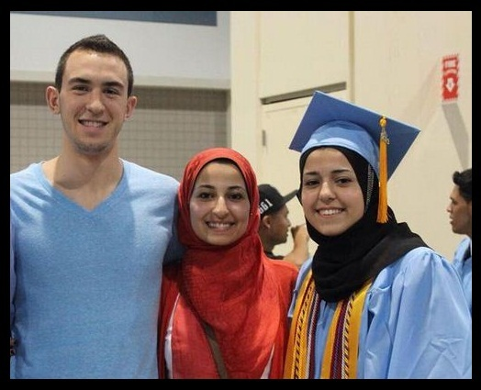

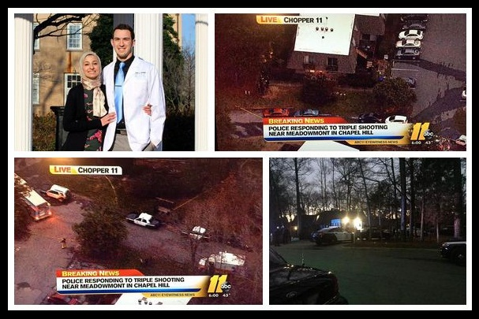

Why We Burn Korans
“Why we burn Korans, a prophetic warning” Dr Terry Jones
http://standupamericanow.org/articles/why-we-burn-korans/

To protest against Islam, against Islamic teachings and against Islamic oppression. The teachings of the Koran are responsible for millions and millions of deaths throughout the 1400 year history of Islam. In Islam Koran dominated countries around the world, there is no freedom of speech, no human rights, civil rights, women’s rights.

To send a warning to the radical element of Islam, the element of Islam in America that would like to institute Sharia here in America.

It is an effective way to draw attention to the event, and to the Koran. There are teachings in the Koran, especially in the section Mohammad wrote during his time in Medina, that are very often used and quoted by the radical element of Islam.

To protest the abuses against minorities in Koran dominated countries. In countries where the Koran or Sharia is the law of the land, minorities, Christians, non-Christians are definitely in the clear disadvantage.

For instance, in Saudi Arabia, Christians at Christmas or Easter are not allowed to practice their religion. They are forced to practice Ramadan, eat Halal meats. Civil violations in Saudi Arabia are innumerable. Women are not allowed to drive, not allowed to vote.

By contrast, in Western countries Muslims are allowed to become citizens. There are thousands of mosques here in America. They can practice their religion every day. They are allowed to dress as they please. There might be some restrictions in some countries concerning security, but that is not to be compared to what happens in Muslim countries where people are beheaded for leaving Islam, where Christians are killed, Coptics are killed, churches are burned down.

We are drawing attention to the plight of Christians and other non-Muslims in Muslim dominated countries. Christians are killed or have houses burned down, or churches are burned down, or they are not allowed at all to build churches, or practice their faith freely. Though controversial, our actions are proper and necessary to draw attention to a problem that has been going on since the Islamic Crusade started 1400 years ago with Muhammad when on his deathbed he gave the command to cleanse the Arabian Peninsular of all unbelievers. And that is exactly what Islam has been doing the whole 1400 years.

No matter how many peaceful verses you quote from the time Mohammad was in Mecca, how many violent verses I quote from the Medina years, the facts in every Muslim dominated country are not pretty. I am going by the fruits. I am not going by what we can discuss back and forth. I am going by the fruits.

When Saudi Arabia allows churches to be built there and Christians to preach on the street, to practice their religion, or in Afghanistan, Pakistan, Iran, Iraq, when they stop killing Christians, when they actually practicing some of those peaceful verses, then that will be something different.

I am interested in the actual practicing of Islam, and I do not see, in the practical aspect, I do not see a peaceful religion.

we should be condemning the conditions that are in Saudi Arabia, as I have mentioned before: the fact that women cannot vote, they cannot obtain a driver’s license, they cannot get an education, travel, without express permission of a male adult, that a woman’s word is worth half of a man’s. Indeed we should be protesting these things, but the United States government and the politicians just simply do not have the guts to do it.

I realize there are different variations between Saudi Arabia and Turkey and other Muslim dominated countries. There are different severities to their rules and regulations, but still it all boils down to the fact that there is not the same type of respect for other religions, there is not the same type of freedom as there is, lets say, here in the United States.

I don’t believe they actually teach the respect of other religions. I don’t really see that. Like I said, in all Muslim dominated countries…. I mean, your explanation I understand. I realize there are different variations between Saudi Arabia and Turkey and other Muslim dominated countries. There are different severities to their rules and regulations, but still it all boils down to the fact that there is not the same type of respect for other religions, there is not the same type of freedom as there is, lets say, here in the United States.

Our First Amendment guarantees us freedom of speech. Freedom of speech is not a practiced, guaranteed, welcomed element in Muslim countries. In Muslim countries you cannot criticize the Koran, you cannot criticize Muhammad, you can’t even criticize Sharia.

So I think definitely just those aspects is a way of Islam insulting, of course, the Jewish religion, insulting the Christian religion. Even the Muslims say Jesus was not the Son of God which is what we believe. That is of course a tremendous insult to Christianity. They do not believe that he died upon the Cross and died for our sins. That is a tremendous insult to Christianity. They believe that he was just a man, or perhaps a prophet. That is lowering what we consider his deity, as being the Son of God.

So I don’t think you can really say that Islam does not insult other religions. Their very teaching insults Christianity, for sure.

Muslims do not believe in “all men are created equal.” Muslims are the better people, that is what the Koran says. Muslims will always believe, not just in Muslim countries, Muslims will never consider Christians, non-believers, women, homosexuals, they will never be considered as equal.

Even though I may not agree with their practice, I do not agree with homosexuality, but I don’t agree with killing them either. So I think that definitely there is just simply no comparison between freedom in Muslim society and freedom in a Islam dominated country.

A journalist cannot criticize Muslim dominated governments. That is just not going to go well for you. If you want to criticize, be able to speak your opinions, speak your mind, speak out against Sharia, Islam, then that is of course going to bear very, very severe consequences.

In America, if you want to speak out and criticize the Bible you can, you can criticize Jesus if you want to, those types of freedom or critical thinking. Critical thinking is part of Western society. Critical thinking, of course, is not allowed or accepted in Islam.

What I see that I am doing, to a certain extent, is giving a prophetic warning to the world, let’s say. There is also that example. There is also the example of warning people if they are going in the wrong direction, giving a warning to society. So I think that is more of what I am doing.

I am giving a prophetic warning and saying, “Watch out! Be careful. There is a part of the Koran that is very dangerous, there is an element of Islam that is very dangerous and oppressive. Do not be fooled by all of the peace talk, because behind the peace talk we do not see the fruits.”

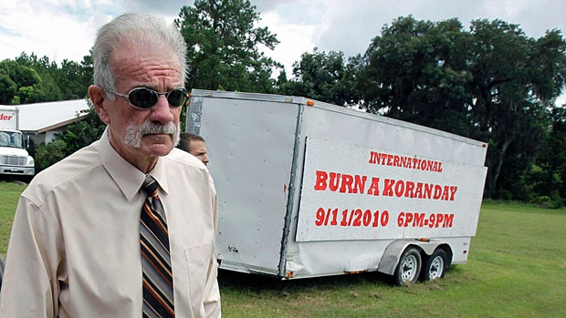

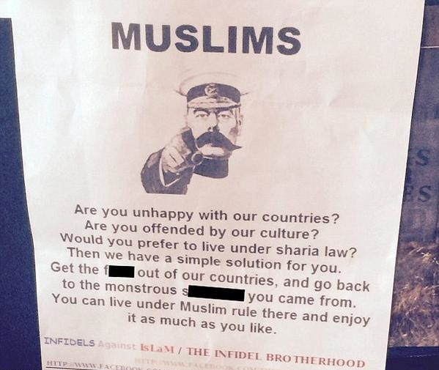

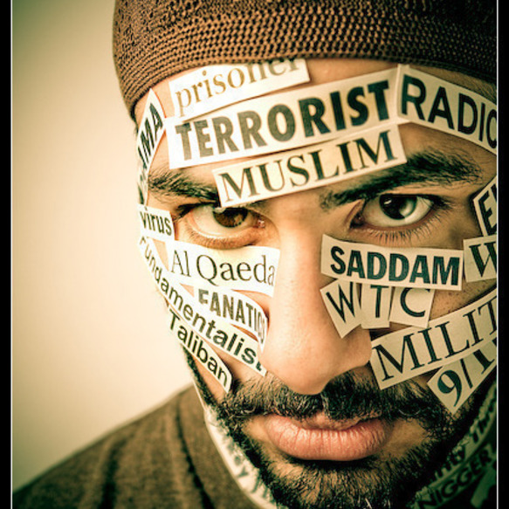

March 13, 2016, 09:56 am

Trump: 27 percent of Muslims very militant
http://thehill.com/blogs/ballot-box/presidential-races/272813-trump-27-percent-of-muslims-very-militant
By Rebecca Savransky
2.6K1
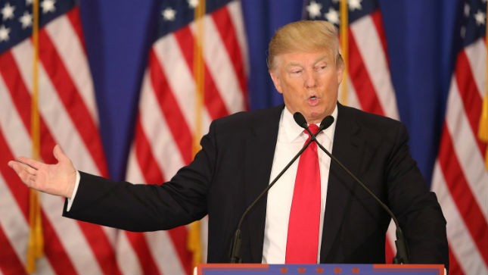
Getty Images
Republican presidential front-runner Donald Trump on Sunday said that Muslims' hatred is "tremendous," doubling down on his comment last week that "Islam hates us."

On "Fox News Sunday," host Chris Wallace said there are 1.6 billion Muslims in the world and, according to the best experts, at most, 100,000 people are fighting for Jihadist causes.

"So why draw a battle line against an entire religion, including major countries that are helping us in the fight against ISIS?" he asked.

Trump said whoever did that survey was "about as wrong as you can get."

He said about 27 percent of Muslims have said they would go to war.

"Twenty-seven percent are really very militant about going after things," he said, citing a poll.

"It's a very significant number; it's not 100,000 people, I can tell you that. That's a ridiculous number," he said.

"There is a big problem, and radical Islamic terrorism is taking place all over the world."

