List of documents in this case study about Indian Boarding Schools
- Introduction to Indian Boarding Schools (American Indian Relief Council)
- Photograph: Sioux boys as they were dressed on arrival at the Carlisle Indian School
- Photograph: Pueblo tribal members visiting the Albuquerque Indian School and staff
- Photograph: Art class, Phoenix Indian School, Arizona
- Photograph: Tom Torino when he arrived at Carlisle Indian School and 3 years later
- Photograph: Three Lakota Boys
- Photograph: Woxie Haury (Cheyene)
- The Meriam Report-Education Section
- “Indian Boarding School: The Runaways” by Louise Erdrich
- Letter from Luther Standing Bear to his father from Carlisle Boarding School- March 1882
- Letter from Luther Standing Bear to his father from Carlisle Boarding School- September 1882

Introduction to Indian Boarding Schools
From American Indian Relief Council

Boarding Schools
The boarding school experience for Indian children began in 1860 when the Bureau of Indian Affairs established the first Indian boarding school on the Yakima Indian Reservation in the state of Washington. These schools were part of a plan devised by well-intentioned, eastern reformers Herbert Welsh and Henry Pancoast, who also helped establish organizations such as the Board of Indian Commissioners, the Boston Indian Citizenship Association and the Women’s National Indian Association.
The goal of these reformers was to use education as a tool to “assimilate” Indian tribes into the mainstream of the “American way of life,” a Protestant ideology of the mid-19th century. Indian people would be taught the importance of private property, material wealth and monogamous nuclear families. The reformers assumed that it was necessary to “civilize” Indian people, make them accept white men’s beliefs and value systems.
Boarding schools were the ideal instrument for absorbing people and ideologies that stood in the way of manifest destiny. Schools would quickly be able to assimilate Indian youth. The first priority of the boarding schools would be to provide the rudiments of academic education: reading, writing and speaking of the English language. Arithmetic, science, history and the arts would be added to open the possibility of discovering the “self-directing power of thought.” Indian youth would be individualized. Religious training in Christianity would be taught. The principles of democratic society, institutions and the political structure would give the students citizenship training. The end goal was to eradicate all vestiges of Indian culture.
By the 1880s, the U.S. operated 60 schools for 6,200 Indian students, including reservation day schools and reservation boarding schools. The reservation day school had the advantage of being relatively inexpensive and caused the least opposition from parents. The reservation boarding school spent half a day teaching English and academics and half a day on industrial training. Regimentation was the order of the day and students spent endless hours marching to and from classes, meals and dormitories. Order, discipline and self-restraint were all prized values of white society.
The boarding schools hoped to produce students that were economically self-sufficient by teaching work skills and instilling values and beliefs of possessive individualism, meaning you care about yourself and what you as a person own. This opposed the basic Indian belief of communal ownership, which held that the land was for all people.
“Kill the Indian, Save the Man”
At this juncture, it was felt that reservation schools were not sufficiently removed from the influences of tribal life. In the eyes of assimilationists, off-reservation boarding schools would be the best hope of changing Indian children into members of the white society. For Col. Richard Henry Pratt, the goal was complete assimilation. In 1879, he established the most well known of the off-reservation boarding schools, the Carlisle Indian School in Carlisle, Pennsylvania. As Headmaster of the school for 25 years, he was the single most impacting figure in Indian education during his time.
Pratt’s motto was, “Kill the Indian, save the man.” Pratt believed that off-reservation schools established in white communities could accomplish this task. By immersing Indians into the mainstream of American life, the “outing” system created by Pratt had students living among white families during the summer. He hoped Indian youths would not return to the reservations but rather become part of the white community. Carlisle was the only off-reservation boarding school built in the East; all others were built in the West.
Carlisle and other off-reservation boarding schools instituted their assault on Native cultural identity by first doing away with all outward signs of tribal life that the children brought with them. The long braids worn by Indian boys were cut off. The children were made to wear standard uniforms. The children were given new “white” names, including surnames, as it was felt this would help when they inherited property. Traditional Native foods were abandoned, forcing students to acquire the food rites of white society, including the use of knives, forks, spoons, napkins and tablecloths. In addition, students were forbidden to speak their Native languages, even to each other. The Carlisle school rewarded those who refrained from speaking their own language; most other boarding schools relied on punishment to achieve this aim.
At the better boarding schools, students could attain a reasonable degree of English literacy in a relatively short period. At other schools, the method of teaching — an object card such as CAT shown to students, then written, pronounced and traced — failed to produce a comprehension of those words that had no equivalent in their Native tongue.
The Indian boarding schools taught history with a definite white bias. Columbus Day was heralded as a banner day in history and a beneficent development in their own race’s fortune, as only after discovery did Indians enter the stream of history. Thanksgiving was a holiday to celebrate “good” Indians having aided the brave Pilgrim Fathers. New Year’s was a reminder of how white people kept track of time and George Washington’s birthday served as a reminder of the Great White Father. On Memorial Day, some students at off-reservation schools were made to decorate the graves of soldiers sent to kill their fathers.
Half of each school day was spent on industrial training. Girls learned to cook, clean, sew, care for poultry and do laundry for the entire institution. Boys learned industrial skills such as blacksmithing, shoemaking or performed manual labor such as farming. Since the schools were required to be as self-sufficient as possible, students did the majority of the work. By 1900, economic practicality became the goal and school curriculum slanted even further toward industrial training while academics languished.
The Carlisle school developed a “placing out system,” placing Indian students in the mainstream community for summer or a year at a time where they could learn skills other than farming. While monitored carefully at Carlisle, other outing programs were often exploitive. At the Phoenix Indian School, girls became the major source of domestic labor for white families, boys were placed in seasonal harvest or other jobs unwanted by white or immigrant laborers and the students were unsupervised, learning very little from their outing experiences.
The Carlisle and Phoenix schools also had football teams, and Phoenix had a band that performed at summer parades and festivals. These activities were meant to support the idea that Indian people were capable of competing with whites.
Conversion to Christianity was also deemed essential to the cause. Indian boarding schools were expected to develop a curriculum of religious instruction, placing emphasis on the Ten Commandments, the Beatitudes and Psalms. Implanting ideas of sin and a sense of guilt were part of Sunday schools. Christianity governed gender relations at the schools and most schools invested their energy in keeping the sexes apart, in some cases endangering the lives of the students by locking girls in their dormitories at night — meaning they could not get out, even in the case of fire. There were, however, ritualized social activities such as dances and promenades.
Discipline within the Indian boarding schools was severe and generally consisted of confinement, deprivation of privileges, threat of corporal punishment or restriction of diet. In addition to coping with the severe discipline, Indian students were ravaged by disease at boarding schools. Tuberculosis and trachoma (“sore eyes”) were the greatest threats. In December of 1899, measles broke out at the Phoenix Indian School, reaching epidemic proportions by January. In its wake, 325 cases of measles, 60 cases of pneumonia, and 9 deaths were recorded in a 10-day period.
Naturally, Indian people resisted the schools in various ways. Sometimes entire villages refused to enroll their children in white men’s schools. Indian agents on the reservations normally resorted to withholding rations or sending in agency police to enforce the school policy. In some cases, police were sent onto the reservations to seize children from their parents, whether willing or not. The police would continue to take children until the school was filled, so sometimes orphans were offered up or families would negotiate a family quota. Navajo police officers avoided taking “prime” children and would take children assumed to be less intelligent, those not well cared for or those physically impaired.
Indian parents also banded together to withdraw their children en masse, encouraging runaways and undermining the schools’ influence during summer and school breaks. An 1893 court ruling increased pressure to keep Indian children in Boarding schools. It was not until 1978 with the passing of the Indian Child Welfare Act that Native American parents gained the legal right to deny their children’s placement in off-reservation schools.
Some Native American parents saw boarding school education for what it was intended to be — the total destruction of Indian culture. Others objected to specific aspects of the education system, the manner of discipline and the drilling. Still others were concerned for their children’s health and associated the schools with death. Resentment of the boarding schools was most severe because the schools broke the most sacred and fundamental of all human ties, the parent-child bond.

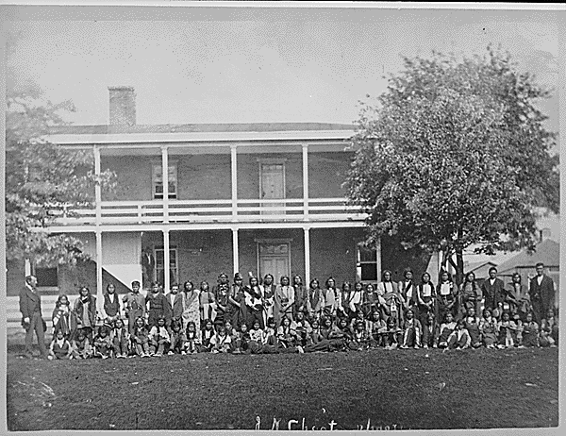

Sioux boys as they were dressed on arrival at the Carlisle Indian School, Pennsylvania.

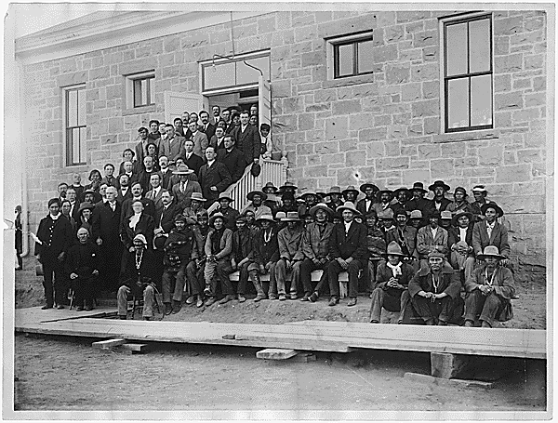
Pueblo tribal members visiting the Albuquerque Indian School and staff.

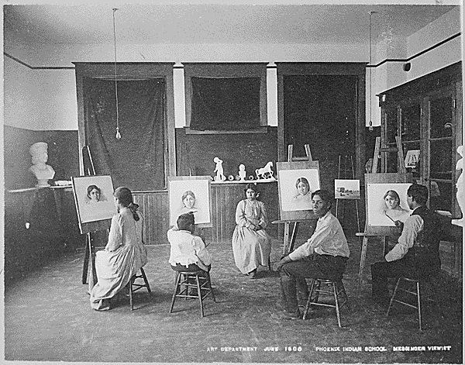
Art class, Phoenix Indian School, Arizona.

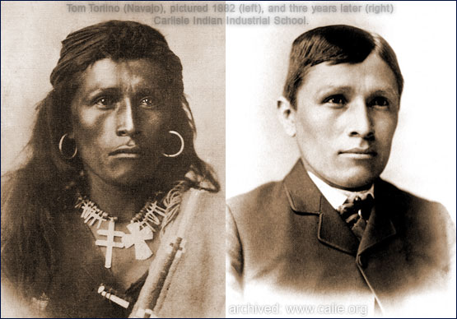

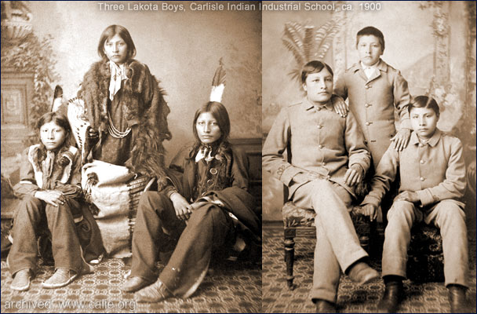

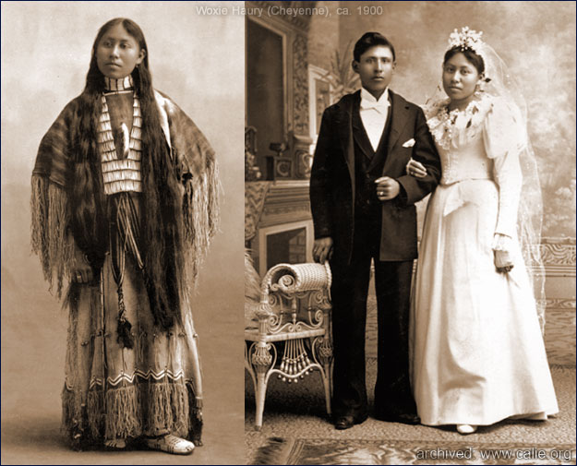

The Meriam Report-Education Section
Background of the Meriam Report:
The Meriam Report (1928), whose official title was The Problem of Indian Administration, was commissioned by the Institute for Government Research (IGR, better known later as the Brookings Institution) and funded by the Rockefeller Foundation. The IGR appointed Lewis Meriam as the technical director of the survey team, to compile information and report of the conditions of American Indians across the country. Meriam submitted the 847-page report to the Secretary of the Interior, Hubert Work, on February 21, 1928.
The report combined narrative with statistics to criticize the Department of Interior's (DOI) implementation of the Dawes Act, and overall conditions on reservations and in Indian boarding schools. The Meriam Report was the first general study of Indian conditions since the 1850s, when the ethnologist and former U.S. Indian Agent Henry R. Schoolcraft had completed a six-volume work for the U.S. Congress. The Meriam Report provided much of the data used to reform American Indian policy through new legislation: the Indian Reorganization Act of 1934. It strongly influenced succeeding policies in land allotment, education, and health care. The report found generally that the U.S. federal government was failing at its goals of protecting Native Americans, their land, and their resources, both personal and cultural.

Chapter IX- Education
Fundamental Needs. The most fundamental need in Indian education is a change in point of view. Whatever may have been the official governmental attitude, education for the Indian in the past has proceeded largely on the theory that it is necessary to remove the Indian child as far as possible from his home environment; whereas the modern point of view in education and social work lays stress on upbringing in the natural setting of home and family life. The Indian educational enterprise is peculiarly in need of the kind of approach that recognizes this principle; that is, less concerned with a conventional school system and more with the understanding of human beings. It is impossible to visit Indian schools without feeling that on the whole they have been less touched than have better public schools by the newer knowledge of human behavior; that they reflect, for the most part, an attitude toward children characteristic of older city schools or of rural schools in backward sections; that they are distinctly below the accepted social and educational standards of school systems in most cities and the better rural communities.
Recognition of the Individual. It is true in all education, but especially in the education of people situated as are the American Indians, that methods must be adapted to individual abilities, interests, and needs. A standard course of study, routine classroom methods, traditional types of schools, even if they were adequately supplied—and they are - not—would not solve the problem. The methods of the average public school in the United States cannot safely be taken over bodily and applied to Indian education. Indian tribes and individual Indians within the tribes vary so much that a standard content and method of education, no matter how carefully they might be prepared, would be worse than futile. Moreover, the standard course of study for Indian schools and the system of uniform examinations based upon it represent a procedure now no longer accepted by schools throughout the United States.
Education and the Indian Problem as a Whole. That the whole Indian problem is essentially an educational one has repeatedly been stated by those who have dealt with Indian affairs. Commissioner Burke says in his foreword to " The Red Man in the United States ":
Practically all our work for the civilization of the Indian has become educational: Teaching the language he must of necessity adopt, the academic knowledge essential to ordinary business transactions, the common arts and crafts of the home and the field, how to provide a settled dwelling and elevate its domestic quality, how to get well when he is sick and how to stay well, how to make the best use of his land and the water accessible to it, how to raise the right kind of live-stock, how to work for a living, save money and start a bank account, how to want something he can call his own, a material possession with the happiness and comforts of family life and a pride in the prosperity of his children.
Similarly, Mr. Malcolm McDowell, secretary of the Board of Indian Commissioners, points out in his statement, issued following the conference of Secretary Work's Committee of One Hundred, that the program for the Indian centers on " the training of all Indians for the best type of American citizenship, looking to their absorption into the general citizenship of the Nation " essentially an educational policy.
Importance of Home and Family Life. Just what pronouncements like these should mean in actual practice has never, how- 349 ever, been clearly defined. None of the statements usually made, for example, takes into consideration home and family life as an essential part of the process of educating the Indian, yet this, as has already been suggested; is fundamental. "However important may be the contribution of the schools," says Dean James E. Russell, " the atmosphere and conditions of the home are, especially in the early days of the child's life, the primary determinant in the development of the child, and, since it is the parents who determine these conditions and create that atmosphere, it is they who are of necessity the most important educational factors in the lives of their children." A recent statement adopted by representatives of many nations places education for family and community as a first requisite in any educational program.
Indian Boarding School: The Runaways
BY LOUISE ERDRICH

Home’s the place we head for in our sleep.
Boxcars stumbling north in dreams
don’t wait for us. We catch them on the run.
The rails, old lacerations that we love,
shoot parallel across the face and break
just under Turtle Mountains. Riding scars
you can’t get lost. Home is the place they cross.

The lame guard strikes a match and makes the dark
less tolerant. We watch through cracks in boards
as the land starts rolling, rolling till it hurts
to be here, cold in regulation clothes.
We know the sheriff’s waiting at midrun
to take us back. His car is dumb and warm.
The highway doesn’t rock, it only hums
like a wing of long insults. The worn-down welts
of ancient punishments lead back and forth.

All runaways wear dresses, long green ones,
the color you would think shame was. We scrub
the sidewalks down because it's shameful work.
Our brushes cut the stone in watered arcs
and in the soak frail outlines shiver clear
a moment, things us kids pressed on the dark
face before it hardened, pale, remembering
delicate old injuries, the spines of names and leaves.

Letter from Luther Standing Bear to his father from Carlisle Boarding School
Source: http://home.epix.net/~landis/standingbear.html
March 31, 1882
DEAR FATHER STANDING BEAR : --
Day before yesterday one of the Sioux boys died. His name is Alvan. He was a good boy always. So we were very glad for him. Because he is better now than he was on Earth. I think you may be don't know what I mean. I mean he has gone in heaven. Because he was a good boy everywhere. I hope you will understand exactly what I mean and you should think that way. I want you must give up Indian way. I know you have give it up a little. But I want you to do more than that and I told you so before this. But I will say it again you must believe God, obey him and pray to Him. He will help you in the right path and He will give you what you want if you ask Him. Dear father I know it is very hard for you to do that out there. But you can try to think that way you must try day after day until you can do it. Then you will be always happy. Now I shall say a few words about what we have done here. We are tyring to speak only English nothing talk Sioux. But English. I have tried. But I could not do it at first. But I tried hard every day. So now I have found out how to speak only English. I have been speaking only English about 14 weeks now I have not said any Indian words at all. So I wish you will try to do like that after while you will go forward in which is no sorry and no trouble. You could not do nothing if you don't believe me what I told you in this letter. So I wish dear father you must turn round and try to walk in the right way. Now dear father I would like to know if you have that store. Do you keep it yet or not? I will help you when I go back home. That is all I have to say, Good-bye from your son.
LUTHER STANDING BEAR.

Letter from Luther Standing Bear to his father from Carlisle Boarding School
Source: http://home.epix.net/~landis/standingbear.html
September, 1982
STANDING BEAR MY DEAR FATHER. –
We had a funeral this evening one of the scholars died. The grandson of Standing Bear, Ponca Chief. What do you think of that? you think we felt sorry and cried walked around and killed horses and gave them away the things which we have? or cut ourselves and crying for him every day because we love him? Now this is what I want to say something about that. You know it is not right to do that way. If we are truly civilized. We know it is not that way what we want to learn the knowledge of civilization. I want you must give up the Indian ways, you must turn to the good way and try to walk in it, the way of which is God love. Try to be civilized while we try to get a good education. I hope you have determined to do this. Don't think just your children shall be civlized and you just keep on the Indian way, because you are too old now. But you must go with us in teh whites road. I feel glad adn happier when I look toward the way of civilization and I feel so sorry when I look back to my own way in the Indians way. Dear father think of this. There only about 250,000 Indians in all. In just one state in New York there are 5,000,000 people. Now if they don't take care of the Indians how can we live if we are not civilized. Father think of this and try to follow the white men's way. Do what I have told you, don't just hear the words and will not do my words. I say to you these words from my heart. I shall be very glad to know if you try to do in this way which I told you to do. Now this is all. We are all very well and happy. From
Your Son.
LUTHER S. BEAR.

