List of documents in this case study about Japanese Internment
- Introduction to Japanese Internment
- Map of Japanese Internment camps
- “Instructions to All Persons of Japanese Ancestry”
- Photograph: Japs Keep Moving
- Photograph: Japanese Store Sold
- Photograph: Japs Not Wanted
- Photograph: Newspaper Headlines
- Transcript of Executive Order 9066
- West Seattle Herald: Get ‘Em Out!
- Newspaper Article: “More Plain Talk”
- Newspaper Article: “Many Who Morn”
- Newspaper Article: “Let Us Keep Our Record Clear”
- Newspaper Article: “Let’s Obey Order Loyalty”
- “We’re Gonna Have to Slap, the Dirty Little Jap, and Uncle Sam’s the guy to do it” Lyrics

INTRODUCTION TO JAPANESE INTERNMENT
The internment of Japanese Americans in the United States was the forced relocation and incarceration during World War II of between 110,000 and 120,000 people of Japanese ancestry who lived on the Pacific coast in camps in the interior of the country. Sixty-two percent of the internees were United States citizens. President Franklin D. Roosevelt ordered the incarceration shortly after Imperial Japan's attack on Pearl Harbor.
President Franklin D. Roosevelt authorized the deportation and incarceration with Executive Order 9066, issued February 19, 1942, which allowed regional military commanders to designate "military areas" from which "any or all persons may be excluded." This power was used to declare that all people of Japanese ancestry were excluded from the entire West Coast, including all of California and much of Oregon, Washington and Arizona, except for those in government camps. Approximately 5,000 Japanese Americans voluntarily relocated outside the exclusion zone, and some 5,500 community leaders arrested after the Pearl Harbor attack were already in custody, but the majority of mainland Japanese Americans were evacuated (forcibly relocated) from their West Coast homes during the spring of 1942. The United States Census Bureau assisted the internment efforts by providing confidential neighborhood information on Japanese Americans.
Of 127,000 Japanese Americans living in the continental United States at the time of the Pearl Harbor attack, 112,000 resided on the West Coast. About 80,000 were nisei (literal translation: "second generation"; American-born Japanese with U.S. citizenship) and sansei ("third generation"; the children of Nisei). The rest were issei ("first generation", immigrants born in Japan who were ineligible for U.S. citizenship by U.S. law).

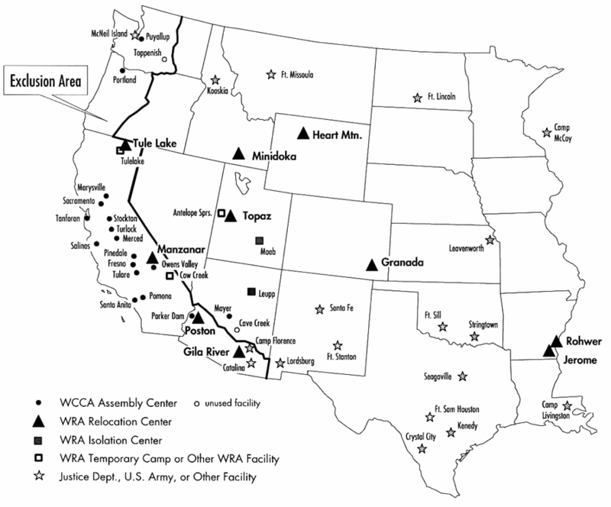

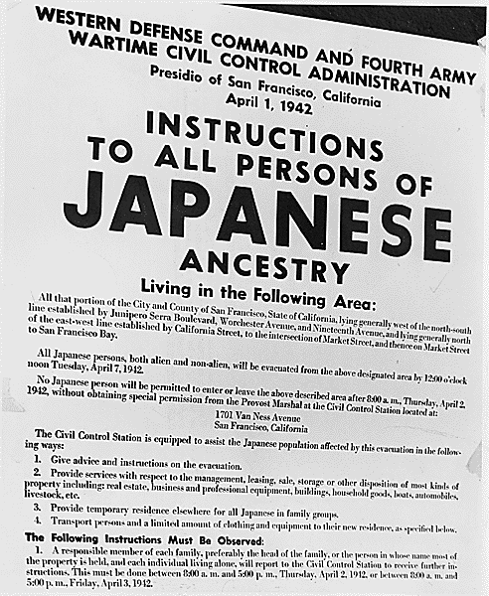

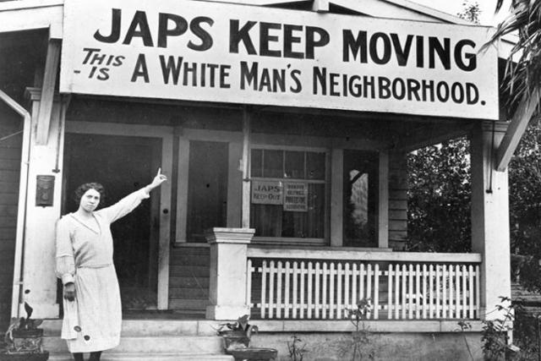

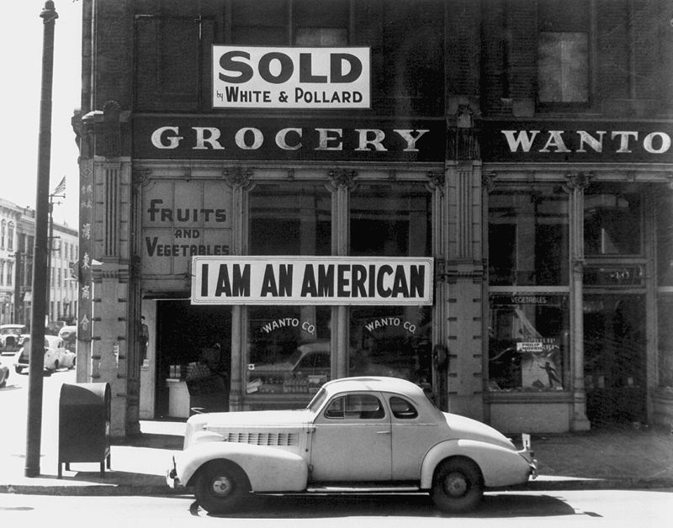

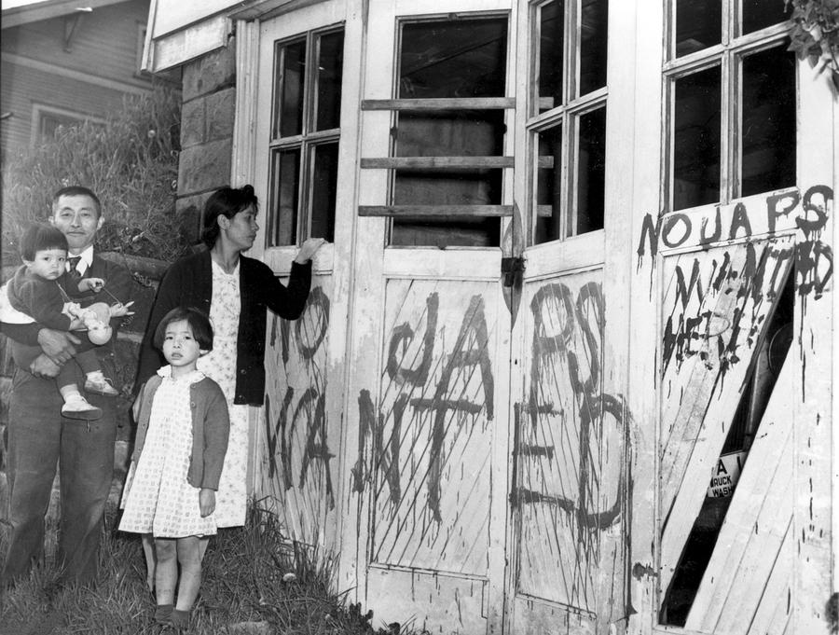

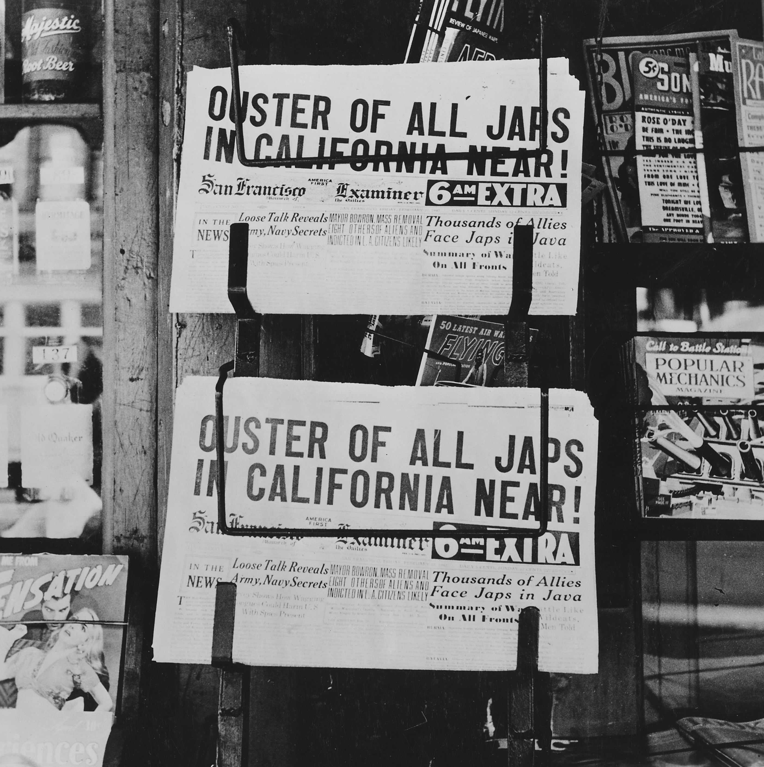

Transcript of Executive Order 9066: Resulting in the Relocation of Japanese (1942)
Executive Order No. 9066
The President
Executive Order
Authorizing the Secretary of War to Prescribe Military Areas
Whereas the successful prosecution of the war requires every possible protection against espionage and against sabotage to national-defense material, national-defense premises, and national-defense utilities as defined in Section 4, Act of April 20, 1918, 40 Stat. 533, as amended by the Act of November 30, 1940, 54 Stat. 1220, and the Act of August 21, 1941, 55 Stat. 655 (U.S.C., Title 50, Sec. 104);
Now, therefore, by virtue of the authority vested in me as President of the United States, and Commander in Chief of the Army and Navy, I hereby authorize and direct the Secretary of War, and the Military Commanders whom he may from time to time designate, whenever he or any designated Commander deems such action necessary or desirable, to prescribe military areas in such places and of such extent as he or the appropriate Military Commander may determine, from which any or all persons may be excluded, and with respect to which, the right of any person to enter, remain in, or leave shall be subject to whatever restrictions the Secretary of War or the appropriate Military Commander may impose in his discretion. The Secretary of War is hereby authorized to provide for residents of any such area who are excluded therefrom, such transportation, food, shelter, and other accommodations as may be necessary, in the judgment of the Secretary of War or the said Military Commander, and until other arrangements are made, to accomplish the purpose of this order. The designation of military areas in any region or locality shall supersede designations of prohibited and restricted areas by the Attorney General under the Proclamations of December 7 and 8, 1941, and shall supersede the responsibility and authority of the Attorney General under the said Proclamations in respect of such prohibited and restricted areas.
I hereby further authorize and direct the Secretary of War and the said Military Commanders to take such other steps as he or the appropriate Military Commander may deem advisable to enforce compliance with the restrictions applicable to each Military area hereinabove authorized to be designated, including the use of Federal troops and other Federal Agencies, with authority to accept assistance of state and local agencies.
I hereby further authorize and direct all Executive Departments, independent establishments and other Federal Agencies, to assist the Secretary of War or the said Military Commanders in carrying out this Executive Order, including the furnishing of medical aid, hospitalization, food, clothing, transportation, use of land, shelter, and other supplies, equipment, utilities, facilities, and services.
This order shall not be construed as modifying or limiting in any way the authority heretofore granted under Executive Order No. 8972, dated December 12, 1941, nor shall it be construed as limiting or modifying the duty and responsibility of the Federal Bureau of Investigation, with respect to the investigation of alleged acts of sabotage or the duty and responsibility of the Attorney General and the Department of Justice under the Proclamations of December 7 and 8, 1941, prescribing regulations for the conduct and control of alien enemies, except as such duty and responsibility is superseded by the designation of military areas hereunder.
Franklin D. Roosevelt
The White House,
February 19, 1942.

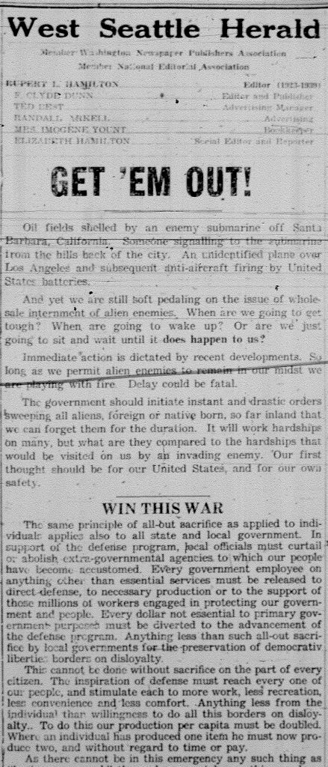

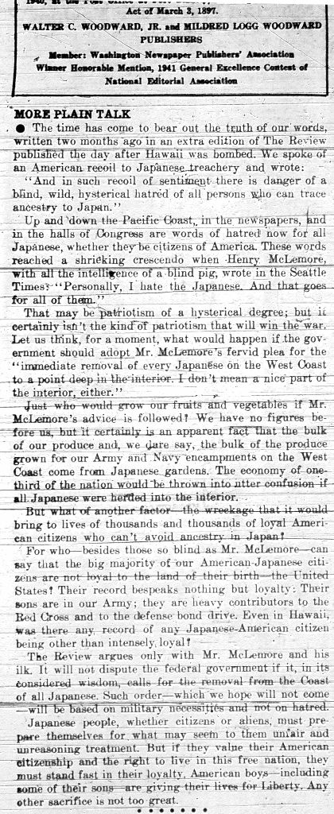

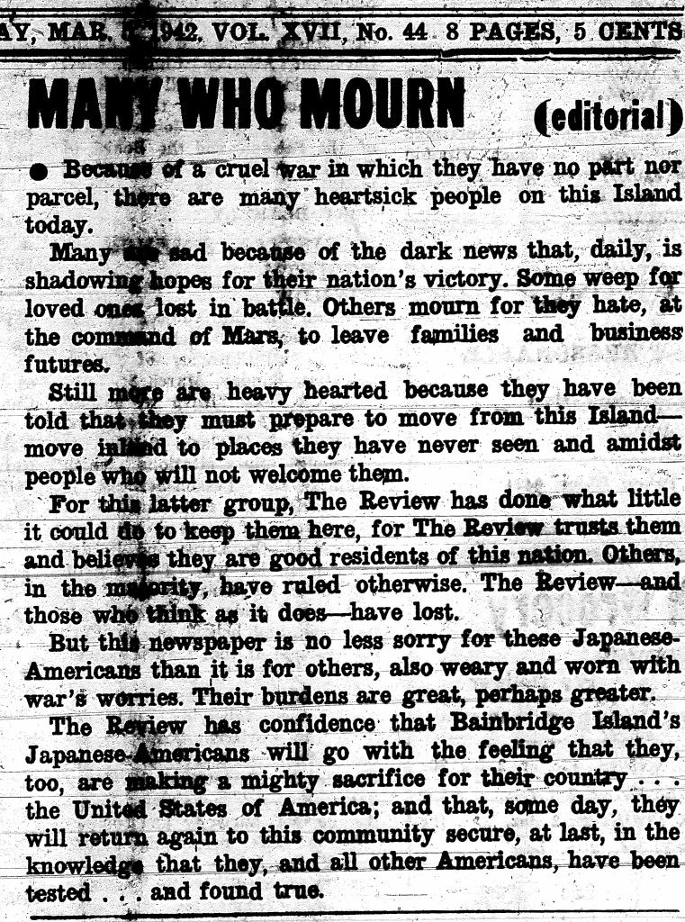

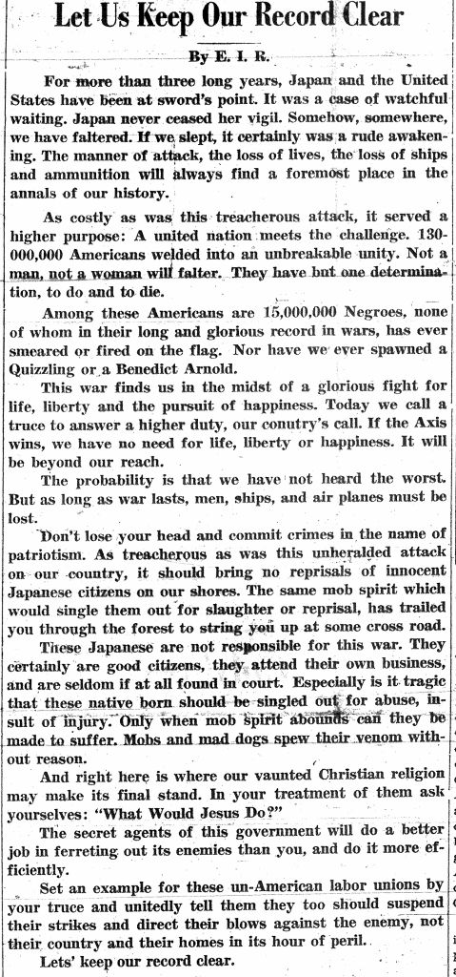

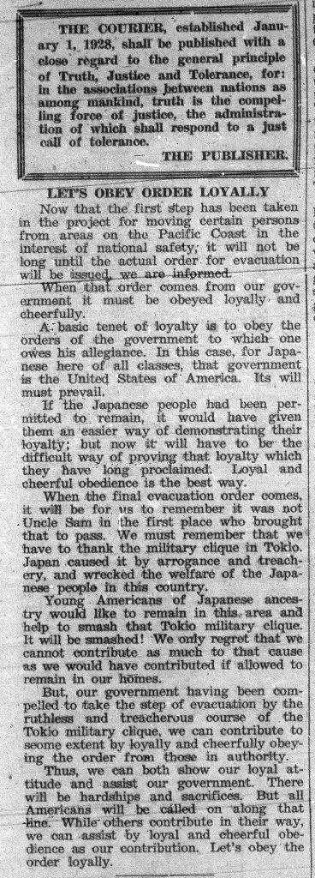
We're Gonna Have To Slap, The Dirty Little Jap, and Uncle Sam's the Guy who can do it
Audio: https://www.youtube.com/watch?v=HJ0emX5RgZQ
Performed by Carson Robison
Recorded December 1941
Words and Music by Bob Miller
We're gonna have to slap the dirty little Jap
And Uncle Sam's the guy who can do it
We'll skin the streak of yellow from this sneaky little fellow
And he'll think a cyclone hit him when he's thru it
We'll take the double crosser to the old woodshed
We'll start on his bottom and go to his head
When we get thru with him he'll wish that he was dead
We gotta slap the dirty little Jap
We're gonna have to slap the dirty little Jap
And Uncle Sam's the guy who can do it
The Japs and all their hooey will be changed into chop suey
And the rising sun will set when we get thru it
Their alibi for fighting is to save their face
For ancestors waiting in celestial space
We'll kick their precious face down to the other place
We gotta slap the dirty little Jap
We're gonna have to slap the dirty little Jap
And Uncle Sam's the guy who can do it
We'll murder Hirohito, massacre that slob Benito
Hang'em with that Shickle gruber when we're thru it
We'll search the highest mountain for the tallest tree
To build us a hanging post for the evil three
We'll call in all our neighbors, let'em know their free
We gotta slap the dirty little Jap

