List of documents in this case study about the Red Summer Riots

- Background Information
- If We Must Die by Claude McKay
- Map of major race riots and lynchings of the Red Summer
- Photograph of man being pulled off bus
- “100 Negros shot, burned, clubbed to death in E. St. Louis Race War”
- Photograph of man being attacked by police dogs
- Anti-Black Propaganda Signs
- “Chicago Race Riots Continue Despite Troops”
- “Six Slain in Race Riot at Church”
- “Riot in Philadelphia”
- “Mob Storms Jail and Gets Blacks”
- Photograph of Willie Brown’s burning body [GRAPHIC]
- Photograph from Elaine, AR
- “To the Negroes of Phillips County” Helena, AR

Background Information
The Great Migration
The Great Migration was the movement of 6 million African Americans out of the rural Southern United States to the urban Northeast, Midwest, and West that occurred between 1910 and 1970. Blacks moved from 14 states of the South, especially Alabama, Mississippi, Louisiana, and Texas, to the other three cultural (and census-designated) regions of the United States. Georgia was especially affected, seeing net declines in its African-American population for three consecutive decades after 1920.

When the Emancipation Proclamation was signed in 1863, less than eight percent of the African-American population lived in the Northeastern or Midwestern United States. This began to change over the next decade; by 1880, a migration was underway to Kansas. The U.S. Senate ordered an investigation into it. In 1900, about 90 percent of blacks still lived in Southern states.

Between 1910 and 1930, the African-American population increased by about forty percent in Northern states as a result of the migration, mostly in the major cities. The cities of Detroit, Chicago, Cleveland, and New York City had some of the biggest increases in the early part of the twentieth century. Tens of thousands of blacks were recruited for industrial jobs, such as positions related to the expansion of the Pennsylvania Railroad. Because changes were concentrated in cities, which had also attracted millions of new or recent European immigrants, tensions rose as the people competed for jobs and scarce housing. Tensions were often most severe between ethnic Irish, defending their recently gained positions and territory, and recent immigrants and blacks.

African Americans moved as individuals or small family groups. There was no government assistance, but often northern industries, such as the railroads, meatpacking, and stockyards, recruited workers and sometimes paid for transportation and relocation.

Redlining
Populations increased so rapidly among both African-American migrants and new European immigrants that there were housing shortages in most major cities. With fewer resources, the newer groups were forced to compete for the oldest, most rundown housing. Ethnic groups created territories which they defended against change. Discrimination often restricted African Americans to crowded neighborhoods. The more established populations of cities tended to move to newer housing as it was developing in the outskirts. Mortgage discrimination and redlining in inner city areas limited the newer African-American migrants' ability to determine their own housing, or obtain a fair price. In the long term, the National Housing Act of 1934 contributed to limiting the availability of loans to urban areas, particularly those areas inhabited by African Americans.

Migrants often encountered residential discrimination, in which white home owners and realtors prevented migrants from purchasing homes or renting apartments in white neighborhoods. In addition, when numerous blacks moved into white neighborhoods, whites would quickly relocate out of fear of a potential rise in property crime, rape, drugs and violence that was attributed to neighborhoods with large black populations. These tendencies contributed to maintaining the "racial divide" in the North, perhaps accentuating it.

Red Summer Riots
The Red Summer refers to the summer and fall of 1919, in which race riots exploded in a number of cities in both the North and South. The three most violent episodes occurred in Chicago, Washington, D.C., and Elaine, Arkansas. On the afternoon of July 27, 1919, a stone-throwing melee between blacks and whites began after a black youth mistakenly swam into territory claimed by whites off the 29th Street beach in Chicago. Amidst the mayhem, Eugene Williams, a black youth, drowned. When a white police officer refused to arrest the white men involved in the death, and instead arrested a black man, racial tensions escalated. Fighting broke out between gangs and mobs of both races. Violence escalated with each incident, and for 13 days Chicago was in a state of turmoil. By the time the riot ended, 23 blacks and 15 whites were dead, 537 injured, and 1,000 black families were left homeless. The Chicago riot was part of a national racial frenzy of clashes, massacres, and lynchings throughout the North and the South. All of the incidents were initiated by whites. In Washington, D.C., from July 19 to 23, four whites and two blacks were killed; whites were astonished that blacks dared to fight back. The NEW YORK TIMES lamented the new black militancy: "There had been no trouble with the Negro before the war when most admitted the superiority of the white race." A "Southern black woman," as she identified herself, wrote a letter to THE CRISIS, praising blacks for fighting back. "The Washington riot gave me a thrill that comes once in a life time ... at last our men had stood up like men. ... I stood up alone in my room ... and exclaimed aloud, 'Oh I thank God, thank God.' The pent up horror, grief and humiliation of a life time -- half a century -- was being stripped from me."

From October 1-3, a race war exploded in Phillips County, Arkansas. On the night of September 30, a small group of black men and women were gathering a rural church to organize a sharecroppers' and tenant farmers' union -- the Progressive Farmers and Household Union of America. When two white law-enforcement officers arrived at the church, one later claiming they were looking for a bootlegger, shots were exchanged. One white officer was killed and the other wounded. As word of the shootings spread throughout the county, the local sheriff sent out a call for men "to hunt Mr. Nigger in his lair." The call went out to Mississippi to come to the aid of white men in Phillips County. Hundreds of armed men jumped into trains, trucks, and cars and, crossing into Arkansas, fired out of windows at every black they saw. Some said that if it was black and moving, it was target practice. Frank Moore, one of the farmers at the church, saw the massacre as it unfolded: "The whites sent word that they was comin down here and kill every nigger they found. There were 300 or 400 more white men with guns, shooting and killing women and children." Soldiers from the United States Army eventually restored order, although some claimed the military participated in the killings. By the time the shooting ended, 25 blacks and five whites were listed as officially dead. Many blacks believed that perhaps as many as 200 were killed, their bodies dumped in the Mississippi River or left to rot in the canebrake. The white establishment charged that blacks had formed a secret conspiracy to rise up and overthrow the white planters, take their land and rape their women. No evidence was ever produced to substantiate the charge.

If We Must Die
By Claude McKay

If we must die, let it not be like hogs
Hunted and penned in an inglorious spot,
While round us bark the mad and hungry dogs,
Making their mock at our accursèd lot.
If we must die, O let us nobly die,
So that our precious blood may not be shed
In vain; then even the monsters we defy
Shall be constrained to honor us though dead!
O kinsmen! we must meet the common foe!
Though far outnumbered let us show us brave,
And for their thousand blows deal one death-blow!
What though before us lies the open grave?
Like men we’ll face the murderous, cowardly pack,
Pressed to the wall, dying, but fighting back!

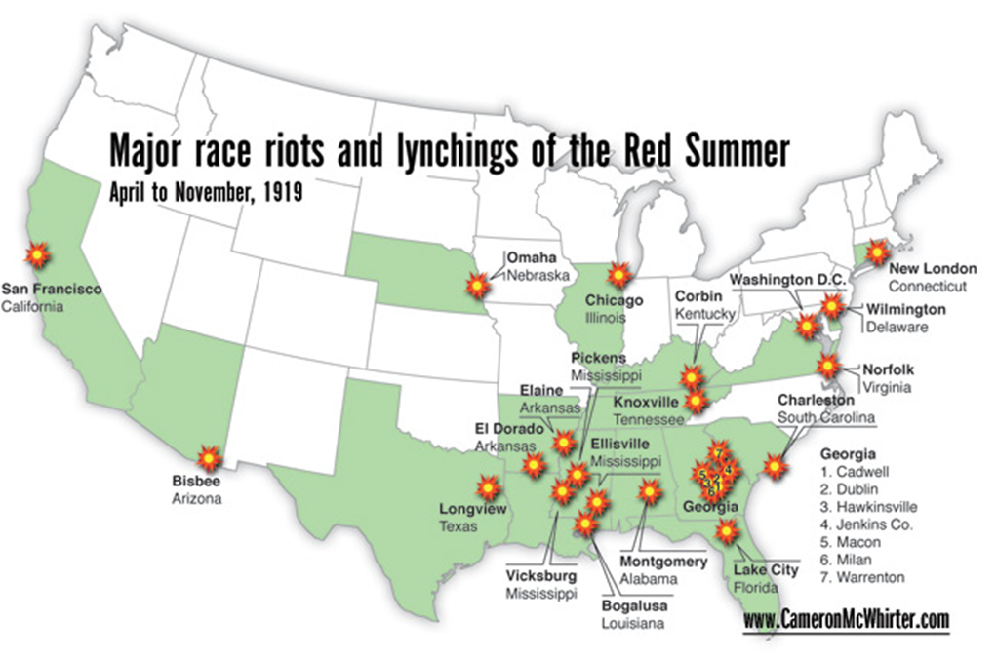

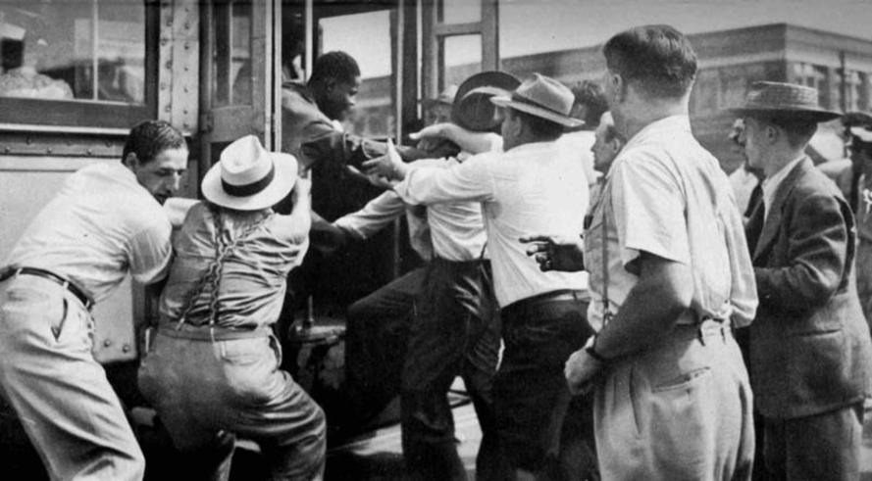

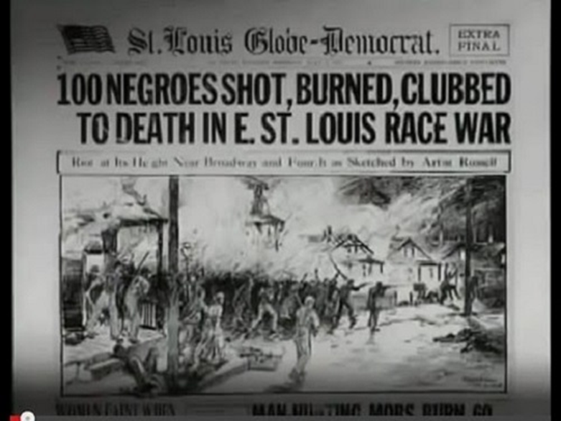
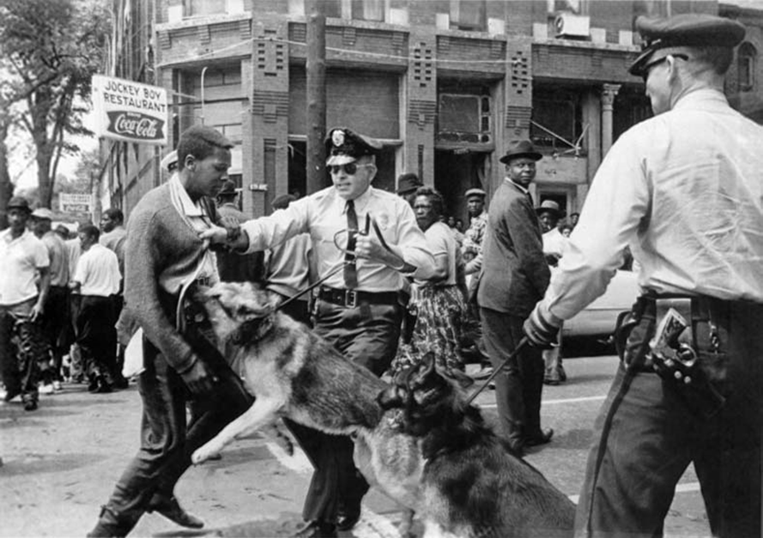

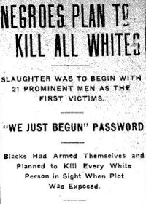

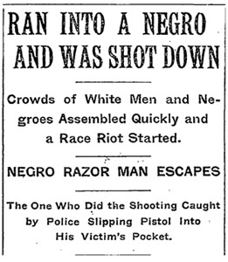

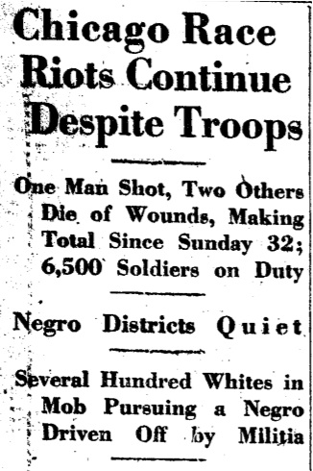
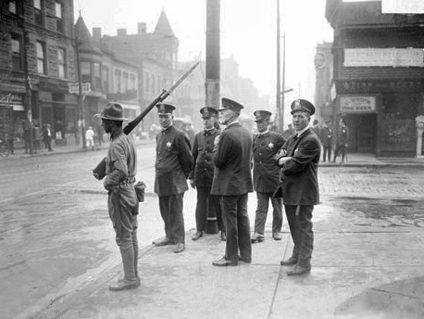
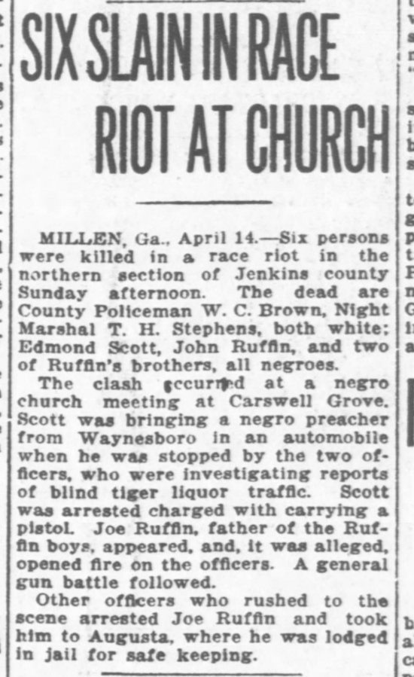

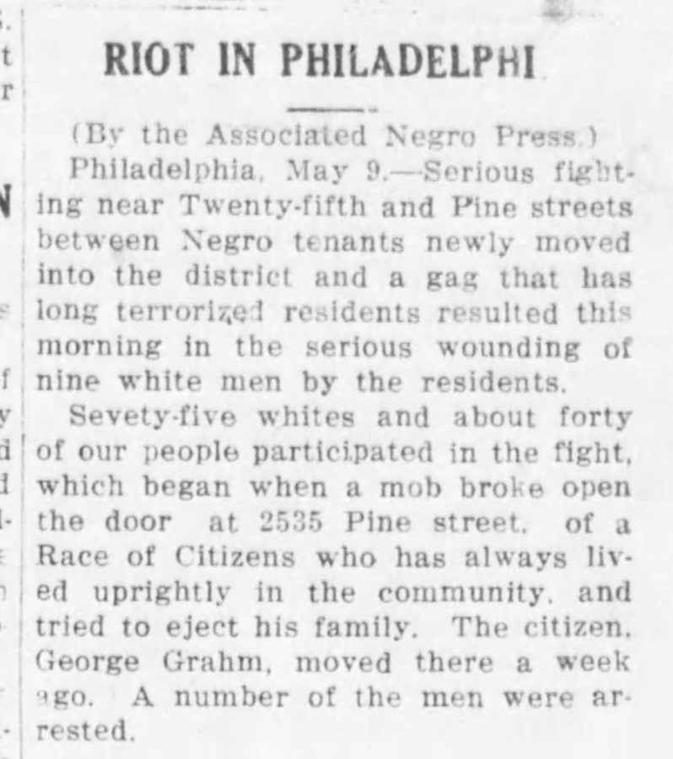

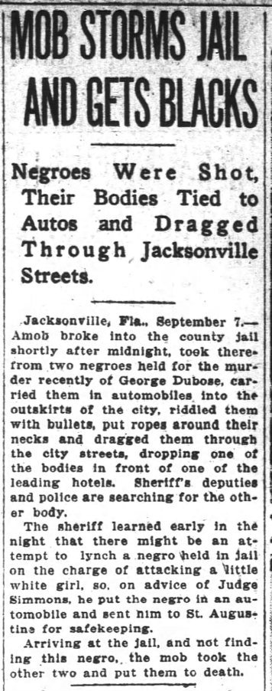

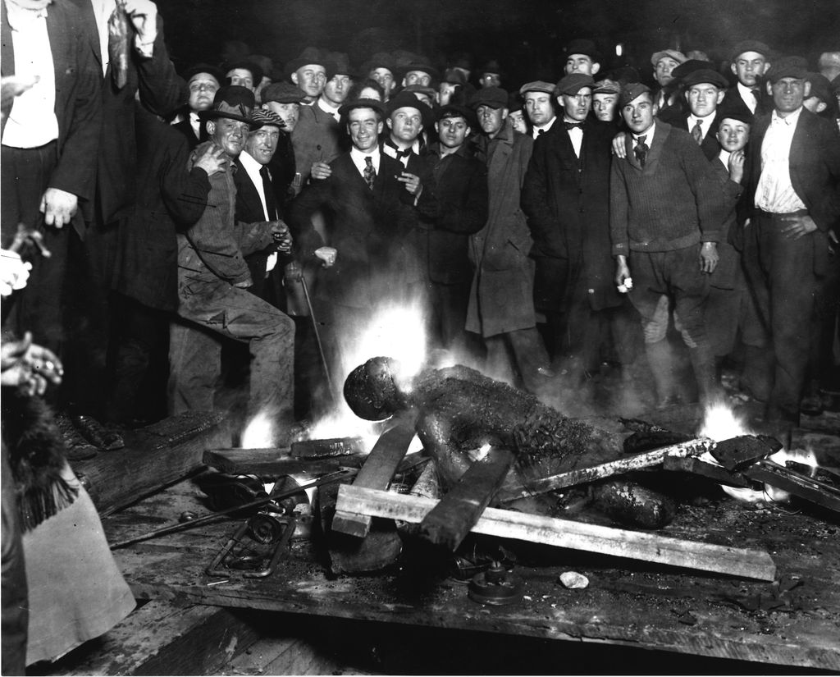

September 28, 1919
Omaha, Nebraska

A crowd in Omaha, Nebraska broke Willie Brown out of jail, hung him from a street post in front of a crowd of hundreds, and then lit him on fire as men, women and children watched. Souvenirs of the lynching were sold to spectators.

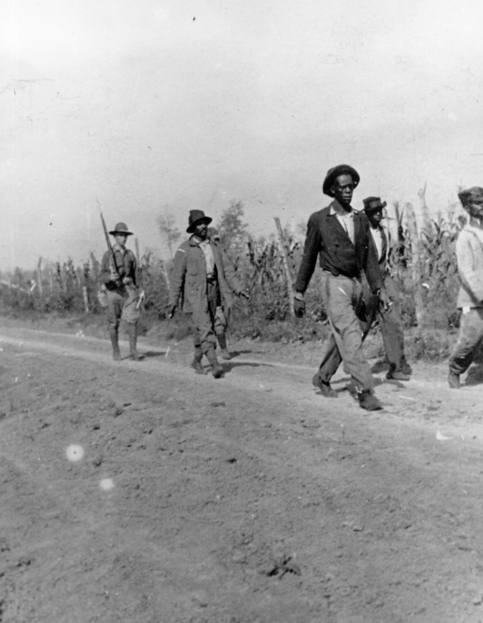
October 1, 1919
Elaine, AR

After blacks holding a union meeting were attacked and began fighting back, all blacks in town were rounded up and had their weapons confiscated, leaving them defenseless. Like Omaha, DC and Chicago, troops were called in to restore peace.

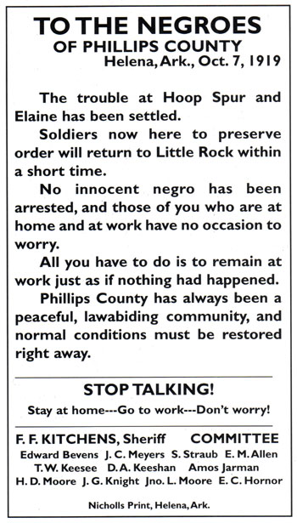
October 7, 1919
Elaine, AR
The Elaine riot, sometimes dubbed the ‘Elaine Masacre’, started between sharecroppers and greedy local landowners. Much more than others, this riot was ultimately about labor and money. The riot itself, and the rounding up of all African American citizens, resulted in a slowing of production. A few days after the riot this advertisement urging blacks to return to work as if nothing happened, appeared in local papers.

