List of documents in this case study about Rwanda:
- Genocide in Rwanda (United Human Rights Council)
- Rwanda: A Historical Chronology (PBS)
- Satellite images of Rwanda before and after the Genocide (Yale)
- Rwanda genocide: 100 days of slaughter (BBC)
- Testimony of Jean-Bosco, a survivor of the Rwandan genocide (UN Prevent Genocide)
- Testimony of Marjorie, a survivor of the Rwandan genocide (UN Prevent Genocide)
- Testimony of Donatha, a survivor of the Rwandan genocide (UN Prevent Genocide)
- Remembering Rwandans Who Followed Their Conscience (NPR)
- Justice and Reconciliation in Rwanda (Outreach Program on the Rwandan Genocide and UN)
- Portriats of Reconcilliation (New York Times)

Genocide in Rwanda
http://www.unitedhumanrights.org/genocide/genocide_in_rwanda.htm
In 1994, Rwanda’s population of seven million was composed of three ethnic groups: Hutu (approximately 85%), Tutsi (14%) and Twa (1%). In the early 1990s, Hutu extremists within Rwanda’s political elite blamed the entire Tutsi minority population for the country’s increasing social, economic, and political pressures. Tutsi civilians were also accused of supporting a Tutsi-dominated rebel group, the Rwandan Patriotic Front (RPF). Through the use of propaganda and constant political maneuvering, Habyarimana, who was the president at the time, and his group increased divisions between Hutu and Tutsi by the end of 1992. The Hutu remembered past years of oppressive Tutsi rule, and many of them not only resented but also feared the minority.
On April 6, 1994, a plane carrying President Habyarimana, a Hutu, was shot down. Violence began almost immediately after that. Under the cover of war, Hutu extremists launched their plans to destroy the entire Tutsi civilian population. Political leaders who might have been able to take charge of the situation and other high profile opponents of the Hutu extremist plans were killed immediately. Tutsi and people suspected of being Tutsi were killed in their homes and as they tried to flee at roadblocks set up across the country during the genocide. Entire families were killed at a time. Women were systematically and brutally raped. It is estimated that some 200,000 people participated in the perpetration of the Rwandan genocide.
In the weeks after April 6, 1994, 800,000 men, women, and children perished in the Rwandan genocide, perhaps as many as three quarters of the Tutsi population. At the same time, thousands of Hutu were murdered because they opposed the killing campaign and the forces directing it.
The Rwandan genocide resulted from the conscious choice of the elite to promote hatred and fear to keep itself in power. This small, privileged group first set the majority against the minority to counter a growing political opposition within Rwanda. Then, faced with RPF success on the battlefield and at the negotiating table, these few power holders transformed the strategy of ethnic division into genocide. They believed that the extermination campaign would reinstate the solidarity of the Hutu under their leadership and help them win the war, or at least improve their chances of negotiating a favorable peace. They seized control of the state and used its authority to carry out the massacre.
The civil war and genocide only ended when the Tutsi-dominated rebel group, the RPF, defeated the Hutu perpetrator regime and President Paul Kagame took control.
Although the Rwandans are fully responsible for the organization and execution of the genocide, governments and peoples elsewhere all share in the shame of the crime because they failed to prevent and stop this killing campaign.
Policymakers in France, Belgium, and the United States and at the United Nations were aware of the preparations for massive slaughter and failed to take the steps needed to prevent it. Aware from the start that Tutsi were being targeted for elimination, the leading foreign actors refused to acknowledge the genocide. Not only did international leaders reject what was going on, but they also declined for weeks to use their political and moral authority to challenge the legitimacy of the genocidal government. They refused to declare that a government guilty of exterminating its citizens would never receive international assistance. They did nothing to silence the radio that televised calls for slaughter. Even after it had become indisputable that what was going on in Rwanda was a genocide, American officials had shunned the g-word, fearing that it would cause demands for intervention.
When international leaders finally voiced disapproval, the genocidal authorities listened well enough to change their tactics although not their ultimate goal. Far from cause for satisfaction, this small success only highlights the tragedy: if weak protests produced this result in late April, imagine what might have been the result if in mid-April the entire world had spoken out.

Rwanda: A Historical Chronology
http://www.pbs.org/wgbh/pages/frontline/shows/rwanda/etc/cron.html
1918 Under the Treaty of Versailles the former German colony of Rwanda-Urundi is made a League of Nations protectorate to be governed by Belgium. The two territories (later to become Rwanda and Burundi) are administered separately under two different Tutsi monarchs.
Both Germany and Belgium turned the traditional Hutu-Tutsi relationship into a class system. The minority Tutsi (14%) are favored over the Hutus (85%) and given privileges and western-style education. The Belgians used the Tutsi minority to enforce their rule.
1926 Belgians introduce a system of ethnic identity cards differentiating Hutus from Tutsis.
1957 PARMEHUTU (Party for the Emancipation of the Hutus) is formed while Rwanda is still under Belgian rule.
1959 Hutus rebel against the Belgian colonial power and the Tutsi elite; 150,000 Tutsis flee to Burundi.
1960 Hutus win municipal elections organized by Belgian colonial rulers.
1961-62 Belgians withdraw. Rwanda and Burundi become two separate and independent countries.
A Hutu revolution in Rwanda installs a new president, Gregoire Kayibanda; fighting continues and thousands of Tutsis are forced to flee. In Burundi, Tutsis retain power.
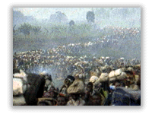
1963 Further massacre of Tutsis, this time in response to military attack by exiled Tutsis in Burundi. Again more refugees leave the country. It is estimated that by the mid-1960s half of the Tutsi population is living outside Rwanda.
1967 Renewed massacres of Tutsis.
1973 Purge of Tutsis from universities. Fresh outbreak of killings, again directed at Tutsi community.
The army chief of staff, General Juvenal Habyarimana, seizes power, pledging to restore order. He sets up a one-party state. A policy of ethnic quotas is entrenched in all public service employment. Tutsis are restricted to nine percent of available jobs.
1975 Habyarimana's political party, the National Revolutionary Movement for Development (Mouvement Revolutionnaire National pour le Developpement, or MRND) is formed. Hutus from the president's home area of northern Rwanda are given overwhelming preference in public service and military jobs. This pattern of exclusion of the Tutsis continues throughout the '70s and '80s.
1986 In Uganda, Rwandan exiles are among the victorious troops of Yoweri Museveni's National Resistance Army who take power, overthrowing the dictator Milton Obote. The exiles then form the Rwandan Patriotic Front (RPF), a Tutsi-dominated organization.
1989 Coffee prices collapse, causing severe economic hardship in Rwanda.
July 1990 Under pressure from Western aid donors, Habyarimana concedes the principle of multi-party democracy.
Oct. 1990 RPF guerillas invade Rwanda from Uganda. After fierce fighting in which French and Zairean troops are called in to assist the government, a cease-fire is signed on March 29, 1991.
1990/91 The Rwandan army begins to train and arm civilian militias known as interahamwe ("Those who stand together") For the next three years Habyarimana stalls on the establishment of a genuine multi-party system with power-sharing. Throughout this period thousands of Tutsis are killed in separate massacres around the country. Opposition politicians and newspapers are persecuted.
November 1992 Prominent Hutu activist Dr. Leon Mugusera appeals to Hutus to send the Tutsis "back to Ethiopia" via the rivers.
February 1993 RPF launches a fresh offensive and the guerillas reach the outskirts of Kigali. French forces are again called in to help the government side. Fighting continues for several months.
August 1993 Following months of negotiations, Habyarimana and the RPF sign a peace accord that allows for the return of refugees and a coalition Hutu-RPF government. 2,500 U.N. troops are deployed in Kigali to oversee the implementation of the accord.
Sept.1993-Mar.1994 President Habyarimana stalls on setting up of power-sharing government. Training of militias intensifies. Extremist radio station, Radio Mille Collines, begins broadcasting exhortations to attack the Tutsis. Human rights groups warn the international community of impending calamity.
March 1994 Many Rwandan human rights activists evacuate their families from Kigali believing massacres are imminent.
April 6, 1994 President Habyarimana and the president of Burundi, Cyprien Ntaryamira, are killed when Habyarimana's plane is shot down near Kigali Airport. Extremists, suspecting that the president is finally about to implement the Arusha Peace Accords, are believed to be behind the attack. That night the killing begins.
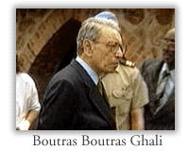
April 7, 1994 The Rwandan Armed Forces (FAR) and the interahamwe set up roadblocks and go from house to house killing Tutsis and moderate Hutu politicians. Thousands die on the first day. U.N. forces stand by while the slaughter goes on. They are forbidden to intervene, as this would breach their "monitoring" mandate.
April 8, 1994 The RPF launches a major offensive to end the genocide and rescue 600 of its troops surrounded in Kigali. The troops had been based in the city as part of the Arusha Accords.
April 21, 1994 The U.N. cuts its forces from 2,500 to 250 following the murder of ten Belgian soldiers assigned to guard the moderate Hutu prime minister, Agathe Uwiliyingimana. The prime minister is killed and the Belgians are disarmed, tortured, and shot and hacked to death. They had been told not to resist violently by the U.N. force commander, as this would have breached their mandate.
April 30, 1994 The U.N. Security Council spends eight hours discussing the Rwandan crisis. The resolution condemning the killing omits the word "genocide." Had the term been used, the U.N. would have been legally obliged to act to "prevent and punish" the perpetrators. Meanwhile, tens of thousands of refugees flee into Tanzania, Burundi and Zaire. In one day 250,000 Rwandans, mainly Hutus fleeing the advance of the RPF, cross the border into Tanzania.
May 17, 1994 As the slaughter of the Tutsis continues the U.N. agrees to send 6,800 troops and policemen to Rwanda with powers to defend civilians. A Security Council resolution says "acts of genocide may have been committed." Deployment of the mainly African U.N. forces is delayed because of arguments over who will pay the bill and provide the equipment. The United States argues with the U.N. over the cost of providing heavy armoured vehicles for the peacekeeping forces.
June 22, 1994 With still no sign of U.N. deployment, the Security Council authorizes the deployment of French forces in south-west Rwanda. They create a "safe area" in territory controlled by the government. Killings of Tutsis continue in the safe area, although some are protected by the French. The United States government eventually uses the word "genocide."
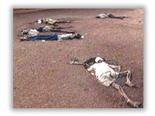
July 1994 The RPF captures Kigali. The Hutu government flees to Zaire, followed by a tide of refugees. The French end their mission and are replaced by Ethiopian U.N. troops. The RPF sets up an interim government of national unity in Kigali. A cholera epidemic sweeps the refugee camps in Zaire, killing thousands. Different U.N. agencies clash over reports that RPF troops have carried out a series of reprisal killings in Rwanda. Several hundred civilians are said to have been executed. Meanwhile the killing of Tutsis continues in refugee camps.
August 1994 New Rwandan government agrees to trials before an international tribunal established by the U.N. Security Council.
November 1994 U.N. Security Council establishes an international tribunal that will oversee prosecution of suspects involved in genocide.
Jan. 5-10 1995 U.N. begins process towards finalizing plans with Zaire and Tanzania that will lead to the return of one and a half million Hutus to Rwanda over the next five months. U.N. Security Council refuses to dispatch an international force to police refugee camps.
Feb. 19, 1995 Western governments, including the U.S. ($60 million), pledge $600 million in aid to Rwanda.
Feb. 27, 1995 U.N. Security Council urges all states to arrest people suspected of involvement in the Rwandan genocide.
Mid-May 1995 Tensions increase between the United Nations and the Rwandan government; the government growing resentful of the lack of international financial aid
June 10, 1995 U.N. Security Council unanimously agrees to cut by more than half the number of U.N. troops in Rwanda after a direct request from the Rwandan government to withdraw U.N. forces.
July 1995 More than 720,000 Hutu refugees around Goma refuse to return to Rwanda.
August 1995 U.N. Security Council lifts arms embargo until September 1, 1996.
Sept. 20, 1995 At a Mass in Nairobi, Pope John Paul II urges an end to the bloodshed in Rwanda and Burundi.
Dec. 12, 1995 United Nations Tribunal for Rwanda announces first indictments against eight suspects; charges them with genocide and crimes against humanity.
Dec. 13, 1995 U.N. Security Council extends its peacekeeping mission for three more months and agrees to reduce the number of troops.
Nov. 1996 Mass repatriation from Zaire begins; the Rwandan government orders a moratorium on arrests of suspected genocide perpetrators.
December 1996 Trials begin for Hutus involved in 1994 genocide.
Mid-Dec. 1996 Tanzania closes refugee camps and repatriates Rwandans, bringing the total to over one million.
January 10, 1997 First case in the Rwandan genocide trials comes before the International Criminal Tribunal in Arusha, Tanzania. The case is against Jean Paul Akayesu, a local government official accused of ordering mass killings in his area.
January 17, 1997 In a Rwanda court, Francois Bizimutima becomes the third Hutu convicted and sentenced to death for his role in genocide.
January 13-17, 1997 A woman who testified against Jean Paul Akayesu is murdered along with her husband and seven children by Hutu extremists.
January 22, 1997 Over 300 are killed in an attempt by the Rwandan army to capture Hutu insurgents responsible for killings in Northwestern Rwanda, including the murder of the three Spanish aid workers. U.N. officials state many victims are recently returned refugees who witnessed the 1994 genocide and are potential trial witnesses.
February 2, 1997 In Gikongoro, Rwanda, Venuste Niyonzima is the first man tried locally for crimes against humanity in his own village. A U.N. Human Rights official in Rwanda expresses "serious concern" over the lack of lawyers and adequate defense for those accused of participation in the 1994 genocide. Canadian priest, Guy Pinard, a witness to the 1994 genocide, is murdered by Hutu terrorists while saying mass.
February 4, 1997 Five human rights observers are killed in an ambush in Cyangugu, Rwanda. The murders are viewed as an effort by Hutu terrorists to get foreign observers out of the country. All human rights observers in Cyangugu, Kibuye, and Gisenyi are withdrawn by the U.N. to Kigali.
February 12, 1997 United Nations watchdog agency criticizes the management of the Rwandan genocide trials.
February 14, 1997 United Nations Secretary General Kofi Annan asks the five permanent security council members to look into reports that the Zairean army is providing arms to Rwandan Hutus in an Eastern Zaire refugee camp.
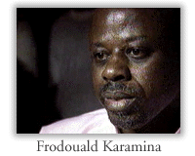
February 14, 1997 Vincent Nkezazaganwa, a Rwandan Supreme Court Justice, is gunned down by uniformed gunmen at his house. Frodouald Karamina, leader of a Hutu extremist political movement, is sentenced to death for his involvement in the genocide. Karamina is believed to be one of the leaders and organizers of the genocide, having coined the slogan "Hutu Power" and made many racist radio broadcasts urging mass murder. Karamina expressed no remorse for the part he had played in the genocide. Karamina was born a Tutsi and assimilated himself as a Hutu only later in life.
February 19-20, 1997 Four prominent Rwandans accused of genocide appear in court for the first time.
February 23, 1997 Israel Nemeyimana is the first defendant in the genocide trials to be found not guilty. Authorities state there was a lack of evidence and witnesses.
February 26, 1997 Citing mismanagement and inefficiency, U.N. Secretary-General Kofi Annan fires the chief administrator Andronico Adede, and deputy prosecutor Honore Rakoromoanana in the Rwanda criminal trials. Agwu Okali of Nigeria is appointed new chief minister. By this date, the court has indicted 21 suspects.
February 28, 1997 Virginia Mukankusi is sentenced to death for her participation in the genocide.
December 1999 A leader of a Hutu militia that helped lead the genocide, businessman Georges Rutaganda, is found guilty of genocide, crimes against humanity, and sentenced to life in prison. He is the sixth person found guilty since the tribunal began hearings in Arusha, Tanzania.

Satellite Maps of Rwanda Before and After the 1994 Genocide
http://gsp.yale.edu/case-studies/rwanda-genocide-project/maps-satellite-images/satellite-maps-rwanda-and-after-1994

Rwanda before the Genocide
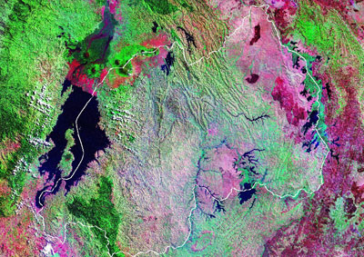
Mosaic of Landsat TM images of Rwanda from 1990. The country border is shown in white. Dense forest areas surrounding the Parc National des Volcans and the Foret de Nyungwe appear green in the image, north and south of Lake Kivu, respectively.

Rwanda after the Genocide
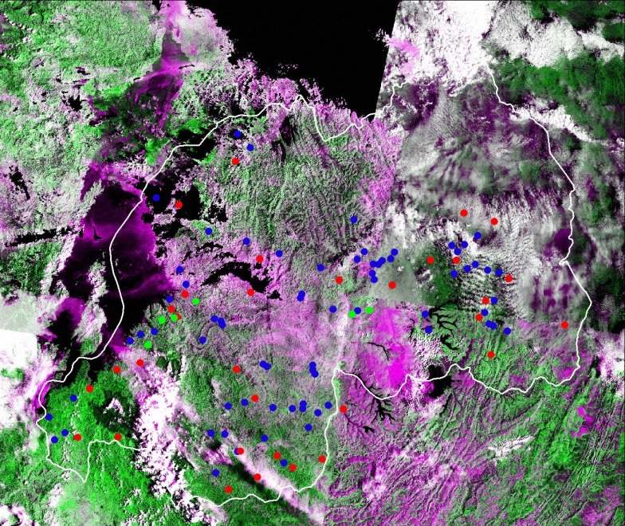

This is a 1995 Landsat TM mosaic for the country of Rwanda after the genocide. The national border is shown in white.
Genocide sites:
- Mass Graves (“lieus publics”) are shown in blue
- Memorials (“lieux de culte”) in red, and
- Resistance sites (“collines de résistance”) in green.

Rwanda genocide: 100 days of slaughter
- 7 April 2014
http://www.bbc.com/news/world-africa-26875506
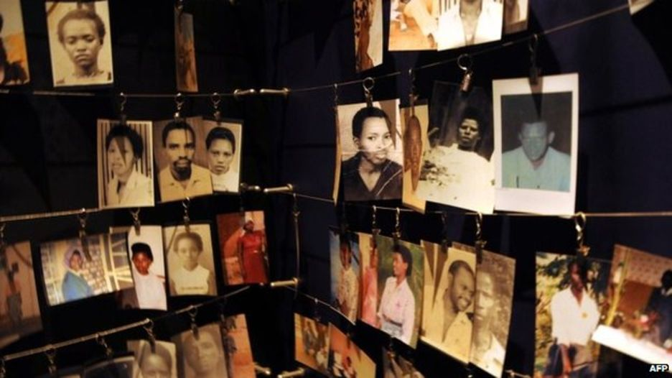
There are numerous memorials around Rwanda to those killed in the genocide

In just 100 days in 1994, some 800,000 people were slaughtered in Rwanda by ethnic Hutu extremists. They were targeting members of the minority Tutsi community, as well as their political opponents, irrespective of their ethnic origin.
Why did the Hutu militias want to kill the Tutsis?
About 85% of Rwandans are Hutus but the Tutsi minority has long dominated the country. In 1959, the Hutus overthrew the Tutsi monarchy and tens of thousands of Tutsis fled to neighbouring countries, including Uganda. A group of Tutsi exiles formed a rebel group, the Rwandan Patriotic Front (RPF), which invaded Rwanda in 1990 and fighting continued until a 1993 peace deal was agreed.
On the night of 6 April 1994 a plane carrying then President Juvenal Habyarimana, and his counterpart Cyprien Ntaryamira of Burundi - both Hutus - was shot down, killing everyone on board. Hutu extremists blamed the RPF and immediately started a well-organised campaign of slaughter. The RPF said the plane had been shot down by Hutus to provide an excuse for the genocide.
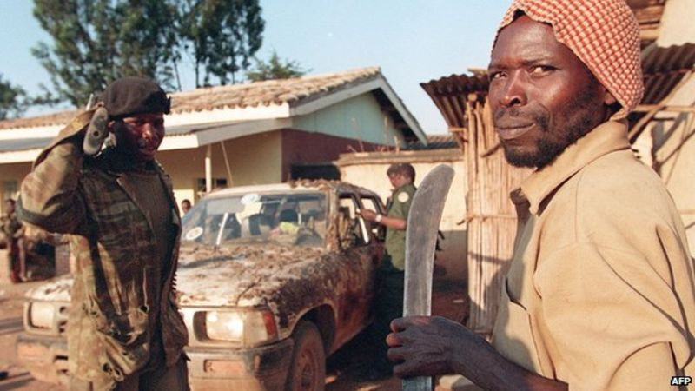
How was the genocide carried out?
With meticulous organisation. Lists of government opponents were handed out to militias who went and killed them, along with all of their families. Neighbours killed neighbours and some husbands even killed their Tutsi wives, saying they would be killed if they refused. At the time, ID cards had people's ethnic group on them, so militias set up roadblocks where Tutsis were slaughtered, often with machetes which most Rwandans kept around the house. Thousands of Tutsi women were taken away and kept as sex slaves.
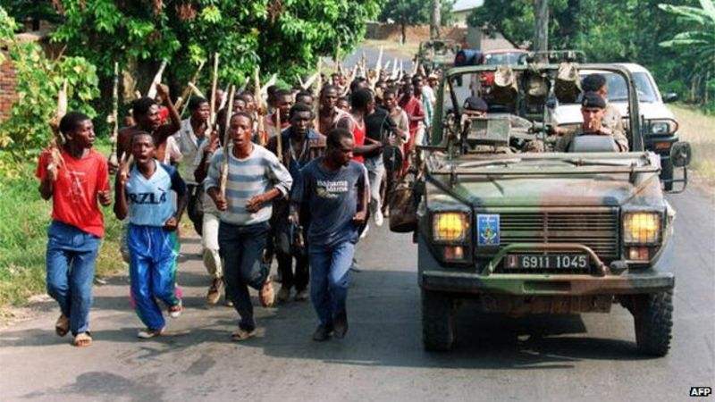
French forces in Rwanda were accused of not doing enough to stop the killing
Did anyone try to stop it?
The UN and Belgium had forces in Rwanda but the UN mission was not given a mandate to stop the killing. A year after US troops were killed in Somalia, the US was determined not to get involved in another African conflict. The Belgians and most UN peacekeepers pulled out after 10 Belgian soldiers were killed. The French, who were allies of the Hutu government, sent a force to set up a supposedly safe zone but were accused of not doing enough to stop the slaughter in that area. Rwanda's current president has accused France of taking part in the massacres - a charge denied by Paris.
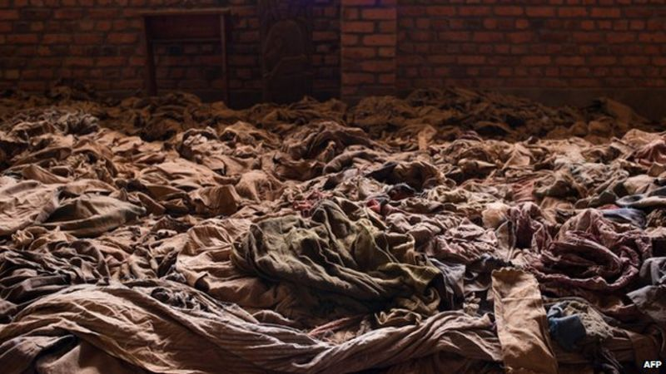
Clothes of people killed in the Nyamata Church, which has been turned into a memorial

Why was it so vicious?
Rwanda has always been a tightly controlled society, organised like a pyramid from each district up to the top of government. The then governing party, MRND, had a youth wing called the Interahamwe, which was turned into a militia to carry out the slaughter. Weapons and hit-lists were handed out to local groups, who knew exactly where to find their targets.
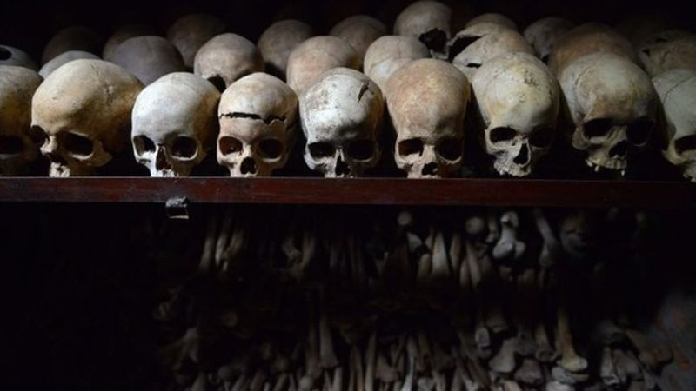
The skulls of some of those killed in Nyamata church

The Hutu extremists set up radio stations and newspapers which broadcast hate propaganda, urging people to "weed out the cockroaches" meaning kill the Tutsis. The names of those to be killed were read out on radio. Even priests and nuns have been convicted of killing people, including some who sought shelter in churches.
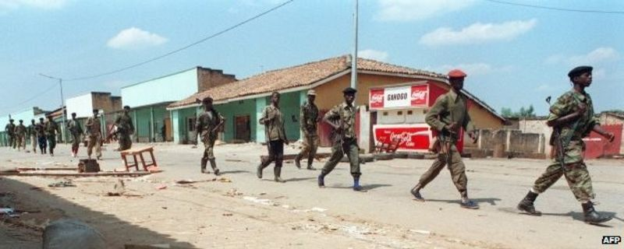
The Uganda-backed RPF took the capital in July, ending the killing of Tutsis

How did it end?
The well-organised RPF, backed by Uganda's army, gradually seized more territory, until 4 July, when its forces marched into the capital, Kigali. Some two million Hutus - both civilians and some of those involved in the genocide - then fled across the border into DR Congo, at that time called Zaire, fearing revenge attacks.
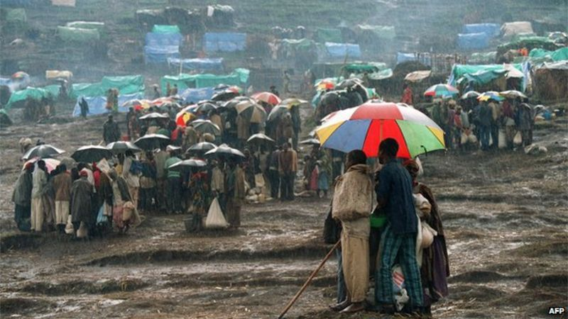
Some two million people fled into DR Congo (then Zaire)

Human rights groups say the RPF killed thousands of Hutu civilians as they took power - and more after they went into DR Congo to pursue the Interahamwe. The RPF denies this. In DR Congo, thousands died from cholera, while aid groups were accused of letting much of their assistance fall into the hands of the Hutu militias.
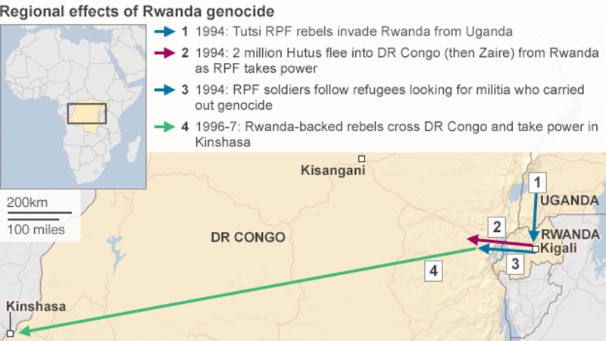
What happened in DR Congo?
The genocide in Rwanda has directly led to two decades of unrest in DR Congo, which have cost the lives of an estimated five million people. Rwanda's government, now run by the RPF, has twice invaded DR Congo, accusing its much larger neighbour of letting the Hutu militias operate on its territory. Rwanda has also armed local Congolese Tutsi forces. In response, some locals have formed self-defence groups and the civilians of eastern DR Congo have paid the price.
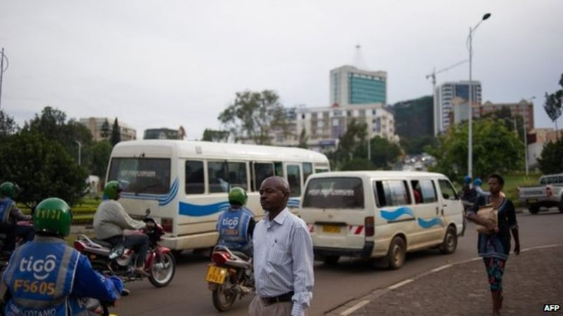
Rwanda is one of Africa's fast-growing economies

What is Rwanda like now?
RPF leader and President, Paul Kagame, has been hailed for overseeing rapid economic growth in the tiny country. He has also tried to turn Rwanda into a technological hub and is very active on Twitter. But his critics say he does not tolerate dissent and several opponents have met unexplained deaths. Almost two million people were tried in local courts for their role in the genocide and the ring-leaders at a UN tribunal in neighbouring Tanzania. It is now illegal to talk about ethnicity in Rwanda - the government says this is to prevent more bloodshed but some say it prevents true reconciliation and is just putting a lid on tensions, which will only boil over again in the future.

Testimony of Jean-Bosco, a survivor of the Rwandan genocide
http://www.un.org/en/preventgenocide/rwanda/testimonies/pdf/25%20-%20Jean-Bosco%202009.pdf
We were a large family at home; my extended family. When the genocide started, I was only
six years old. The killers came and first killed my parents and an uncle. Another uncle of mine
threw me over the hedge into the neighbour's yard and that is how I survived the first
encounter with the killers. I heard my parents scream as they were hacked down with
machetes and udufuni (small hoes). I escaped to relatives who hid me. I later learned that they
had left my grandmother but came back later and killed her along with two aunts.
We hid for some time with neighbouring kids. The interahamwe chased us out of hiding –
together we requested to pray before they killed us. In the middle of the prayer I ran for my life
and the killers took off after me. Since I had a clear lead on them, I fell into a deep ditch that
had been dug specifically to throw the bodies of the slain Tutsis ­ I was out of their sight. They
did not know where I was so they decided to leave. One of my younger uncles had seen me
falling into the pit and he came to my rescue; he had had his entire family killed. He told me
that he had nowhere to take me since he was on the run himself and I decided to try seek
sanctuary with a distant relative. I learned later my uncle was killed too.
I hid until the RPF invaded. One of the liberating soldiers looked after me, his family had been
killed alongside mine. My maternal grandmother learnt I had survived and then looked after
me. But in 1998 she died too. We had been living together just the two of us. She had no other
family as they had all been killed in the genocide. I was the only surviving relative and upon
her death, another distant uncle who had survived, took me in. We are still living together now.

While at my grandmother's, I did not have money to pay for school fees. When I moved in with
my uncle, he had difficulty to pay my fees. I was always being chased for payment, which
affected my marks. I was lucky though to get a place at secondary school with support from
the Survivors Fund, who also helped pay for books and other materials.
They recently brought together young genocide survivors like myself, which helped me to open
up and to talk about my past. I came home happier and more positive about things.

I know the people who killed my family; my parents, three brothers and a sister. I would forgive
them because there is nothing I can do now to bring them back; but it also depends on the way
they ask for this forgiveness.
When I grow up I would like to be a construction engineer; my ultimate plan is to study hard
and develop myself. I would also like to see a more stable Rwanda that is no threat to children;
a Rwanda where there will be no more genocide.

Testimony of Marjorie, a survivor of the Rwandan genocide

http://www.un.org/en/preventgenocide/rwanda/testimonies/pdf/34%20-%20Marjorie%202009.pdf

I was the ninth of ten children in my family.

The killings began on 11th April 1994 in our home area. There was much noise and
shouting so we decided to leave the house, but were ordered to go to the district
offices. Our house was then destroyed.

At the district office, we spent then next three days without food or water. The
interahamwe were in control and closed the water tap so that we would die of thirst. If
someone tried to leave to look for food, they were killed immediately. On the third day, at half four in the morning, two trucks full of interahamwe and soldiers carrying
grenades and guns arrived. Then the massacre started. Some men among us started to
defend themselves using stones but because we were fighting against guns and
grenades, it was obvious that there was no way they could win. Many of us were killed.
My father, three brothers, two cousins and an uncle were killed at that moment. The
children, and their mothers, lay on the floor to protect themselves against the
explosions of the grenades but the interahamwe used machetes to kill them.

There were so many of us, that they did not have enough bullets to finish the job so
they returned home. Along with the other survivors, we decided to flee to another
district. We had to cross a lake to get there but my father’s boat, that we were hoping to
use, had been destroyed. We sat down because we couldn’t do anything else, as death
was everywhere. Some of my companions swam for it. Others wanted to kill themselves
and drown in the lake.

When we heard the shouts of interahamwe, my cousin and I ran. Because we knew our
home so well, it was easy to find somewhere to hide. But the people who were
swimming were followed by interahamwe in their boats. The interahamwe killed many
people in the lake using machetes. The lake became a pool of blood. It was terrible. I
saw many people being killed.

We finally reached a house where we asked for refuge. The woman there was
frightened because she was also a Tutsi so the house was already a target. We could
not stay there, so spent three days in the bush.

The woman would come to see us, and finally took us to a Christian lady who was her
neighbour. We hid there. Once the killers came to check but we knew they were coming
beforehand so went to hide near the house in a plantation.

After a time, the Christian lady came and told us that my mother had just been killed
with an axe. My young sister was with her and had escaped death, but had been injured
in the head and she was unconscious. They buried my mother and left my sister beside
the grave because she was not yet dead. She was four years old and she spent three
days in those conditions.

She survived. The wind woke her up. She went to ask refuge from the neighbours. But
they refused. She then came to the house whose owners were related to the people
who were hiding me. They sent a message that I should come to their house.

When I found my sister, I felt a deep hurt in me. She used to cough and spit out meat.
She couldn’t eat, or speak but she recognised me. A lot of the time I just wept. We
heard news of our family members who had been killed.
The people who hid us were Adventist Christians and they looked after my sister well, but they couldn’t believe she would get better or survive.
The killers would check from house to house looking for people to kill. We had to hide in
the bush near the house from 5am to 8pm. During the night we could return to the
house. We lived in these conditions until the month of June.

The war was advancing. Our protectors fled and left us in the bush. The rain soaked us.
We were hungry and my sister cried a lot. I wanted to die and I decided to commit
suicide in the river. I left my sister alone and went towards the river. But death didn’t
want me and I found myself alive. I returned to the bush where I had left my sister.

Two chiefs of the interahamwe, whose names I know, were the ones who gave the
order to destroy our house and kill the people of our village. They were much feared in
the region. They discovered our hiding place and took us to their house. The men raped
me whenever they wanted to, until the war finished. I was told later that they were killed
while fighting.

Our brother survived too. He returned home to find out if any of our family had survived. That was in 1995. We went to live with him in Kigali. I did not return to school until 1997, because until then I was looking after my little sister who couldn’t speak because of
trauma. In 1999 I graduated to secondary school. When I was about to finish the
secondary school, I too became sick with trauma. I had heart problems and I stopped
studying.

During that time, I walked by foot from Kigali to our home village. My brother didn’t
know where I had gone. I was like a crazy person. They looked for me and found me,
then took me to my cousin’s house where I stayed sick for a period of time.

After getting better, I came back to my brother’s house. My brother had a low paid job, but because of my illness we were falling into debt. Things were getting desperate. I
continued to feel ill. I was then tested for HIV. I was positive. My brother had to sell
some of the house contents to pay for my treatment.
I have now stopped going to school. I have many problems that are beyond my belief.
When my heart problems started, I received treatment. I now feel a little bit better.

But sometimes we don’t have anything to eat. However a neighbour takes pity on us
and gives us food to cook. Surviving has been the most difficult challenge for us.

Testimony of Donatha, a survivor of the Rwandan genocide
http://www.un.org/en/preventgenocide/rwanda/testimonies/pdf/38%20-%20Donatha%202009.pdf

The night the president died, I heard that two of our neighbors whose wives were Tutsis
were killing them and their children. These men were saying that even their children
had the blood of snakes. One of the two men was dividing his children into two parts:
those who were going to stay with him and those who were going with their mother. The
children who looked like Tutsis were “of his wife” and those who were like Hutus were
going to stay with him.

The next morning, we saw interahamwe with many people. They were saying they were
taking them to Arusha. After three days, we saw them coming to our house. There
were twelve of us in that house. They asked us to line up outside and asked for our
papers. Some of us did not give them our papers because our ethnic group was written
on them. They asked me for my papers and I replied that I was not yet eighteen, the
age to have papers. They did not agree but they left me alone. Among us there were
some young boys. They took them and we that was the last time we saw them.
After several days, they came back. They told us that they would come back to kill us
later because they wanted to kill the boys first. They said that the girls and women had
their destiny.

We had more troubles when the old lady with us had a stroke. Her arms and legs were
paralyzed. We had to take her to the hospital, but it was very difficult as the roads were
full of interahamwe. We used the short paths and managed to return safely.
On May 5, we heard many people singing in the road. They were wearing banana
leaves and when they arrived at our house, they ordered us outside. I asked God to
receive us into his kingdom. They asked the old lady to go back into the house and
sleep. They followed her in, covered her with all the clothes that were in the room, poured petrol on her and set her alight. I tried to run away, but at a roadblock I was
caught by two men. They asked me if I was from the house. I said no, but they
nevertheless brought me back, raped me and locked me in the toilet. When they left, I
escaped and went to the neighbors.
I met one of the girls there from my house. We waited for the owner of that house and
when he came, he threw us out, telling us that he could not hide Tutsis ­ that we were
damned by the whole world. We were forced to leave. The girl I was with told me that
she knew someone who could hide us.

When we arrived, they hid us but eventually their neighbors found out that they were
hiding Tutsis. They came and told us that we should leave because they did not want to
be killed too. We refused and told them we were going to be killed anyway and it was
better that they kill us themselves. They took us to an interahamwe nicknamed Ninja
who asked us if we had brothers. We said no but he told us that he was going to show
them to us.
We arrived at a place where there were many people that were wounded by machetes
and they were in agony because of the pain. He told us that they were our family. He
asked us to go and tell “our family” to shut up. We did not move and he was very
angry, and said he would punish us. He took us to a house near the roadblock and
invited other men to join him in raping us. He said he was tired and he returned us to
the house of the family that had taken us to him.

He said he would come to see us later. We tried to help them in domestic duties so they
would change their mind, and keep us. In the meantime, interahamwe made a list of
they would be killing the remaining Tutsis. We were sixth on the list and we knew they
would come for us on Sunday.

On that eve, we were rescued by soldiers of the Rwandan Patriotic Army. The family I
was with said that, as nobody was remaining in my family, I had to stay with them. I
later found that out of my five siblings, only one of my sisters survived. The family
forced me to do many things such as their domestic duties.

Later, I found a friend of mine who had also been a neighbor. I could not believe my
eyes, because I thought all the Tutsi had been exterminated. She told me that she was
living with her brother. I decided to follow her. She told me about my family and my
sister who had survived. I started crying but she told me that I had to remain calm
because it was the same for everybody, including her. She told me how my family was
killed; they were trying to flee to Burundi but they were killed on the road with many
other people. Only a few among them, including herself, made it to Burundi. With her
brother they helped me to find my uncle who had survived too. I am still living with him
and I returned to school in July 1995.

Remembering Rwandans Who Followed Their Conscience
April 8, 20144:28 PM ET
Heard on All Things Considered
http://www.npr.org/sections/parallels/2014/04/08/300508669/remembering-rwandans-who-followed-their-conscience

GREGORY WARNER

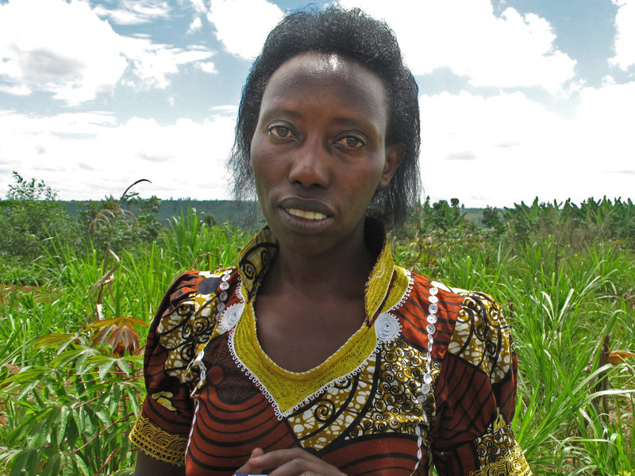i
Olive Mukankusi, a 42-year-old Hutu woman, stands near the banana beer pit where she says she hid three Tutsi people in 1994. Her husband spent 12 years in prison before they could convince the authorities he'd been a protector, and not a killer, of Tutsis.
Gregory Warner/NPR
Olive Mukankusi lives in a two-room house with mud walls and a dirt floor in a village called Igati, in eastern Rwanda's Rwamagana province. To get there, you have to drive about 30 minutes down a dirt road.
It's there, in her home, on a warm and sunny afternoon, that she tells a story that she's only told three times in 20 years: first to a local judge, then to an American genocide researcher — and now.
The story begins in April 1994, at the start of the genocide of Tutsis carried out by Hutu militias called Interhamwe. As she walked down a road of recently torched houses, Mukankusi, a Hutu, met two Tutsi girls, age 15 and 17. The girls had been her neighbors before she married and moved away.
"They seemed to be confused, not knowing where to go," Mukakusi remembers. "They had a few things folded in their hands."
The girls told her to go back home.
And she told them: "Come with me."
Mukankusi, now 42, knew the act of hiding Tutsis was punishable by death. But in that moment, it didn't matter.
"I knew these girls. I saw how much pain they were in," she says. "I was ready to die with them, whatever would happen to me or my family."
Mukankusi also brought another neighbor, a 55-year-old woman. She hid them behind her house, in a pit for making banana beer. Then her husband came home.
"Of course I was a little bit worried that he might give them in, like most other men were doing," Mukankusi says. "But he saw that I had loved these people. If he betrayed these people, he would have betrayed me as well."
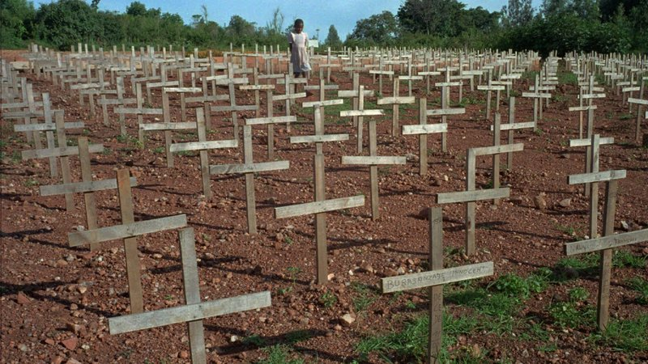
A young Rwandan girl walks through Nyaza cemetery outside Kigali, Rwanda, in 1996, where thousands of victims of the 1994 genocide are buried. The three months of ethnic violence left 800,000, mostly Tutsis, dead.
Ricardo Mazalan/AP
The Rwandan genocide — three months of brutal ethnic violence that pitted majority Hutus against the minority Tutsis — proceeded quickly in some parts of the country, more slowly in others.
In Mukankusi's village, the Hutu militias killed only men at first, saying they wished to save the women as future wives. But a couple of weeks later, they started killing women, too. A huge gang of militiamen came to her house and dragged out the two young girls and the older woman. (A neighbor had tipped them off.) They marched the four, including Mukankusi, to a killing site by the river.
All might have been lost if not for a habit that Mukankusi had picked up. Lacking a bank account and worried about thieves, she kept all of her cash sewn up in the kanga fabric of her dress. That fateful April, she'd just sold her harvest, and had enough money to last her family the next six months. It was 20,000 francs — worth about $140 at the time.
"When they saw the money, they were very happy," she says. "They didn't let me keep even some of it. They took it and forgot whatever was happening."
They left — she now assumes, to hit the bars — and left the women behind. Four days later, the Tutsi army, led by the current president of Rwanda, arrived and chased off the Interhamwe militias. The soldiers rescued the Tutsis who had survived, including the girls that Mukankusi and her husband had protected.
Then they put her husband in prison, where he would stay for the next 12 years. They said there wasn't yet evidence to distinguish killer from protector.
At the office of the Aegis Trust in Kigali, Rwanda's capital, dozens of young Rwandans wearing headphones are transcribing the testimonies of survivors, perpetrators and rescuers. Deputy Director Yves Kamuronsi says that featuring the testimonies of these rescuers is more important today than ever.
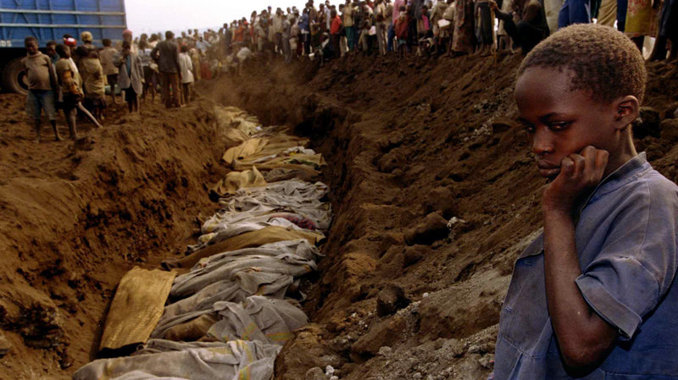i
A Rwandan refugee girl stares at a mass grave where dozens of bodies were laid to rest in July 1994.
Corinne Dufka/Reuters/Landov
"It's now 20 years after genocide," Kamuronsi says. "And in every commemoration, every movie, we see stories of survivors, we see stories of perpetrators. We see less stories of rescuers."
Those stories are particularly important, he says, for the more than half of the country's population born after the genocide, to see that not every Rwandan played their ethnically assigned role of killer or victim.
Yet most of Rwanda's rescuers are not officially recognized. A government program to give rescuers an official "thank you" was put on hold after canvassing just 20 percent of the country and identifying fewer than 300 of them. In comparison, Yad Vashem — the Holocaust memorial and research center — was seeking out the stories of German rescuers, the "righteous among nations," by the 1950s — less than 10 years after the war.
Godleaves Mukamunana is another rescuer from Igati village. She says she has been ostracized by some Hutu neighbors.
"When they talk to me about rescuing, they ask me, 'Well, you rescued Tutsis, if something bad happened, do you think they would rescue you?'" Mukamunana says. "And I always tell them, 'Yes they would. I have no doubt about it.'"
You're no longer one of us, those Hutus say.
And rescuers haven't been embraced by all Tutsis either. While Olive Mukankusi's husband was in prison, a local Tutsi leader claimed part of her land. They're still fighting over it in court.
And Godleaves Mukamunana says during the years her husband was in prison, her own children questioned her deed.
"They would ask me, 'If you hid people at home, why is it they decided to take daddy?'" she recalls. "I told them, 'You don't have to worry, because the act we did, God is going to reward us, the right way.'"
In 2007, Mukankusi and Mukamunana got the chance to tell their stories, for the first time, in local courts called gacaca. Neighbors confirmed the stories and their husbands were quickly released. Today, the family is making up for that lost decade of earnings. Mukamunana would like to send her bright, middle daughter to college, but she's coming to realize she'll never afford it.
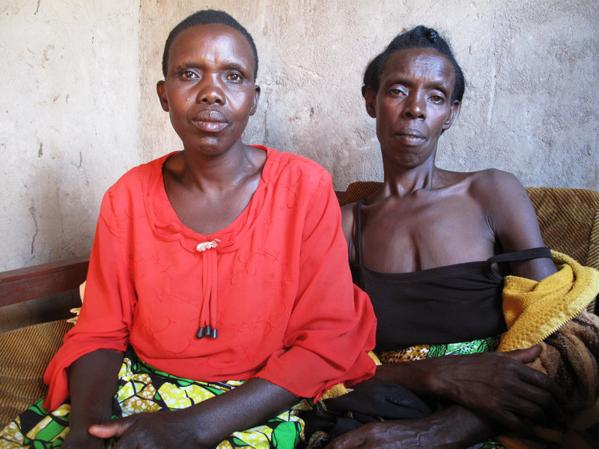i
Godleaves Mukamunana, left, hid Domitil Mukakumuranga, in her house for weeks so that Hutu militias wouldn't kill her. "Seeing her alive is the best thing," Mukamunana says. "That kind of relationship we have is priceless. The fact that I don't have more like her --” those who were killed — that's what's hurting."
Gregory Warner/NPR
After all that — as her daughter asked her before — does she have second thoughts? Had she and her family fled earlier, instead of staying to help her Tutsi neighbors, her husband might not have been rounded up and arrested. He might have avoided those 12 years in jail.
"That cannot stop me from doing it again!" she says emphatically. "Actually, I'd do it double. I'd do it again and again and again. Because now I see the outcome. I can talk with anyone, with no problem."
Her reward, she says, is her clear conscience.

Justice and Reconciliation Process in Rwanda
http://www.un.org/en/preventgenocide/rwanda/about/bgjustice.shtml
During the 1994 genocide in Rwanda, up to one million people perished and as many as 250,000 women were raped, leaving the country’s population traumatized and its infrastructure decimated. Since then, Rwanda has embarked on an ambitious justice and reconciliation process with the ultimate aim of all Rwandans once again living side by side in peace.
Justice after the genocide
In the years following the genocide, more than 120,000 people were detained and accused of bearing criminal responsibility for their participation in the killings. To deal with such an overwhelming number of perpetrators, a judicial response was pursued on three levels:
- the International Criminal Tribunal for Rwanda,
- the national court system, and
- the Gacaca courts.
The International Criminal Tribunal for Rwanda
The International Criminal Tribunal for Rwanda (ICTR) was established by the United Nations Security Council on 8 November 1994, and formally closed on 31 December 2015. The Tribunal had a mandate to prosecute persons bearing great responsibility for genocide and other serious violations of international humanitarian law committed in Rwanda between 1 January and 31 December 1994.
The first trial started in January 1997, and by December 2012, the Tribunal had completed the trial phase of its mandate. During its two decades of work in Arusha, Tanzania, the ICTR sentenced 61 people to terms of up to life imprisonment for their roles in the massacres. Fourteen accused were acquitted and 10 others referred to national courts. The ICTR held 5,800 days of proceedings, indicted 93 people, issued 55 first-instance and 45 appeal judgements, and heard the “powerful accounts of more than 3,000 witnesses who bravely recounted some of the most traumatic events imaginable during ICTR trials,” ICTR President Judge Vagn Joensen told the UN Security Council in December 2015.
The Mechanism for International Criminal Tribunals (MICT), set up by the Security Council in December 2010, took over the remaining tasks of the ICTR – and of the International Criminal Tribunal for the former Yugoslavia (ICTY). The Mechanism plays an essential role in ensuring that the ICTR’s closure does not leave the door open to impunity for the remaining fugitives. The ICTR branch of the Mechanism began to function on 1 July 2012.
The Tribunal has issued several landmark judgments, including:
- In the first judgment by an international court on genocide, a former mayor, Jean-Paul Akayesu, was convicted in 1998 of nine counts of genocide and crimes against humanity. The judgment was also the first to conclude that rape and sexual assault constituted acts of genocide insofar as they were committed with the intent to destroy, in whole or in part, a targeted group.
- The conviction of the prime minister during the genocide, Jean Kambanda, to life in prison in 1998 was the first time a head of government was convicted for the crime of genocide.
- The Tribunal’s "Media Case" in 2003 was the first judgment since the conviction of Julius Streicher at Nuremberg after World War II to examine the role of the media in the context of international criminal justice.
The national court system
Rwanda’s national courts prosecute those accused of planning the genocide or of committing serious atrocities, including rape. By mid-2006, the national courts had tried approximately 10,000 genocide suspects. In 2007, the Rwandan government abolished the death penalty, which had last been carried out in 1998 when 22 people convicted of genocide-related crimes were executed. This development removed a major obstacle to the transfer of genocide cases from the ICTR to the national courts, as the ICTR draws to a close.
The Gacaca court system
To address the fact that there were thousands of accused still awaiting trial in the national court system, and to bring about justice and reconciliation at the grassroots level, the Rwandan government in 2005 re-established the traditional community court system called “Gacaca” (pronounced GA-CHA-CHA),.
In the Gacaca system, communities at the local level elected judges to hear the trials of genocide suspects accused of all crimes except planning of genocide. The courts gave lower sentences if the person was repentant and sought reconciliation with the community. Often, confessing prisoners returned home without further penalty or received community service orders. More than 12,000 community-based courts tried more than1.2 million cases throughout the country.
The Gacaca trials also served to promote reconciliation by providing a means for victims to learn the truth about the death of their family members and relatives. They also gave perpetrators the opportunity to confess their crimes, show remorse and ask for forgiveness in front of their community. The Gacaca courts officially closed on 4 May 2012.
Unity and Reconciliation in Rwanda
The reconciliation process in Rwanda focuses on reconstructing the Rwandan identity, as well as balancing justice, truth, peace and security. The Constitution now states that all Rwandans share equal rights. Laws have been passed to fight discrimination and divisive genocide ideology.
Primary responsibility for reconciliation efforts in Rwanda rests with the National Unity and Reconciliation Commission, established in 1999. It makes use of the following approaches:
- Ingando: A programme of peace education. From 1999 to 2009, more than 90,000 Rwandans participated in these programmes, which aim to clarify Rwandan history and the origins of division amongst the population, promote patriotism and fight genocide ideology.
- Itorero: Established in 2007, the Itorero programme is a leadership academy to promote Rwandan values and cultivate leaders who strive for the development of the community. From 2007 to 2009, 115,228 participants took part in the Itorero program.
- Seminars: Training of grassroots leaders, political party leaders, youth and women in trauma counseling, conflict mitigation and resolution, and early warning systems.
- National summits: Since 2000, several national summits have been organized on topics related to justice, good governance, human rights, national security and national history.
- Research: The National Unity and Reconciliation Commission has published a number of studies investigating the causes of conflicts in Rwanda and how to mitigate and resolve them.

Portraits of Reconciliation
http://www.nytimes.com/interactive/2014/04/06/magazine/06-pieter-hugo-rwanda-portraits.html?_r=0
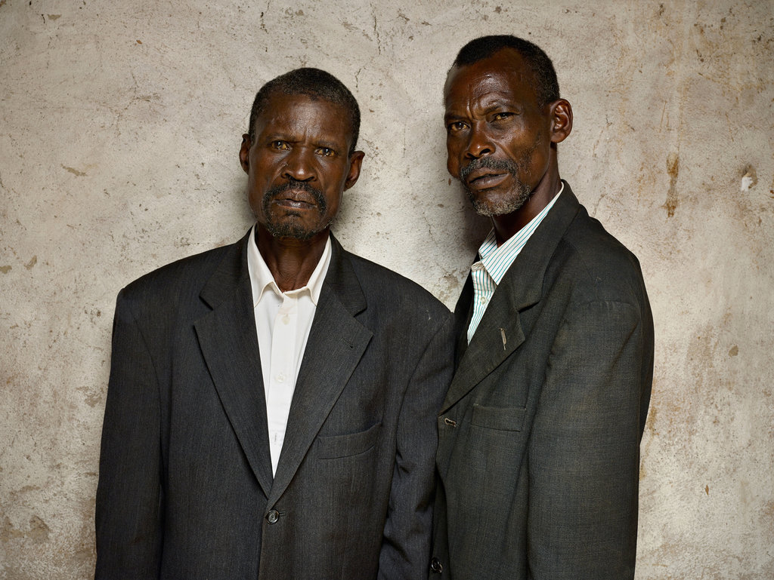
François Sinzikiramuka, perpetrator (left); Christophe Karorero, survivor.
Last month, the photographer Pieter Hugo went to southern Rwanda, two decades after nearly a million people were killed during the country’s genocide, and captured a series of unlikely, almost unthinkable tableaus. In one, a woman rests her hand on the shoulder of the man who killed her father and brothers. In another, a woman poses with a casually reclining man who looted her property and whose father helped murder her husband and children. In many of these photos, there is little evident warmth between the pairs, and yet there they are, together. In each, the perpetrator is a Hutu who was granted pardon by the Tutsi survivor of his crime.
The people who agreed to be photographed are part of a continuing national effort toward reconciliation and worked closely with AMI (Association Modeste et Innocent), a nonprofit organization. In AMI’s program, small groups of Hutus and Tutsis are counseled over many months, culminating in the perpetrator’s formal request for forgiveness. If forgiveness is granted by the survivor, the perpetrator and his family and friends typically bring a basket of offerings, usually food and sorghum or banana beer. The accord is sealed with song and dance.
The photographs on the following pages are a small selection of a larger body on display — outdoors, in large format — starting this month in The Hague. The series was commissioned by Creative Court, an arts organization based there, as part of “Rwanda 20 Years,” a program exploring the theme of forgiveness. The images will eventually be shown at memorials and churches in Rwanda.
At the photo shoots, Hugo said, the relationships between the victims and the perpetrators varied widely. Some pairs showed up and sat easily together, chatting about village gossip. Others arrived willing to be photographed but unable to go much further. “There’s clearly different degrees of forgiveness,” Hugo said. “In the photographs, the distance or closeness you see is pretty accurate.”
In interviews conducted by AMI and Creative Court for the project, the subjects spoke of the pardoning process as an important step toward improving their lives. “These people can’t go anywhere else — they have to make peace,” Hugo explained. “Forgiveness is not born out of some airy-fairy sense of benevolence. It’s more out of a survival instinct.” Yet the practical necessity of reconciliation does not detract from the emotional strength required of these Rwandans to forge it — or to be photographed, for that matter, side by side.
SINZIKIRAMUKA, PERPETRATOR (OPENING IMAGE, LEFT): “I asked him for forgiveness because his brother was killed in my presence. He asked me why I pleaded guilty, and I replied that I did it as someone who witnessed this crime but who was unable to save anybody. It was the order from authorities. I let him know who the killers were, and the killers also asked him for pardon.”
KARORERO, SURVIVOR: “Sometimes justice does not give someone a satisfactory answer — cases are subject to corruption. But when it comes to forgiveness willingly granted, one is satisfied once and for all. When someone is full of anger, he can lose his mind. But when I granted forgiveness, I felt my mind at rest.”
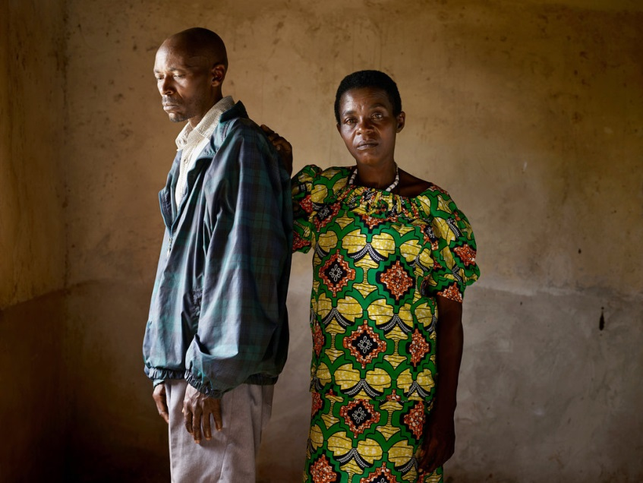
Jean Pierre KarenziPerpetrator (left)Viviane NyiramanaSurvivor
KARENZI: “My conscience was not quiet, and when I would see her I was very ashamed. After being trained about unity and reconciliation, I went to her house and asked for forgiveness. Then I shook her hand. So far, we are on good terms.”
NYIRAMANA: “He killed my father and three brothers. He did these killings with other people, but he came alone to me and asked for pardon. He and a group of other offenders who had been in prison helped me build a house with a covered roof. I was afraid of him — now I have granted him pardon, things have become normal, and in my mind I feel clear.”
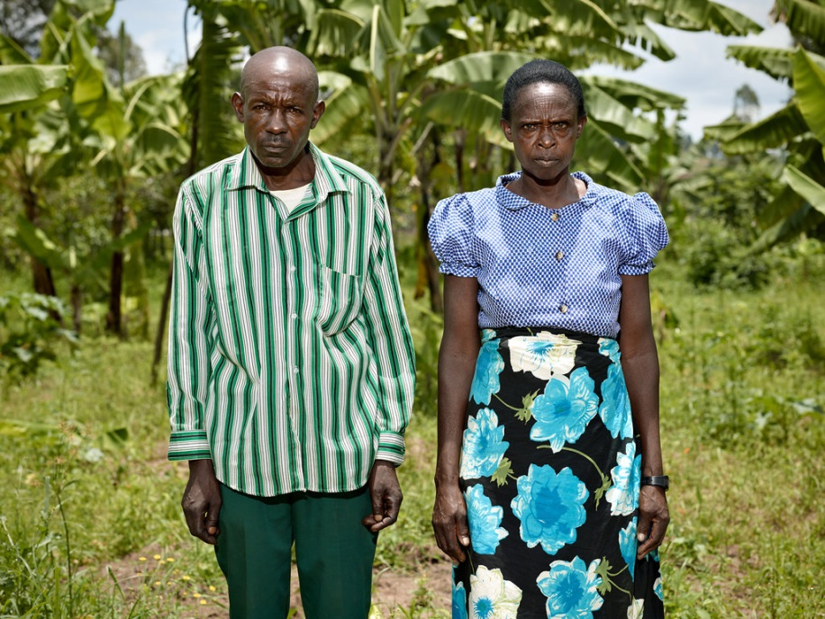
Godefroid MudaheranwaPerpetrator (left)Evasta MukanyandwiSurvivor
MUDAHERANWA: “I burned her house. I attacked her in order to kill her and her children, but God protected them, and they escaped. When I was released from jail, if I saw her, I would run and hide. Then AMI started to provide us with trainings. I decided to ask her for forgiveness. To have good relationships with the person to whom you did evil deeds — we thank God.”
MUKANYANDWI: “I used to hate him. When he came to my house and knelt down before me and asked for forgiveness, I was moved by his sincerity. Now, if I cry for help, he comes to rescue me. When I face any issue, I call him.”
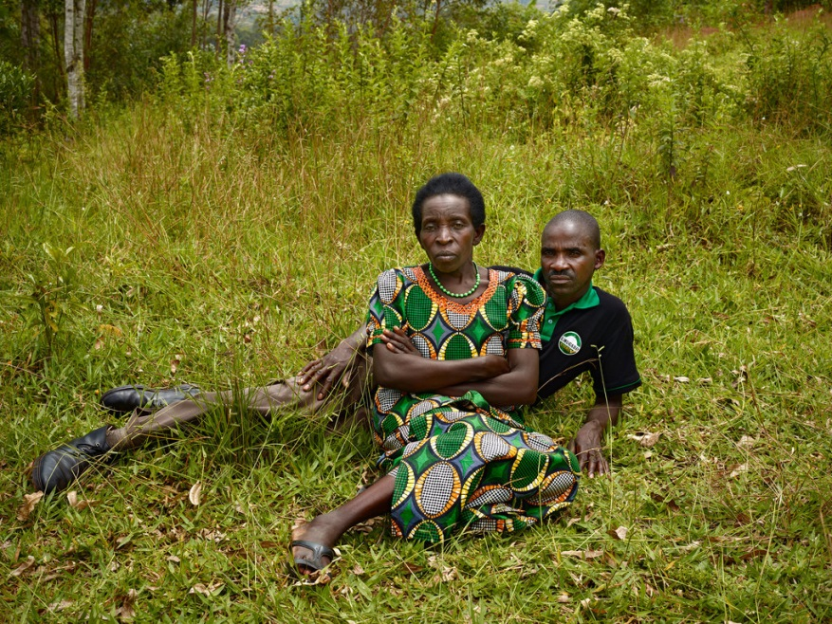
Juvenal NzabamwitaPerpetrator (right)Cansilde KampunduSurvivor
NZABAMWITA: “I damaged and looted her property. I spent nine and a half years in jail. I had been educated to know good from evil before being released. And when I came home, I thought it would be good to approach the person to whom I did evil deeds and ask for her forgiveness. I told her that I would stand by her, with all the means at my disposal. My own father was involved in killing her children. When I learned that my parent had behaved wickedly, for that I profoundly begged her pardon, too.”
KAMPUNDU: “My husband was hiding, and men hunted him down and killed him on a Tuesday. The following Tuesday, they came back and killed my two sons. I was hoping that my daughters would be saved, but then they took them to my husband’s village and killed them and threw them in the latrine. I was not able to remove them from that hole. I knelt down and prayed for them, along with my younger brother, and covered the latrine with dirt. The reason I granted pardon is because I realized that I would never get back the beloved ones I had lost. I could not live a lonely life — I wondered, if I was ill, who was going to stay by my bedside, and if I was in trouble and cried for help, who was going to rescue me? I preferred to grant pardon.”
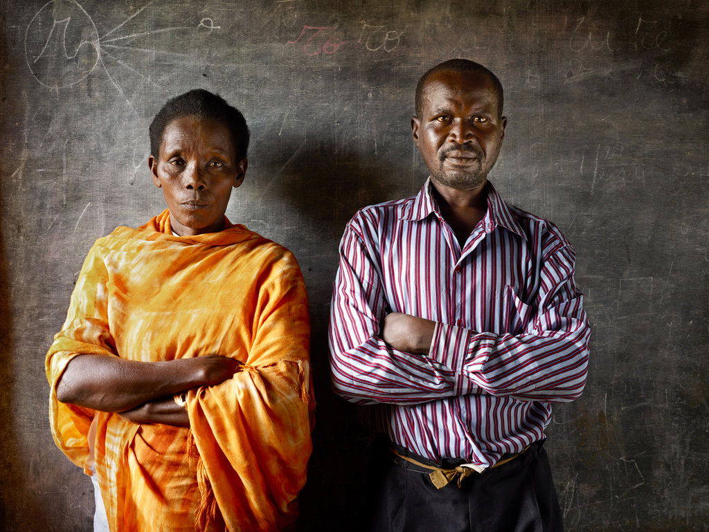
Deogratias Habyarimana Perpetrator (right) Cesarie Mukabutera Survivor
HABYARIMANA: “When I was still in jail, President Kagame stated that the prisoners who would plead guilty and ask pardon would be released. I was among the first ones to do this. Once I was outside, it was also necessary to ask pardon to the victim. Mother Mukabutera Caesarea could not have known I was involved in the killings of her children, but I told her what happened. When she granted me pardon, all the things in my heart that had made her look at me like a wicked man faded away.”
MUKABUTERA: “Many among us had experienced the evils of war many times, and I was asking myself what I was created for. The internal voice used to tell me, ‘‘It is not fair to avenge your beloved one.’’ It took time, but in the end we realized that we are all Rwandans. The genocide was due to bad governance that set neighbors, brothers and sisters against one another. Now you accept and you forgive. The person you have forgiven becomes a good neighbor. One feels peaceful and thinks well of the future.”
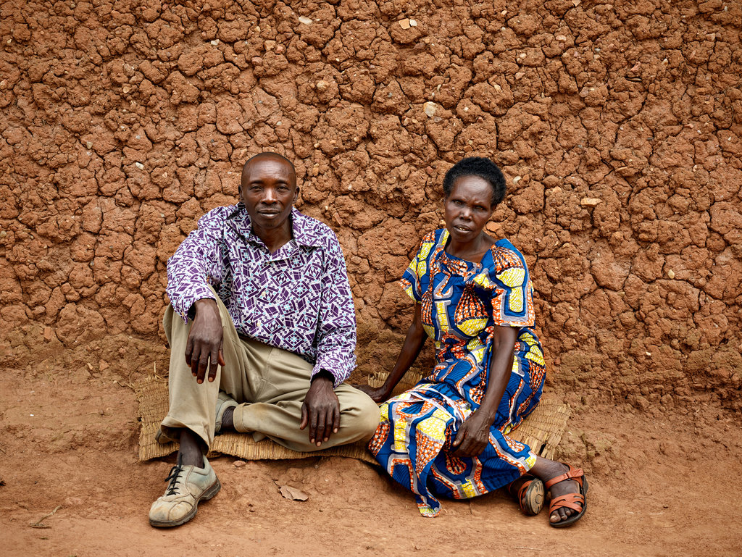
François Ntambara Perpetrator (left)Epiphanie Mukamusoni Survivor
NTAMBARA: “Because of the genocide perpetrated in 1994, I participated in the killing of the son of this woman. We are now members of the same group of unity and reconciliation. We share in everything; if she needs some water to drink, I fetch some for her. There is no suspicion between us, whether under sunlight or during the night. I used to have nightmares recalling the sad events I have been through, but now I can sleep peacefully. And when we are together, we are like brother and sister, no suspicion between us.”
MUKAMUSONI: “He killed my child, then he came to ask me pardon. I immediately granted it to him because he did not do it by himself — he was haunted by the devil. I was pleased by the way he testified to the crime instead of keeping it in hiding, because it hurts if someone keeps hiding a crime he committed against you. Before, when I had not yet granted him pardon, he could not come close to me. I treated him like my enemy. But now, I would rather treat him like my own child.”
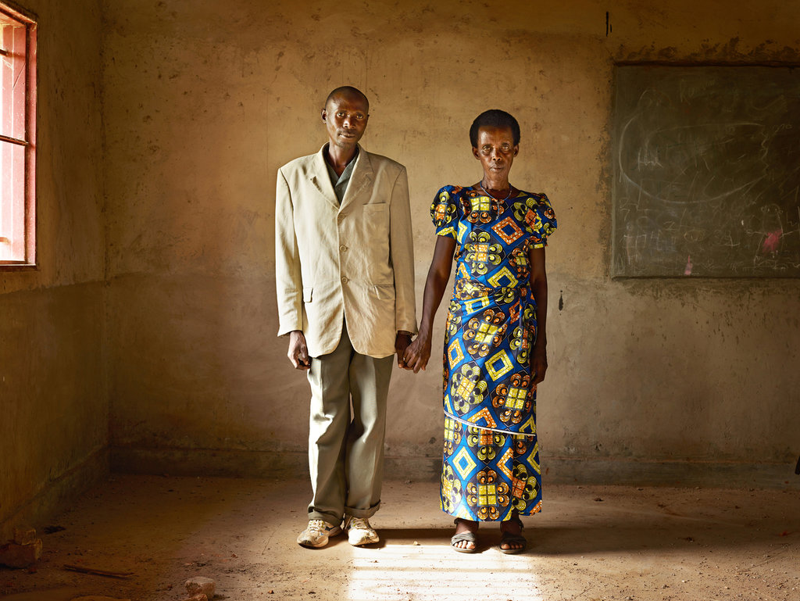
Dominique Ndahimana Perpetrator (left)Cansilde Munganyinka Survivor
NDAHIMANA: “The day I thought of asking pardon, I felt unburdened and relieved. I had lost my humanity because of the crime I committed, but now I am like any human being.”
MUNGANYINKA: “After I was chased from my village and Dominique and others looted it, I became homeless and insane. Later, when he asked my pardon, I said: ‘I have nothing to feed my children. Are you going to help raise my children? Are you going to build a house for them?’ The next week, Dominique came with some survivors and former prisoners who perpetrated genocide. There were more than 50 of them, and they built my family a house. Ever since then, I have started to feel better. I was like a dry stick; now I feel peaceful in my heart, and I share this peace with my neighbors.”
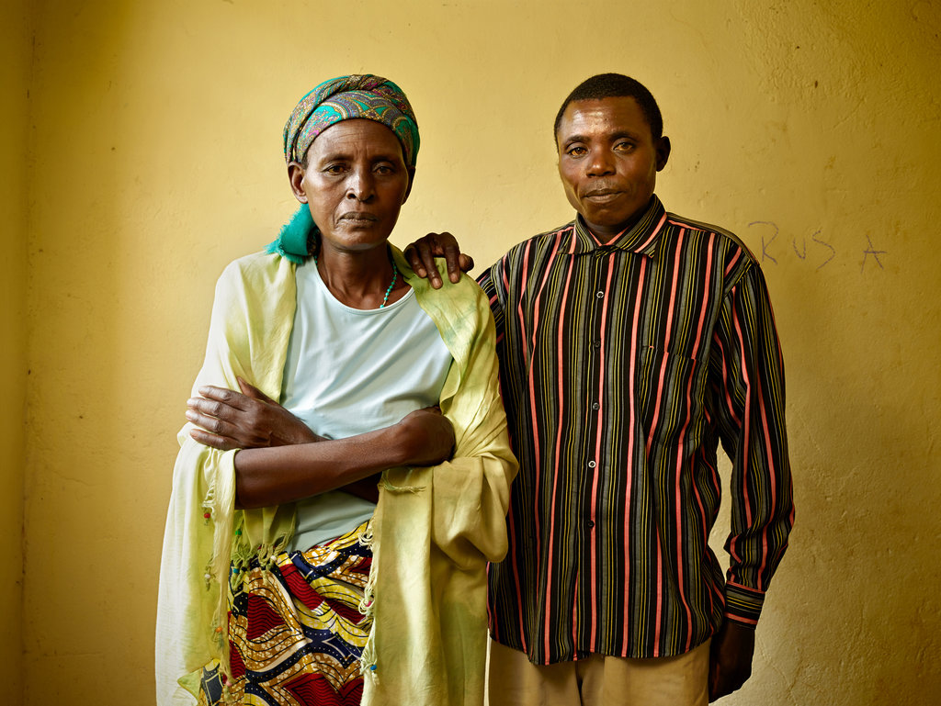
Laurent Nsabimana Perpetrator (right)Beatrice Mukarwambari Survivor
NSABIMANA: “I participated in destroying her house because we took the owner for dead. The houses that remained without owners — we thought it was better to destroy them in order to get firewood. Her forgiveness proved to me that she is a person with a pure heart.”
MUKARWAMBARI: “If I am not stubborn, life moves forward. When someone comes close to you without hatred, although horrible things happened, you welcome him and grant what he is looking for from you. Forgiveness equals mercy.”

